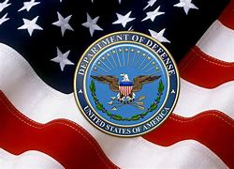
UNCLASSIFIED
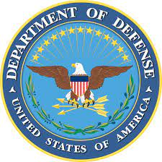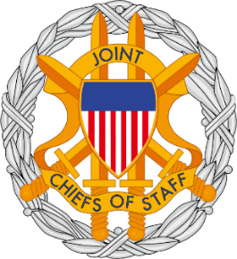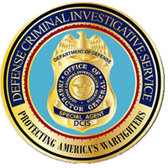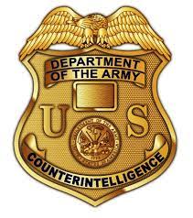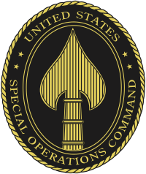
MILITARY WHISTLEBLOWER PROTECTION ACT COMMUNICATION
04/30/2022
AUTHORITY TO PROSECUTE:

ARTICLE I, SECTION 8, U.S. CONSTITUTION.
COUNCIL OF NATIONAL DEFENSE ACT OF 1916, AS AMENDED.
THE ESPIONAGE ACT OF 1917, AS AMENDED.
THE SECURITIES ACT OF 1933, AS AMENDED.
THE SECURITIES EXCHANGE ACT OF 1934, AS AMENDED.
THE COMMUNICATIONS ACT OF 1934, AS AMENDED.
FOREIGN AGENT REGISTRATION ACT OF 1938, AS AMENDED.
NATIONAL SECURITY ACT OF 1947, AS AMENDED.
THE INTERNAL SECURITY ACT OF 1950, AS AMENDED.
THE SUBVERSIVE ACTIVITIES CONTROL ACT OF 1950, AS AMENDED.
THE IMMIGRATION AND NATIONALITY ACT OF 1952, AS AMENDED.
THE COMMUNIST CONTROL ACT OF 1954, AS AMENDED.
THE ATOMIC ENERGY ACT OF 1954, AS AMENDED.
THE COMMUNICATIONS SATELLITE ACT OF 1962, AS AMENDED.
TITLE 18 U.S.C. SECTIONS 1961-68, 207, 792, 793, 798, 1030(a)(1), 2381, and 2382.
50 U.S.C. SECTION 783, as amended. 50 U.S.C. CHAPTER 13, AS AMENDED.
42 U.S.C. SECTIONS 2274, 2278, AS AMENDED.
FOREIGN INTELLIGENCE SURVEILLANCE ACT OF 1978, AS AMENDED.
EXECUTIVE ORDER 12333 OF DECEMBER 04, 1981, AS AMENDED.
TITLE 10 U.S.C. SECTION 1034, AS AMENDED.
PROVIDING MATERIAL SUPPORT TO TERRORISTS (2339A).
THE ANTITERRORISM AND EFFECTIVE DEATH PENALTY ACT OF 1996, AS AMENDED.
THE USA PATRIOT ACT OF 2001, AS AMENDED.
THE INTELLIGENCE REFORM AND TERRORISM PREVENTION ACT OF 2004, AS AMENDED.
JUSTICE AGAINST SPONSORS OF TERRORISM ACT (JASTA) OF 2016.
CONSPIRACY TO COMMIT OFFENSE OR TO DEFRAUD UNITED STATES (18 U.S.C. SECTION 371)
GARTHERING OR DELIVERING DEFENSE INFORMATION TO AID FOREIGN GOVERNMENT (18 U.S.C. SECTION 794)
https://www.unglobalcompact.org/what-is-gc/participants?page=1607
AUTHORIZED FOR PUBLIC RELEASE---MILITARY WHISTLEBLOWER PROTECTION ACT---PAGE 1 OF 5
UNCLASSIFIED
UNCLASSIFIED
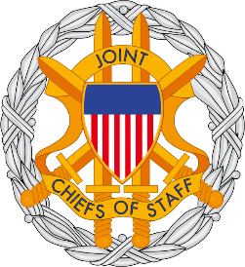
MILITARY WHISTLEBLOWER PROTECTION ACT COMMUNICATION

https://www.unglobalcompact.org/what-is-gc/participants/1184-Barrick-Gold-Corporation

https://www.barrick.com/English/about/default.aspx
https://www.barrick.com/English/about/governance/default.aspx
Company Barrick Gold Corporation

International Advisory Board
Chairman
The Right Honourable Brian Mulroney
CANADA
Prime Minister 1984-1993

Members
His Excellency José María Aznar
SPAIN
Prime Minister 1996-2004
Gustavo A. Cisneros
DOMINICAN REPUBLIC
Chairman, Cisneros Group of Companies

The Honorable Newt Gingrich
UNITED STATES
Speaker of the House of Representatives 1995-1999
AUTHORIZED FOR PUBLIC RELEASE---MILITARY WHISTLEBLOWER PROTECTION ACT---PAGE 2 OF 5
UNCLASSIFIED
UNCLASSIFIED
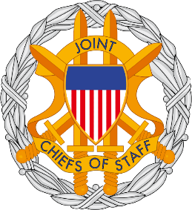
MILITARY WHISTLEBLOWER PROTECTION ACT COMMUNICATION

J. Robert S. Prichard, OC, OOnt
CANADA
Chairman, Torys LLP and Chairman, Bank of Montreal

The Honourable John R. Baird
CANADA
Minister of Foreign Affairs 2011-2015

Secretary William S. Cohen
UNITED STATES
Senator 1979-1997 and Secretary of Defense 1997-2001

The Honorable Newt Gingrich
UNITED STATES
Speaker of the House of Representatives 1995-1999

The Honourable Karl-Theodor zu Guttenberg
GERMANY
Federal Minister of Defense 2009-2011

John L. Thornton
UNITED STATES
Executive Chairman, Barrick Gold Corporation

AUTHORIZED FOR PUBLIC RELEASE---MILITARY WHISTLEBLOWER PROTECTION ACT---PAGE 3 OF 5
UNCLASSIFIED
UNCLASSIFIED
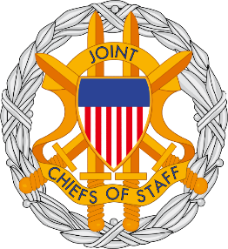
MILITARY WHISTLEBLOWER PROTECTION ACT COMMUNICATION

Mark Bristow
MAURITIUS
President and Chief Executive Officer, Barrick Gold Corporation

Isela Costantini
ARGENTINA
In House Consultant & General Manager, Grupo ST S.A.

Lord Charles Powell of Bayswater KCMG
UNITED KINGDOM
Foreign Policy Advisor to Prime Minister Margaret Thatcher 1983-1991

AUTHORIZED FOR PUBLIC RELEASE---MILITARY WHISTLEBLOWER PROTECTION ACT---PAGE 4 OF 5
UNCLASSIFIED
UNCLASSIFIED
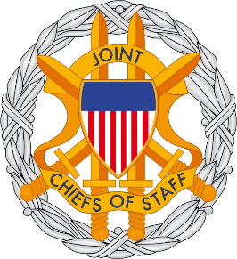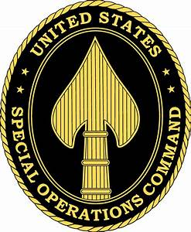
MILITARY WHISTLEBLOWER PROTECTION ACT COMMUNICATION

I CERTIFY UNDER PENALTY OF PERJURY UNDER THE LAWS OF THE UNITED STATES OF AMERICA, I AM AN EMPLOYEE OFTHE UNITED STATES GOVERNMENT, DEFENSE CONTRACT MANAGEMENT AGENCY, DEPARTMENT OF DEFENSE. I AM A U.S. ARMY SPECIAL OPERATIONS -DELTA FORCE NATIONAL NUCLEAR SECURITY OFFICER/”Q” NATIONAL NUCLEAR SECURITY ADMINISTRATION. I AM A MEMBER IN GOODSTANDING OF THE NATIONAL TELECOMMUNICATIONS SECURITY WORKING GROUP, COMMITTEE ON NATIONAL SECURITY SYSTEMS. I AM A DEFENSE SECURITY SERVICE CERTIFIED U.S. ARMY FOREIGN DISCLOSURE CONTACT OFFICER/DEFENSE COUNTERINTELLIGENCE AND SECURITY AGENCY. I AM WITH THE DEFENSE INTELLIGENCE AGENCY/JOINT CHIEFS OF STAFF, ASSIGNED TO THE OFFICE OF THE SECRETARY OF DEFENSE. I HAVE PERSONAL KNOWLEDGE OF THE FACTS STATED HEREIN. THAT THE FOREGOING DOCUMENT IS TRUE AND CORRECT, TO THE BEST OF MY KNOWLEDGE AND BELIEF, PURSUANT TO THE PROVISIONS OF TITLE 28 U.S.C. SECTION 1746. EXECUTED ON 4/30/2022.
_/s/ WILLIAM MAVERICK WINSLOW AC 56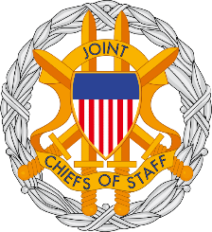
OFFICE OF THE SECRETARY OF DEFENSE
DEFENSE CONTRACT MANAGEMENT AGENCY
DEFENSE INTELLIGENCE AGENCY/JOINT CHIEFS OF STAFF
DSS/DEFENSE COUNTERINTELLIGENCE AND SECURITY AGENCY
U.S. ARMY SPECIAL OPERATIONS-DELTA FORCE
williamwinslow@deltaforce12333.army
williamwinslow@us-armedforces-foundation.army

UNITED STATES SPECIAL OPERATIONS COMMAND
UNITED STATES OF AMERICA
AUTHORIZED FOR PUBLIC RELEASE---MILITARY WHISTLEBLOWER PROTECTION ACT---PAGE 5 OF 5
UNCLASSIFIED

