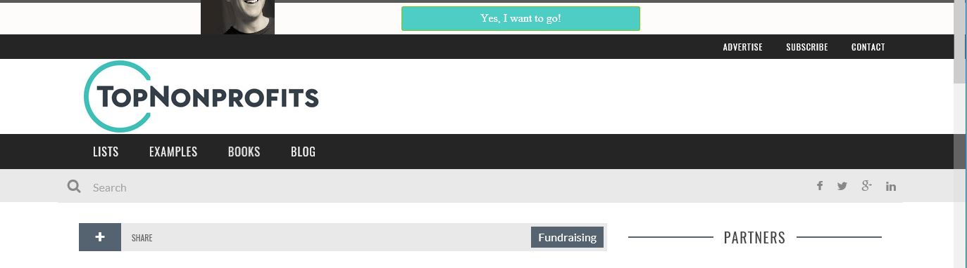

How to Increase Funding Using Cross-Sector Partnerships
Post on: Apr 3, 2017
Bruce Burtch
0
Wouldn’t it be pretty phenomenal if your nonprofit could not only increase its funding, but at the same time attract new volunteers and business partners, get more in-kind donations, earned income opportunities, better media coverage, and free legal or creative services?
Amazingly, these are only some of the 31 benefits we have found that your nonprofit can receive when you partner with a for-profit in a cross-sector partnership. Better yet, these beneficial collaborations are great for nonprofits of all sizes, and many times work best for small to midsize nonprofit organizations.
For-profits get even more benefits in cross-sector partnerships – 38 that I’ve found so far.
For-profits love cross-sector partnerships for similar reasons. As a matter of fact, for-profits get even more benefits in cross-sector partnerships – 38 that I’ve found so far. These include increased sales and brand loyalty, better employee retention and shareholder return, free media coverage, new business partners, and of course tax deductions (see the full list ). So it’s easy to understand why for-profits are focusing more of their funds ($1.7 billion in 2012, according to IEG) on cause-related partnerships with nonprofits.
However, you can’t just sashay into the lobby of your favorite company and expect the CEO to come running. You’ll have to put on your corporate business hat to get in the door for something this significant. I have worked with over 125 different nonprofits, but I rarely see what’s most effective when approaching for-profits – the same way a business approaches a new opportunity: providing a Business Value Proposition (BVP).

4 Steps to Creating a successful Business Value Partnership (BVP)
To write a BVP that gets the nod, start by closely assessing potential partners. Then:

Step 1: Find Aligned For-Profits
Research for-profits in your area. Talk to staff, volunteers and other stakeholders, and check your local business journals or Chamber of Commerce for partner ideas. Create a list of companies that could best align with your organization’s goals and mission.

Step 2: Do Your Homework
Zero in on 2-3 companies. Then learn everything you can about their business and marketing objectives. Search the Internet and read their annual report, press releases and other company information. Use Hoovers.com, LinkedIn and other business information providers and people with connections at these companies.

Step 3: Integrate for-profit benefits and partnership goals
Integrate the information from your research with the cross-sector partnership benefits discussed earlier and online, showing specific ways this partnership can provide “wins” for the company. And stay focused on the greater good of this partnership – it is the mission that drives the success of any cross-sector partnership. Then develop a business value proposition like they have never seen before from a nonprofit.

Step 4: Target the Marketing Department
Marketing drives the revenue of any business and so the Marketing Department has the pulse of the company and the ear of the CEO, and it drives PR, sales and brand. Importantly, the marketing budget is usually over 100 times larger than their foundation budgets. So open the Marketing door first. Nothing in business provides as much economic and social benefit, on as many levels, to as many stakeholders, as a strategic partnership between nonprofit and for-profit organizations when focused on the greater good. After 35 years of developing such cross-sector partnerships, I’ve not seen anything come even close.

Get Bruce’s book here for free!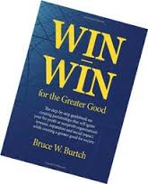

About author

Bruce Burtch
Bruce W. Burtch has been helping for-profit and nonprofit organizations develop win-win partnerships to maximize their strategic marketing and fund development success for over 35 years. He is an internationally-recognized cause marketing and cross-sector partnership expert and author of Win-Win For the Greater Good.

