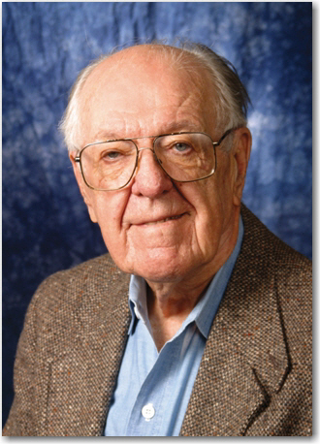****

**2023 Neal Amundson Award**

**Nomination Form**

**The Neal Amundson Award**

In 1996, the ISCRE, Inc. Board of Directors established the Neal R. Amundson Award for Excellence in Chemical Reaction Engineering. This award recognizes pioneers in the field of Chemical Reaction Engineering who have exerted a major influence on the theory and/or practice of the field, through originality, creativity, and novelty of concept or application. Additional information about the Amundson award and previous winners can be found at <https://www.iscre.org/awards/amundson-award/>.

**Submission Deadline – October 7, 2022**

All submission forms and supporting documents should be sent to Matthew Neurock by October 7th, 2022.

**Nomination Information**

**1. Name of Nominee**

**2. Nominee’s Present Position**

**3. Nominee’s Contact Information**

**4. Nominator’s Contact Information**

**5. Citation:**

**Nomination package should include:**

1. Proposed citation (not more than 25 carefully edited words that reflect specific achievements);
2. Statement of scientific and technological accomplishments - limited to one single-spaced page, highlighting contributions and emphasizing how they have been a source of influence;
3. Nominee’s CV including a list of publications and prior awards/honors.