^{Office Use Only:}
Date Processed:

Membership No:

Paid by etransfer or cheque:

Receipt Number:

Okotoks Rifle & Pistol Club (ORPC)
P.O. Box 273
Okotoks, Alberta T1S 1A5
(403) 938-6510

2022-2023 MEMBERSHIP APPLICATION

Please complete and return this Membership Application by email to orpc67@gmail.com or by regular mail.
Please include a clear colour picture of your Firearms Licence (PAL or RPAL).
Your application will be kept strictly confidential. ORPC membership records can be requested and provided to the CFO and/or RCMP. Your new Membership Card and receipt will be mailed using Canada Post.
Your membership fees can be sent by etransfer (Interac®) to: orpc67@gmail.com
Recipient Name: ORPC

Regular mail with a cheque is also acceptable for payment.
MEMBERSHIP | FEES
Adult | $ 250
Family* | $ 300
Junior | $ 10

Current Membership Number:
Membership Information:

Name: |  |  |  |  |  | Date of Birth: |  |  |  |  | RPAL #:
Address:
Town: |  |  |  |  | Province: |  |  |  |  |  |  | Postal Code:
Phone (Home): |  |  |  |  |  |  |  | (Cell/Work):

E-Mail:

Family Membership Information (*Family Memberships can include spouse or partner plus dependent children less than 18 and living at home):
Name: |  |  | Date of Birth: |  |  | RPAL #:
Child/Jr Member Name: |  |  |  |  | Date of Birth:
Child/Jr Member Name: |  |  |  |  | Date of Birth:
Child/Jr Member Name: |  |  |  |  | Date of Birth:
Child/Jr Member Name: |  |  |  |  | Date of Birth:
I agree by my(our) signature(s) below, to abide by the Range Rules and conditions of Okotoks Rifle and Pistol Club and understand that failure to do so may result in the cancellation of my membership.
Signature(s):_______________________________________________________ Date: _______________

2022-2023 memberships will expire on June 30, 2023.

By checking this box, I hereby CONSENT to receiving electronic (e-mail) messages from ORPC regarding business related to the club, including renewal notices. I can withdraw my consent at any time.

Okotoks Rifle & Pistol Club (ORPC)

2021-2022 MEMBERSHIP APPLICATION – Page 2

Current Membership Number: | 113
Picture of RPAL - Front

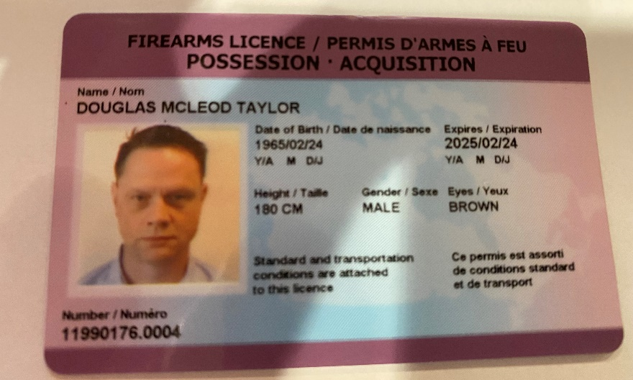

Picture of RPAL – Back

