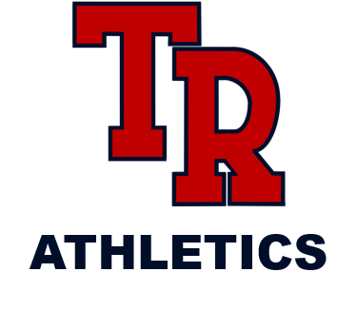

COVID-19 EXTENDED CLOSURE

Due to the current COVID-19 Extended Closure, all camps have been suspended until further notice. We will notify athletes, parents, and community members when a definitive date has been approved.

GO RIDERS!

