**NRG specification sheet**

Part 1 — General

SUBMITTAL  
Submit color samples for selection from manufacturer. Submit product literature, certifications, test reports and full size sample(s) of each color specified.

QUALITY ASSURANCE  
Certifications: All NRG. Insulated Concrete Masonry Units will meet or exceed the compressive strength and absorption requirements of Standard ASTM Specification C-90, Hollow Load Bearing Concrete Masonry Units.

Material: All insulated, web-less, concrete masonry units shall be NRG™ ICMU’s, (Insulated Concrete Masonry Units) except corner, half, solid bottom bond beam and sash units. These “special” units shall be conventional units and shall interspersed into the NRG™ wall construction where needed. Incorporation of conventional CMU’s into the NRG™ wall system will have no significant adverse effect upon thermal performance of the overall system. NRG™ ICMU’s are available from manufacturers licensed by Niagara Regional Group, Ltd. ICMU’s shall be specified as lightweight, medium weight, or normal weight NRG™ design units. Lightweight and medium weight are not recommended to be specified for walls that directly contact the building exterior.

All NRG units and conventional cmu’s installed with NRG units exposed to the building exterior shall contain a manufacturer-approved integral water-repellent CMU admixture at the time of manufacture. The NRG™ ICMU’s are available in finishes and colors determined by individual manufacturers.

All Masonry Units must contain an integral Expanded Polystyrene Insert installed at the site of production.  
All Masonry Units must contain a Dovetail design to lock the insulation and inner and outer module together. All Masonry Units must not contain a thermal bridge from face to back where as sound, moisture, and thermal energy can be conducted through the wall.

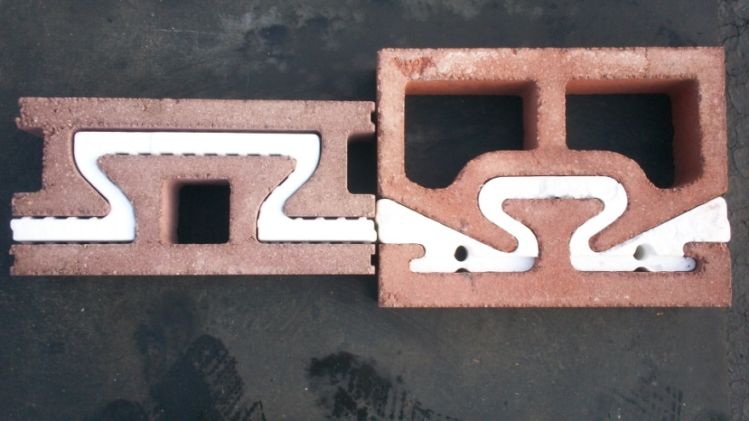

General Conditions  
**Part I:** It is important to note that the NRG™ ICMU (Insulated Concrete Masonry Unit) is designed with an off-centered core configuration. Therefore, the vertical rebar (positioned and set in the poured foundation) must be matched to the same off-centered designation. (According to specific size units the position of the vertical rebar will vary.) i.e.: 12” ICMU offset is 2.5”

**Part II:** List the requirements for mortar, reinforcing, concrete block work and other associated work and details that relate to this product. If this information is detailed in another section, it should be cross-referenced under this heading. The NRG ™ Insulated Wall System is laid similar to any other block, either in a running bond or stacked bond. 10" and 12" NRG units shall be presented to the mason, and the mason shall lay each ICMU with each “cap” on top of the block and facing the same direction. (To insure that the thermal mass of the unit is on the inside, face shell and thumb holes toward the outside exterior of the wall.) 8" NRG units with square cells shall be installed with the blocks in each course "flipped" from the course beneath it.

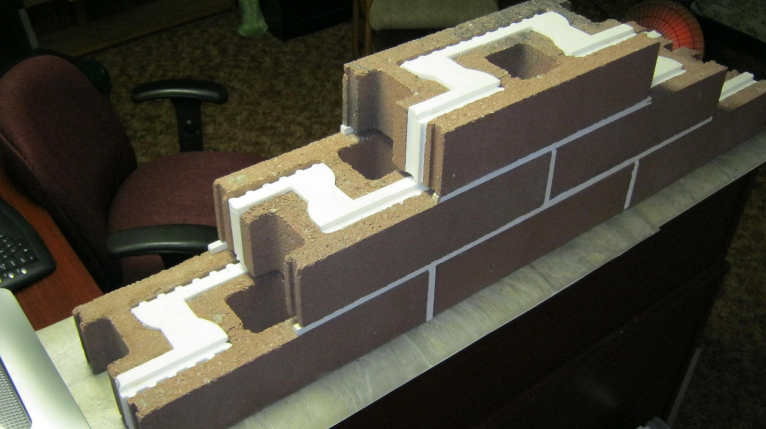

**Note:** This will also insure that the wall is laid with the tightest thermal barrier.  
**Scope:** Interior and exterior walls shall be insulated, web-less, concrete masonry units as shown on the plans/ or indicated on the finish schedule.

Fire Resistance:10" and 12" fire rated for up to 4 hours, 8" will have a 2 hour fire rating. Define hourly ratings required by NCMA TEK Notes.

Field Constructed Mock-ups: Construct a sample panel, no less than 4′ x 4′, of units of each color and size to be used in the project. (These units need not be NRG™ ICMUs).

A full size unit is required to illustrate color and texture for approval. Manufacturer requires a sample panel be installed at the jobsite prior to installation. This panel will represent both the quality of the product and the workmanship to be expected for the project. The panel must be approved by either the owner or architect for the project. Manufacturer will provide 4″ units for a 4′ by 4′ sample panel at no cost for the material (excluding freight to site).

DELIVERY, STORAGE AND HANDLING  
Units shall be delivered to the jobsite on covered banded pallets with cardboard between layers. Store pallets in single stacks on level ground and cover with waterproof covering (e.g., tarpaulins) to protect the blocks from inclement weather. Handle blocks carefully to avoid breakage and damage to the finished surfaces.

PROJECT/SITE CONDITIONS  
Protection of Work: Cover walls each day after installation to keep open walls protected and dry. After units are installed they should be protected from damage by other trades performing operations that can stain or otherwise damage the finished surfaces by covering walls with plastic. Corners should be protected from damage after installation by covering them with plywood.

Part 2 — Products

PRODUCT NAME  
NRG™ Insulated units are manufactured by quality block producers listed at www.energyefficientblock.com (see NRG producers).

RELATED MATERIALS  
Colored matching or contrasting mortar is available from manufacturer. Consult NCMA TEK Notes for mortar type and specifications. For all exterior mortar, use matching manufacturer-approved water repellent mortar admixture following manufacturer’s instructions. Consult manufacturer for recommendations.

SIZES AND SHAPES  
Face Sizes: Modular 8”x 16”, 4" x 16", wall depth 8”, 10”, and 12”  
Face Mortar Joints: 3\8” exposed.

Shapes: Shapes not available in the NRG™ design shall be substituted for using conventional hollow core CMU’s matching the same finish and color of the NRG™ units. These conventional blocks shall also contain an integral water repellent when exposed to the building exterior.

Scoring: Scoring of the face shall be accomplished through the molding process, or by cutting 3/8” wide x 1/4” deep grooves into the face of the ICMU’s or CMU’s These grooves shall be pointed and tooled using the same mortar as used to lay the units. *When center scored units are used, the finished wall will be much neater to lay if stack bond is used. The use of scored units which have bonding patterns that do not require continuous vertical joints can be installed faster and more economically.

Face joints shall be 3\8” wide and the block joints on the sides, top and bottom shall be 3\8” wide, (thereby giving the visual effect of 8” x 8” squares)  
Miscellaneous Tools and Products Required by Masons: Contractor shall include products such as mortar, reinforcing, ties, anchors, and other masonry attachments as may be required to properly finish the project. Striking or jointing tools, rags, and masonry cleaners shall also be required.

MASONRY CLEANERS Carefully following manufacturer’s instructions, use Burnished Custom Masonry Cleaner by PROSOCO (dilute 1 part to 3 parts clean water). Available from manufacturer. **Do not powerwash**.

CAUTION! Never use Muriatic Acid solution or any cleaner with an acid base on units.

Part 2 — Products

LAYING MASONRY WALLS

Workmanship: ICMU’s shall be laid with the faces level, plumb, and true to a line strung horizontally at the face. Units shall have uniform joint dimensions 1/4” both horizontal and vertical. Joints shall be tooled, straight and inform neatly after they are finger hard. Cut pieces shall be sized and placed appropriately to maintain consistency and bond. Masonry construction shall be completed using procedures and workmanship consistent with the best masonry practices.

Control Joints: Control joints shall be installed in the locations designated in design plans.

Coping: As shown in details/ Or specified.

Draw blocks from more than one pallet at a time during installation. All exterior mortar shall include manufacturer-approved matching water-repellent additive added to each batch in the appropriate dosage rates for mortar type (M, S or N) per manufacturer’s instructions. Refer to NCMA TEK Notes, for Hot and Cold weather construction practices.

Lay units using the best concrete masonry practices. Install only quality units; reject all defective units as defined by ASTM C90. Lay blocks with the faces level, plumb and true to the line strung horizontally at the ground or filled and polished face. Units shall have uniform, 3/8″-wide joints both horizontally and vertically on the finished side of the wall. Tool joints neatly after they are finger-hard to make them straight and uniform. Size and place cut pieces appropriately to maintain consistency and bond. Complete masonry construction using procedures and workmanship consistent with the best masonry practices.

INSTALLATION

Lighting: Provide adequate lighting for masonry work by placing all lighting at a reasonable distance from the wall for even illumination. Do not use trough lighting.

Cutting: All cuts for bonding, boxes, holes, etc. shall be made using a motor driven masonry saw using either an abrasive or diamond blade.

**Note:** The NRG unit should not be cut in half.

MORTAR BEDDING and JOINTING

1. Lay units with full mortar coverage on head and bed joints taking care not to block cores to be grouted or filled with masonry insulation.
2. Tool all mortar joints when thumbprint hard into a concave configuration.
3. Care should be taken to remove mortar from the face of masonry units before it sets.
4. Tuckpoint the joints of scored units for proper appearance. All exterior scored units must be tuckpointed to prevent water penetration. **NO RAKE JOINTS**.

IMPORTANT for the NRG 8::

TMS 402 Grouting Limitations:

In accordance with TMS 402 grout space requirements, it should be noted that the code

allows for ½-inch mortar protrusions into the grouted cell. Using this allowance, the grout

space would be reduced to 2 inches by 2 inches, and grout placement would be limited to 1-foot pour heights of fine grout.



Designers would need to prohibit mortar joint protrusions in order to be permitted to use

higher pour heights. This would require special attention by the masons to remove all mortar

protrusions from the cells.

FLASHING OF MASONRY WORK  
Install flashing at locations shown in the plans and in strict accordance with the details and the best masonry flashing practices.

WEEP HOLES AND VENTS  
The bottom 2” of the vertical joints shall be left open in every other block unit in the first course above grade. Such open joints shall also be left open above flashing, beam units, and filled block areas that act as water stops. Consult NCMA TEK Notes for proper flashing and drawings.

INSPECTION  
The faces shall conform to the requirements of ASTM C90 when viewed from a distance of twenty (20) feet at right angles to the wall with normal lighting.

CLEANING  
Keep walls clean daily during installation using brushes, rags and the burlap squares supplied on the pallets. Do not allow excess mortar lumps or smears to harden on the finished surfaces. Harsh cleaning methods after walls have been erected will mar the surface of the blocks.

FINAL CLEANDOWN  
Clean the completed walls with PROSOCO Burnished Custom Masonry Cleaner (dilute 1 part to 3 parts clean water), strictly following the manufacturer’s instructions – including thorough rinsing. Do not use acid or abrasives on the finished surfaces. Failure to strictly follow manufacturer’s instructions can result in permanent damage to the finished faces. Do not apply Burnished Custom Masonry Cleaner with pressure spray above 50 psi. **Do not powerwash**.

FIELD COAT APPLICATION  
Apply to walls after cleandown and when the walls are dry. Apply the acrylic evenly to cover the entire surface without forming drips or runs. For maximum coverage and best appearance, apply with airless spray equipment. Consult manufacturer for further information.

MAINTENANCE  
Properly installed and cleaned, units need virtually no maintenance other than routine cleaning (i.e. Pinesol or Fantastik). Graffiti, paint or dye stains may need special cleaning methods and products. Contact manufacturer for specific cleaning recommendations.

INSTALLATION RECOMMENDATIONS  
Consult NCMA TEK Notes, for proper installation of concrete masonry units.