2020 HEALTHCARE TECH THAT IS CHANGING LIVES FOR SENIORS, FAMILIES AND RESIDENTS – NOW LOOKING FOR INVESTMENT PARTNERS
For persons with serious medical issues like Alzheimer’s, Parkinson’s, Dementia, Arthritis, Blindness, Osteoporosis, Epilepsy, Stroke and Multiple Sclerosis OR LIVE ALONE - Falls and Injury prevention continues to be a considerable challenge among all seniors. Falls are a life-threatening concern for older adults aged 60 years and above. A fall can significantly reduce one’s quality of life and the ability to retain their independence. According to the Center for Disease Control (2017), 3 million seniors are treated in emergency departments for fall injuries each year and over 800,000 patients will be hospitalized due to head and hip injuries. As a caregiver or healthcare professional, it is our duty to ensure that safety is the utmost priority. From 2007 to 2016 the fall death rate in the United States has increased 30% (CDC, 2017).
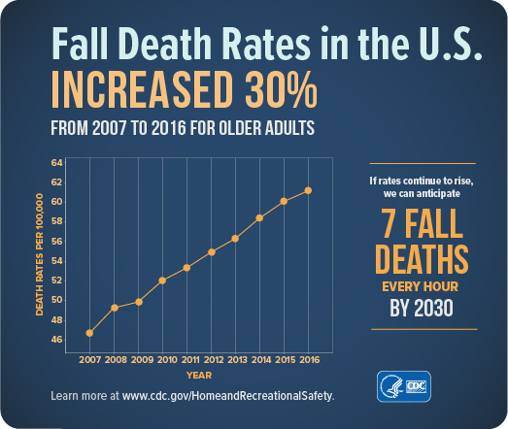
Falls are not an inevitable part of aging and there are proven ways to reduce falls. The risk factors that can be managed include medication side effects, environmental hazards, and muscle weakness. Ensure medications are not causing side effects such as lightheadedness, sedation, visual impairments, or orthostatic hypotension that increases one’s risk for falls. Environmental hazards that can be reduced include, but are not limited to, clutter removal, securing loose rugs, cleaning spilled liquids and foods, using non-slip mats in the shower, wearing properly fitted, non-skid shoes, and having adequate lighting. Additionally, one of the most important modifiable risk factors is staying physically active. Those seniors who are afraid of moving are more likely to experience a fall. Physical activity prevents muscle atrophy, improves balance, flexibility, and motor coordination (Mayo Clinic, 2018).
For over 25 years, Predictive Health Devices Inc. has been involved in the emerging healthcare area of proactive and predictive healthcare. Our team is dedicated to reducing negative medical outcomes in healthcare facilities and at home. Our mission is to ensure the best solutions available using the most predictive, proactive, game-changing technologies and the integration of artificial intelligence following years of research. We have consulted with most top hospitals and healthcare organizations to provide fall prevention monitoring and advice on numerous valuable technologies to improve patient safety and risk. This approach has saved thousands of facilities, and the senior community, billions of dollars in unnecessary risk and patient safety. It is estimated the total medical costs for falls totaled more than $50 billion dollars last year (CDC, 2018).
These latest technologies are going to be invaluable to seniors and their families. Some of the devices include wearable/inflatable hip protectors, unique watch-like wearables, wireless fall and exit alarms, and wireless caregivers. These products aide improvement in self-care and provide ongoing guidance outside of a professional encounter but may include telehealth in these technologies. Each with a tracking platform that continuously collects patient data with abilities to transmit clinically valid objective data back to healthcare, relatives, professionals and caregivers. The real-time fall protection devices allow for timely notifications of important indicators of concern regarding a patient’s status. By enabling individuals with the latest health technology, they can live a healthier, safer and more active life.
Our Predictive Health Devices Include:
Zanthion – Proven Senior Protection -For Wondering (GPS) Location anywhere via
Smart Watch, Fall Prediction and Detection, Smart Bed Exit, Shower Exit, Door Exit, Toilet
Sensor, Continuous Monitoring with Alerts to Family, Friends, Neighbors, and Caregivers.
Collaborative personal care – Dignity without intrusion – Live with Freedom and Confidence.
Product utilized in Homes, Long Term Care, Assisted Living and Hospitals
http://www.predictivehealthdevices.com/products/zanthion/ (see video)

Tango – Active Protective Belt – Real-time fall protection wearable device Air Bag for the Hips
http://www.predictivehealthdevices.com/products/tango/
  - Multi-sensor smart comfortable wearable belt, detects impending falls, deployable airbags
  - Maximum functionality, reliability, comfort, and ease of use by seniors
  - Continuously logs user motion activity to review patterns and implement interventions to maximize quality of care and sends critical data to doctors and caregivers.
SafeBeing – Remote Monitoring of Residents and Patients and Home Care
http://www.predictivehealthdevices.com/products/safe-being/
- Complete location monitoring and alerts for wondering out of designated safe zones, ad alerts for critical changes in parameters
- Detailed monitoring of falls – location and alert, activity levels, sleeping, walking, drinking, UTI risk, developing fall risk, emergency button, pressure ulcer risk and much more!!!
We Sense – 2020- Latest Continence Management – New Innovative Technology
http://www.predictivehealthdevices.com/products/we-sense/

- Offers real-time wetness events monitoring that enables caregivers to change patients and resident’s briefs at the right time with compliance reporting. This also helps reduce the incidence of falls surrounding toileting issues. Incontinence is continuously monitored reducing costs of Urinary Tract Infections, Wounds and falls. All residents are monitored via smart phone or tablet. Overall costs are reduced using less briefs and minimizing staff time and resident discomfort
UprightVR – New Technology for Low Cost Fall Prevention Balance and Assesment
http://www.predictivehealthdevices.com/products/uprightvr/
  - Low-cost, easy to administer, ‘pre-fall’ balance tests and fall risk assessments must be easily and regularly available, where seniors live, shop, and receive medical care if Government and private fall prevention objectives to be realized.
- UprightVR’s mission is to “catch them before they fall” by facilitating a new balance assessment paradigm.

Trazer – Most Advanced Rehabilitation Technology
http://www.predictivehealthdevices.com/products/trazer/
Nearly 1/3 of seniors living in their own home, or the home of adult children caregivers suffer from a serious fall at least once each year, most will die the first year after a hip fracture. Many may never completely recover from the injury (Cleveland Clinic, 2016). New technologies are changing the way of healthcare delivery and management as it is becoming more complex and demanding. Each of these low-cost fall products optimizes family member/resident’s safety. Many, of which, are covered in the Medicare/telehealth bill. It is giving hope to the quality of life of seniors. For more information visit www.predictivehealthdevices.com.
Angela Pritts, RN BSN
Clinical Specialist
Medical Nurse Training, Inc.
& Predictive Health Devices, Inc.

PLEASE RESPOND WITH ANY QUESTIONS TO

Experts for Quality, Fall Prevention and Protection, Risk Management, Training, Marketing and Distribution

Pat Devaney
President and CEO
Medical Nurse Training and Distribution Inc.
And Subsidiary, Predictive Health Devices Inc.
www.predictivehealthdevices.com
800-674-3476

