PRANA FOUNDATION AND INDVENTR CONSORTIUM ANNOUNCES PARTNERSHIP TO ENABLE A RANGE OF AFFORDABLE VENTILATOR SOLUTIONS DURING THE PANDEMIC

Massachusetts, US and Cochin, India; Sept 14, 2020
The Project Prana Foundation is partnering with IndVentr consortium to mitigate challenges in medical device shortages during the pandemic. With COVID-19 on the rise in many nations, healthcare systems are desperately seeking to bolster their supply of ventilators to meet the volumes of patients requiring mechanical ventilatory support. Low-cost, emergency ventilators and multiplexing systems offer a solution to this rapidly evolving situation.
Project Prana is a not-for-profit foundation which grew out of biomedical engineering efforts at the Massachusetts Institute of Technology (MIT) and the Brigham and Women’s Hospital. The foundation is focused on creating device-based and educational solutions to address the ventilator shortage worldwide. They are operationalizing the individualized System for Augmenting Ventilator Capacity (iSAVE), a rigorously tested platform to multiplex ventilation while enabling patient-specific therapy in several nations worldwide. The validation of this system in ventilating two subjects simultaneously was recently published in Science Translational Medicine.
IndVentr, a consortium of three startup companies, is creating innovative, frugal, easy to manufacture, emergency care ventilators for treating COVID-19 patients. It is a nonprofit, crowdfunded and open-source program driven by the corporate social responsibility (CSR) initiatives of Sinergia Media Labs, Ionics3DP, and Aruvii. They have completed functional prototypes of their designs INDVENTR-100, a BVM-based emergency resuscitator, and INDVENT-200, a feature-rich pneumatic design, which addresses an affordable range of cost and capability points.
“Project Prana and IndVentr will join forces to offer both low-cost ventilators and multiplexing systems to markets in India and neighboring countries.” says Shriya Srinivasan, President of the Project Prana Foundation. “This effort is poised to equip and greatly expand the capacity of healthcare systems in developing nations,” says Khalil Ramadi, Vice President of the Foundation.
“iSAVE is a carefully designed and thoroughly tested ventilator sharing platform which can quickly scale up the ventilator infrastructure around the world which is currently under heavy challenge by the Covid-19 epidemic” says Silji Abraham, SVP & Chief Digital and Transformation Officer at West Pharmaceutical Services and an advisor of the IndVentr consortium. “This innovative, frugal solution, which will cost less that Rs20,000 augments perfectly the solution space IndVentr has been focusing on.” says Prakash Bare, the project head at IndVentr.

Donations to support the development and distribution are welcome at:
https://shareyourfortune.org/causes/others/others-2

About IndVentr Consortium
IndVentr is a consortium of three startup companies - Sinergia Media Labs (Cochin), IONIC3DP (Chennai), and Aruvii (Singapore). The non-profit, crowdfunded, and open source program aims to create emergency care ventilation solutions that are affordable, easy to use, effective for Covid-19 treatment, and quick to manufacture. The products being developed are a BVM Based emergency resuscitator - IndVentr100, and a more capable pneumatic design - IndVentr200.
The program is being supported by advisors, contributors and entities from India, Singapore, US and other parts of the world. Dr. Prahlad Vadakkepat, Associate Professor at the National University of Singapore who specializes on frugal innovations; Silji Abraham, SVP & Chief Digital and Transformation Officer at West Pharmaceutical Services; Ramamurthy Pachaiyappan, an industry veteran and startup consultant based in Bangalore; form the advisory board of IndVentr.
More information on IndVentr can be found at: https://www.indventr.com

About Prana Foundation
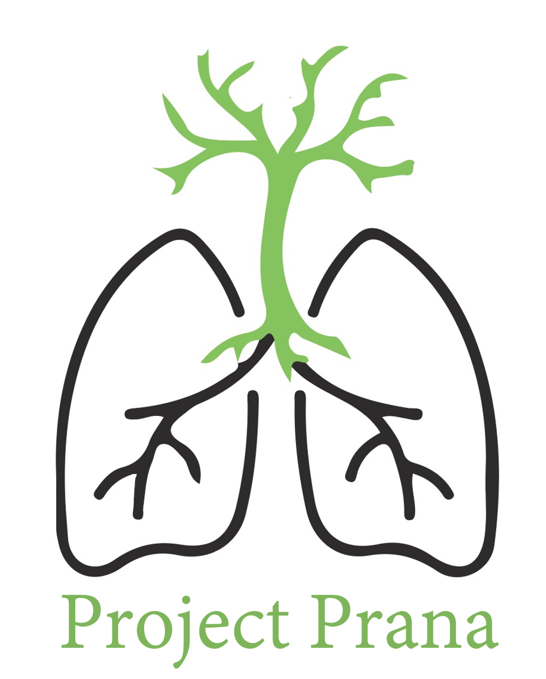
The Project Prana Foundation is a US-based not-for-profit foundation which grew out of biomedical engineering efforts at MIT and the Brigham and Women’s Hospital. The foundation is focused on open-source dissemination of medical technologies to alleviate healthcare burden during the COVID-19 pandemic. They are operationalizing the individualized System for Augmenting Ventilator Capacity (iSAVE), a rigorously tested platform to multiplex ventilation while enabling patient-specific therapy, in several nations worldwide. The leadership team is comprised of Shriya Srinivasan, PhD, a postdoctoral researcher at the Harvard Society of Fellows; Giovanni Traverso, MB, BChir, PhD, an assistant professor of mechanical engineering at MIT & associate physician of gastroenterology at Brigham and Women’s Hospital, Khalil Ramadi, PhD, an MIT postdoctoral researcher and Ruth L. Kirschtein Fellow, Robert Langer, ScD, institute professor of chemical engineering at MIT, and Srin Sridharan, BMath, BBA, the managing partner at Thought. The team has deep expertise in science, engineering, business, and public health, and is poised to proactively affect change and bolster emergency preparedness around the globe. More information can be found at projectprana.org. Donations and partnerships are welcome!

