The Intersection of United States Climate Change with Arthropod Disease Vectors

Audrey B. Blondin

B.S., Southern Connecticut State University, 1975
J.D., Temple University School of Law, 1979

A Public Health Capstone Project

Submitted in Partial Fulfillment of the
Requirements for the Degree of

Master of Public Health
at the
University of Connecticut

2020

i

APPROVAL PAGE

Master of Public Health

Capstone Project

Presented
By
Audrey B. Blondin, B.S., J.D.

Major Advisor ______________________________________________________
Dr. Bonnie McRee

Associate Advisor ___________________________________________________
Dr. Audrey Chapman

Associate Advisor

University of Connecticut

2020

ii
Acknowledgments
I would first like to thank my major advisor, Dr. Bonnie McRee, Ph.D., M.P.H., Assistant Professor in Residence, Department of Public Health Sciences, for all of her guidance and help, not only in writing this paper, but for her time and efforts in supporting my long quest for this degree over many years. She was always there to lend a steady and thoughtful hand to help guide me through the necessities and challenges of completing this advanced degree outside of the usual student parameters.

I must also acknowledge my associate advisor, Dr. Audrey Chapman, Ph.D., Healey Professor of Medical Ethics and Humanities in the Department of Public health Sciences at the University of Connecticut School of Medicine, who is one of the most intelligent and gifted people I have ever known, not only for the four wonderful courses, where I learned so much from her, but for her friendship and support and willingness to always be there not only for myself but for my fellow classmates as well.

Next, I would like to thank my external reader, Dr. Myrna Watanabe, Ph.D.,without whose friendship, support, encouragement and guidance I never would have been able to complete this paper, especially given my personal and the world COVID-19 challenges that came to be just as time was going short to complete this paper.

I must also express my profound love, gratitude and respect for my husband of 45 years and my fellow classmate, Dr. Matthew Blondin, for always being there for me in every possible way and without whom the possibility of researching and completing, not only this paper, but my degree, never would have been possible. I would also like to acknowledge the passing of my Mother on March 25, 2020 at age 90, who always showed us all the importance of living life to its fullest, while working hard to achieve bigger and better goals.

Lastly, I would like to thank all of those involved in the University of Connecticut Graduate Program in Public Health, including my first program professor, Dr. Jan Tate, the many other wonderful professors I’ve had over the years, Morgan Spencer, MPH, MPA, CPH and Barbara Case for their help and administrative guidance over many years, along with all of my fellow classmates for the patience and respect they showed, not only to me, but to my husband, year in and year out despite our generational differences and the challenges we all faced together as one.

iii
Abstract

Background: Climate change has become the most important issue facing our nation and its future. One of the consequences of climate change is the increase and spread of vector-borne diseases (VBDs). The number of vector-borne illnesses has more than tripled in the U. S. and our country is woefully unprepared to handle this increased disease burden. Methods: Through a critical literature review, this topic examined the timely issue of climate change and its effect on VBD outbreaks here in the U.S. along with the associated issues of poverty and ethics. Proposals to combat climate change and projections for the future were explored. Results: Only with increased surveillance systems and a health system that is adequately prepared to respond as needed will we be able to face the challenges existing before us. Discussion: Cooperation and improvements among local, state and Federal officials is essential in reducing vector-borne illnesses.

iv
Table of Contents

I. Foundational and Concentration Competencies Addressed……………………...……1
II. Outline and Summary2 of Systems Thinking Framework………………………..….2
III. Background of Pertinent Theory and Findings on the Subject…………………….….4
IV. Materials and Methods Used………………………………………………………….7
V. Project Results…………………………………………………………………………8
- Climate Change…………………………………………………………………...8
- VBDs……………………………………………………………………………...9
VI. Discussion: Project Relevance to Interprofessional Public Health Practices………..17
- Populations of Concern………………………………………………………….17
- Ethics Issues……………………………………………………………………..20
VII. Conclusions and Next Steps………………………………………………………...23
VIII. Bibliography………………………………………………………………………28

v
- Foundational and Concentration Competencies Addressed
This paper will focus on the current and future biological and social means of addressing and mitigating the effects of climate change (global warming) on arthropod vectors of human disease in the United States. It addresses the following foundational and concentration competencies:
- Design a population-based policy, program, project or intervention;
- Interpret results of data analysis relating to climate change related to public health research, policy and practice;
- Propose strategies to identify stakeholders and build coalitions and partnerships for influencing public health outcomes;
- Apply systems thinking tools to a public health issue; and
- Employ legal-ethical reasoning to advance interprofessional public health policy and practices.
These competencies will be discussed throughout this paper with regard to ways in which public health professionals, political leaders and scientists prepare the public for understanding and mitigating the problem of increase in both vector arthropod numbers and species and the changing groups of pathogens they carry and transmit to the human population. It also will discuss the formation of public health, political, corporate and community coalitions to mitigate or eradicate these health menaces.

1
II. Outline and Summary of Systems Thinking Framework Guiding This Project
The interactions of the atmosphere, oceans, terrestrial and marine biospheres, cryosphere, and land surface determine the Earth’s surface climate. Climate change may be the most complex systems problem our planet has ever faced. Atmospheric concentrations of greenhouse gasses, including carbon dioxide, methane, and nitrous oxide, are increasing, mainly from human activities, such as fossil fuel use, land use change and agriculture, causing the Earth’s temperature to increase. In the 21st century, almost every human activity requires fossil fuels or other sources of climate-altering greenhouse gases.¹ Almost everything that sustains and enriches our lives is affected, directly or indirectly, by climate change. Access to clean water, food prices, national security, health and well-being, and economic opportunities can be jeopardized by a changing climate.¹
We need to address and resolve systems rather than symptoms, if we want to stop the planet’s ever-increasing temperature. A solution will not be effective or enduring if it creates new problems, particularly when facing new and increasing exposures to vector-borne diseases. (VBDs).We need new business models, new technologies, new policy frameworks and, most importantly, new ways of engaging with each other to address these issues.¹
Using systems thinking, identifying and activating leverage points will significantly positively impact climate change mitigation and energy transition for communities worldwide. When governments and communities build data systems to better inform decision makers and policymakers on land and natural resources management by developing waste, water and energy strategies that enhance local economies, as well as introducing innovative financing mechanisms by partnering with employers for energy efficiency, we can succeed in creating measurable, meaningful and lasting contributions to address climate change one system at a time.¹
2

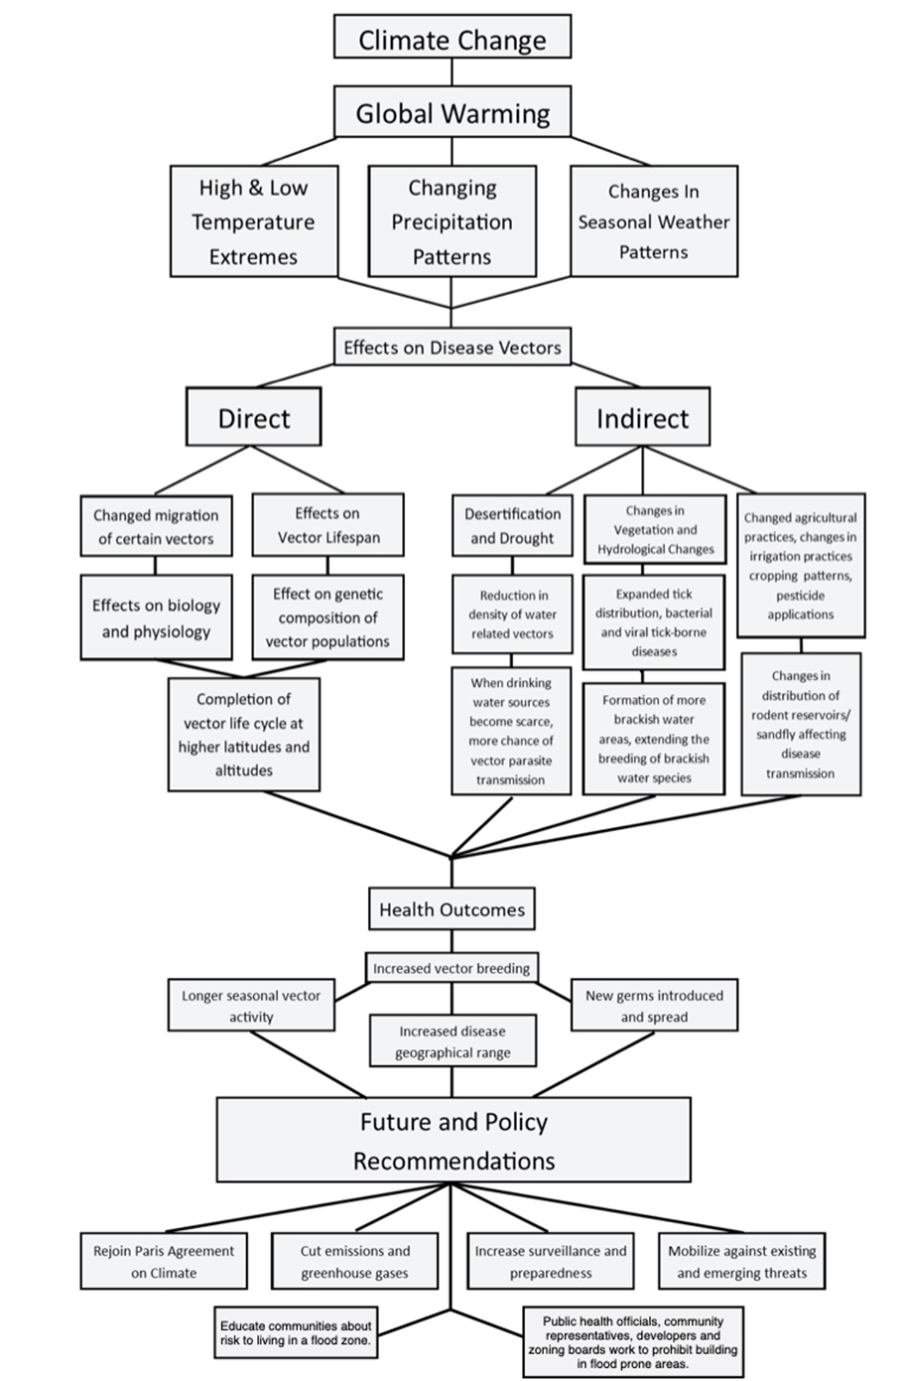

3
III. Background of Pertinent Theory and Findings on the Subject

Climate change, particularly in the U. S., creates new risks for human exposure to VBDs, which are transmitted to humans through the bites of arthropods, including mosquitoes, ticks, flies and fleas. These arthropod vectors can carry disease-causing pathogens. Climate change creates new uncertainties about the spread of VBDs, such as the Zika and dengue fever viruses, the malaria parasite and the Lyme bacterium, by altering conditions that affect the development and dynamics of the disease vectors and the pathogens they carry.²
Rising global temperatures can lengthen the season and increase the geographic range of disease-carrying insects. As temperatures warm, mosquitoes and other warm-weather vectors can move into higher altitudes and new latitudes farther from the Equator. For instance, in some regions in the U.S., warming is lengthening the season for Zika-carrying mosquitoes.
Increased rainfall, flooding and humidity create more viable areas for vector breeding and allow breeding to occur more quickly, as eggs hatch faster in hotter climates. For example, an increase in risk for Zika and West Nile virus infections was anticipated after the massive flooding in Louisiana in August 2016, which increased the breeding habitats for Aedes mosquitoes.²
In addition, human migration exposes people to viruses to which they are not immune, as we now see happening worldwide with the novel coronavirus disease, COVID-19. As populations migrate in response to climate change, they bring disease to new regions and urban areas. Infectious diseases also spread more quickly in overcrowded urban areas and areas of poverty and need.²
Climate can have a direct effect on physical conditions, including temperature and rainfall amounts, and an indirect effect on biologic entities, including plants and animals. These physical and biologic conditions can, in turn, influence vector-borne disease (VBD) risk by impacting the abundance and distribution of animal reservoirs, the presence of suitable habitat for these vectors, and people’s behaviors that bring them into contact with infected vectors. Climate directly impacts short-term and long-term weather conditions at the local and regional levels.³ Most arthropod vectors of disease are sensitive to physical conditions, including humidity levels, daily high and low temperatures, rainfall patterns and the severity, presence or absence of the winter snowpack.³
4
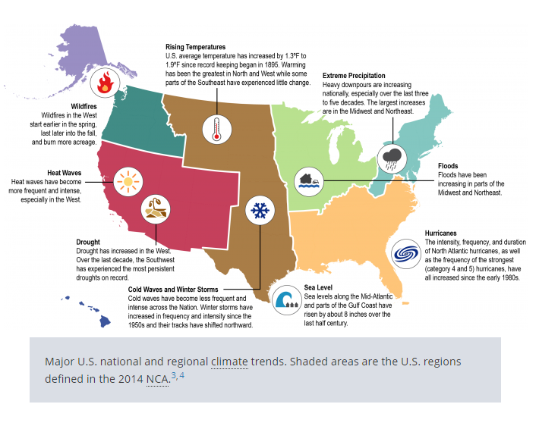

Figure 1. Observed changes in climate and weather differ at local and regional scales.⁴

Figure 1. illustrates climatic changes seen in different regions of the U.S. The extreme precipitation in the northeastern U.S. and the flooding in the former industrial regions of the northern central states, create perfect conditions for mosquitos to breed. Along with the increasing temperature, these wet areas, even areas such as the insides of rubber tires, are perfect breeding grounds for mosquitos that can serve as disease vectors.⁴
5
The impacts of climate change are projected to increase over the next century, while VBD health threats will intensify, and new health threats may emerge. It is important to examine how climate is changing, along with an understanding of how those changes may affect VBDs and associated issues of ethics and poverty fueled by denials of the US government. For example, using both historical data and climate modelling, a dramatic increase in the number of extreme climate events over the last century can be seen below in Figure 2.⁴
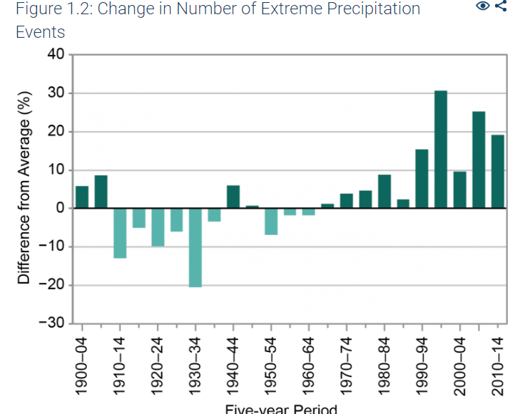
Figure 2. Change in number of extreme precipitation events in the U.S. from 1900-2014 ⁴
In many parts of the world, impoverished people may live in lowland areas subject to flooding. Flooded areas are more prone to harbor breeding mosquitoes, thus threatening the inhabitants with mosquito-borne diseases. This problem is not just a function of climate or climate change, but also a function of socioeconomic issues, such as the lack of employment and/or failure of crops, resulting in poverty. By looking at a broader picture, suggestions may then be provided to assist in making informed decisions about mitigating and reducing the amount of future climate change and its effects on populations, suggesting priorities for protecting public health, and help in identifying future research needs.⁴
6
IV. Materials and Methods Used

A literature search of Google Scholar was begun in 2019 using the following search terms: climate change, global warming, VBDs, NOAA, weather, disease resilience, CDC, human vulnerability, infectious diseases, ethics, policy recommendations, malaria, and WHO. Some of these terms were much too broad, such as NOAA, weather, CDC, human vulnerability, ethics, policy recommendations and WHO. An in-depth, balanced preliminary review of the research literature relevant to this topic was conducted to investigate issues pertaining to this topic.
This review examined and analyzed what is known about climate change and VBDs. It also assisted in the development of topical points to be made as a part of this research project, while examining the potential for future research and development in this field of study. Issues relating to populations of concern as well as the ethics and related concerns of equity and social justice relating to climate change and vector-bornse diseases were also analyzed and explored. Relevant research was also focused on an examination of future trends and suggestions for possible help in addressing the challenges faced herein.
The search identified 50 publications and websites that were appropriate to my focus area. Emphasis was given to the most current information available to provide accuracy and timeliness to the research pertinent to this topic. I organized and reviewed the information received from the publications and websites as to their appropriateness to this study. Of these, I selected 31 which were used as cited references for this paper.

7
V. Project Results
- Climate Change
Earth has warmed over the last century. U.S. average temperatures have increased by 1.3 °F to 1.9 °F since recordkeeping began in 1895, with most of this increase occurring since 1970. ⁵ The first decade of the 2000’s was the warmest on record throughout the U.S. ⁶ Global warming is one aspect of climate change, and the current increase in global average temperature appears to be occurring much faster than at any point in the last 11,000 years,⁷ and the rate of global warming occurring during recent decades has been unprecedented over the past millennium.⁸
According to the National Oceanic and Atmospheric Administration (NOAA), 2019 was the second hottest year on record for Earth, just behind 2016. The world’s five warmest years have all occurred since 2015, with nine of the ten warmest years occurring since 2005. 2019 was also the 43rd consecutive year with global land and ocean temperatures at least nominally above average. The average temperature across the globe in 2019 was 1.71 °F above the 20th century average and just 0.07 of a degree cooler than the 2016 record.⁷
Climate differs from weather. Weather is the state of the atmosphere at a particular location over the short-term. Climate is the average of the weather patterns in a location over a longer period of time, usually 30 years or more.⁸ Weather can change quickly, from one moment to the next and over short distances. Climate changes occur more slowly and do not vary much over short distances, except in the mountains.⁸ Climate change refers to any significant change in the measurement of climate for extended periods of time, usually over decades or longer. This includes major, long-term changes in temperature, precipitation, humidity, ocean heat, wind patterns, sea level and sea ice, and how these changes affect life on Earth.⁸
8
Climate change results from both human activities and natural causes. Human activities include the emission of heat-trapping greenhouse gasses, such as carbon dioxide and methane, into the atmosphere and changes in land-use patterns, such as agriculture and urbanization. Natural causes range from regular pattern shifts in the dynamics of our oceans and atmosphere, such as El Nino/La Nina, to volcanic eruptions that emit large amounts of carbon dioxide and aerosols into the atmosphere, to long-term changes in the Earth’s orbit around the sun, to variations in the amount of energy from the Sun that reaches the Earth.⁹ Climate change encompasses both increases and decreases in temperature as well as shifts in precipitation, changing risks of certain types of severe weather events, and changes to other features of the climate system.⁸
Climate change is expected to cause mass migration and conflict as people flee flooded homes or arid farmland and fight over scarce resources. It may also mean economic slowdown as industries are affected and societies spend money to adapt to a changing world.¹⁰

- Vector-Borne Diseases
Climate change greatly impacts the spread of VBDs, such as the Zika virus, dengue fever, malaria and Lyme disease by altering conditions that can affect the development and dynamics of disease vectors and the pathogens that they carry.¹¹ Some of the effects of climate change on human health are summarized in Figure 3.²
9
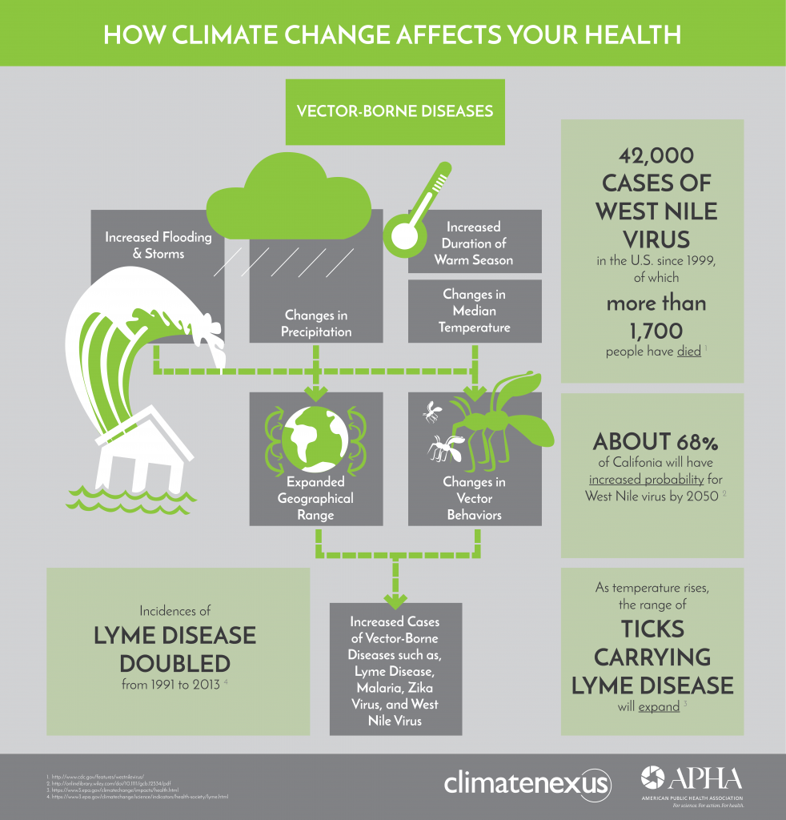
Figure 3. Effect of climate change on health.²

VBDs are illnesses that are transmitted by vectors, which include mosquitoes, ticks, flies and fleas. These vectors can carry infectious pathogens, such as viruses, bacteria and protozoa, which can be transferred from one host carrier to another.¹¹ In the U.S., there are currently 14 VBDs that are national public health concerns. These diseases account for a significant number of human illnesses and deaths each year and are required to be reported to the National Notifiable Diseases Surveillance System at the Centers for Disease Control and Prevention (CDC).¹¹ Rising global temperatures can lengthen seasons and increase the geographic range of disease-carrying arthropods Increased rainfall, flooding and humidity create more viable areas for vector breeding and allow breeding to occur more rapidly, as eggs hatch faster in hotter climates.¹² Human migration also exposes people to viruses to which they are not immune. As populations migrate in response to climate change, they bring disease to new regions and urban areas. Infectious diseases spread more quickly in overcrowded urban areas.²
10
In the U. S., mosquito season has expanded in 76% of our major cities since the 1980’s because of increases in hot and humid weather conditions.⁹ VBDs overwhelmingly and disproportionately impact people living in tropical and subtropical parts of the world, though warmer temperatures, migration, travel, and trade increase the risk of these diseases spreading to areas that formerly were more-temperate climates.²
The three key components that determine the occurrence of VBDs are:
- Vector and host abundance
- Local prevalence of disease-causing parasites and pathogens
- Human population behavior and resilience of the diseases²
Insect vectors have several physical traits that help them take advantage of climate impacts, such as flooding, increased precipitation, and warmer weather. Insects cannot regulate their body temperature and are dependent on external warmth to survive.² Rising temperatures may cause vector range patterns to shift, increasing risk to new human populations. Humidity and water are crucial for vector breeding, so more insects can hatch in areas with standing water and high precipitation. The incubation period of pathogens within vectors is also temperature dependent and becomes shorter in warmer conditions.² VBD cycles are complex because of constantly changing interactions between pathogens, insects, and people. Changes in climate here in the U.S. make these interactions less predictable, multiplying the risks of disease.²
11
Increasing temperatures will result in more heavy downpours, as well as the melting of ice at the poles. This will lead to an increase in oceanic waters and water temperatures, leading to flooding and to increased atmospheric water, resulting in more frequent and more violent storms. Changes in VBDs would likely occur as both short-term epidemics and long-term gradual changes in disease trends.²
VBDs have become significantly more common and more widespread in the U.S. in the 13 years from 2004 to 2016. Reported cases of diseases caused by infected ticks, mosquitoes, and fleas increased more than 23 times from 2004 to 2016, with 27,388 cases reported in 2004 and 642,602 in 2016. Figure 4. ¹³
Disease | Year
 | 2004 | 2005 | 2006 | 2007 | 2008 | 2009 | 2010 | 2011 | 2012 | 2013 | 2014 | 2015 | 2016 | Total
Tickborne diseases
Lyme disease† | 19,804 | 23,305 | 19,931 | 27,444 | 35,198 | 38,468 | 30,158 | 33,097 | 30,831 | 36,307 | 33,461 | 38,069 | 36,429 | 402,502
Anaplasmosis/Ehrlichiosis§ | 875 | 1,404 | 1,455 | 1,999 | 2,107 | 2,267 | 2,615 | 3,586 | 3,725 | 4,551 | 4,488 | 5,137 | 5,750 | 39,959
Spotted fever rickettsiosis¶ | 1,713 | 1,936 | 2,288 | 2,221 | 2,563 | 1,815 | 1,985 | 2,802 | 4,470 | 3,359 | 3,757 | 4,198 | 4,269 | 37,376
Babesiosis** | N | N | N | N | N | N | N | 1,128 | 937 | 1,796 | 1,760 | 2,100 | 1,910 | 9,631
Tularemia | 134 | 154 | 95 | 137 | 123 | 93 | 124 | 166 | 149 | 203 | 180 | 314 | 230 | 2,102
Powassan virus | 1 | 1 | 1 | 7 | 2 | 6 | 8 | 16 | 7 | 15 | 8 | 7 | 22 | 101
Subtotal tickborne diseases | 22,527 | 26,800 | 23,770 | 31,808 | 39,993 | 42,649 | 34,890 | 40,795 | 40,119 | 46,231 | 43,654 | 49,825 | 48,610 | 491,671
Mosquitoborne diseases
Dengue viruses†† | 721 | 2,462 | 882 | 4,484 | 1,118 | 2,759 | 11,611 | 1,795 | 6,714 | 10,727 | 1,226 | 1,015 | 1,178 | 46,692
Zika virus | N | N | N | N | N | N | N | N | N | N | N | N | 41,680 | 41,680
West Nile virus | 2,539 | 3,000 | 4,269 | 3,630 | 1,356 | 720 | 1,021 | 712 | 5,674 | 2,469 | 2,205 | 2,175 | 2,149 | 31,919
Malaria** | 1,458 | 1,498 | 1,476 | 1,411 | 1,257 | 1,456 | 1,778 | 1,726 | 1,504 | 1,594 | 1,654 | 1,397 | 1,958 | 20,167
Chikungunya virus | N | N | N | N | N | N | N | N | N | N | 7,521 | 1,133 | 427 | 9,081
California serogroup viruses§§ | 118 | 80 | 69 | 55 | 62 | 55 | 75 | 137 | 81 | 112 | 96 | 70 | 53 | 1,063
St. Louis encephalitis virus | 15 | 13 | 10 | 9 | 13 | 12 | 10 | 6 | 3 | 1 | 10 | 23 | 8 | 133
Eastern equine encephalitis virus | 7 | 21 | 8 | 4 | 4 | 4 | 10 | 4 | 15 | 8 | 8 | 6 | 7 | 106
Yellow fever virus | 0 | 0 | 0 | 0 | 0 | 0 | 0 | 0 | 0 | 0 | 0 | 0 | 1 | 1
Subtotal mosquitoborne diseases | 4,858 | 7,074 | 6,714 | 9,593 | 3,810 | 5,006 | 14,505 | 4,380 | 13,991 | 14,911 | 12,720 | 5,819 | 47,461 | 150,842
Fleaborne disease
Plague | 3 | 8 | 17 | 7 | 3 | 8 | 2 | 3 | 4 | 4 | 10 | 16 | 4 | 89
Total vectorborne diseases | 27,388 | 33,882 | 30,501 | 41,408 | 43,806 | 47,663 | 49,397 | 45,178 | 54,114 | 61,146 | 56,384 | 55,660 | 96,075 | 642,602
Abbreviation: N = not notifiable.
* U.S. territories included are Puerto Rico, U.S. Virgin Islands, and American Samoa.
† Lyme disease reporting changed in 2008 to include probable cases in addition to confirmed cases.
§ Anaplasmosis and ehrlichiosis were reported separately after 2008 but are combined here for the entire period.
¶ Includes R. rickettsii, R. parkeri, R. species 364D.
** Surveillance data for babesiosis and malaria may be reported independently to different CDC programs; these data might vary slightly from those presented elsewhere.
†† Dengue became reportable to the National Notifiable Diseases Surveillance System in 2010. 2004–2009 data from Dengue Branch, Division of VBDs, CDC.
§§ Includes Jamestown Canyon, La Crosse, and unspecified California serogroup viruses.
12
Figure 4. Table 1. VBD cases reported to the National Notifiable Disease Surveillance System—U.S. State and Territories*, 2004-2016.¹³
Lyme disease, caused by the bacterium Borrelia burgdorferi, accounts for more than two-thirds of all U.S. VBD cases and, despite the reported national statistics, probably causes more than 300,000 human illnesses each year.¹⁴ The bacterium is transmitted to people through the bite of an infected blacklegged tick (Ixodes scapularis) (commonly referred to as “deer ticks” in the Eastern and upper Midwestern United States).¹⁴ Of the many cases that are diagnosed and reported every year, health surveys and blood tests suggest that this represents only 10 percent of the actual annual infections, the number seen in Table 1. Symptoms include fever, chills, fatigue, and joint and muscle pain. Early stages can be treated with antibiotics, but in some patients, especially those not treated early, symptoms can be life-threatening and can persist for years.¹⁴
Climate variables have been shown to be strong predictors of geographic locations in which ticks will reside.² Today, these ticks live in 44 percent more counties than they did in 1996, spread over 43 states. The most dramatic changes were visible in the northern U.S., where climate change is predicted to increase their habitats. Warmer winter and spring temperatures are projected to lead to an earlier annual onset of Lyme disease cases in the eastern U. S. and an expansion to higher latitudes and elevations in the future.²
The life cycle of the deer tick comprises three growth stages: larva, nymph and adult. It takes about two years for the tick to hatch from the egg, go through all three stages, reproduce, and then die. A blood meal is required to progress to each successive statge in their life cycles.
13
Nymphs are most active during the summer months, and most people acquire the disease from infected nymphs because of their small size.¹⁵
Other diseases carried by I. scapularis continue to emerge, including ehrlichiosis, anaplasmosis, babesiosis, and Powassan virus disease. Rocky Mountain spotted fever is a disease carried by the lone star tick, causing more than 3,000 infections a year, some fatal. The lone star tick, which has recently moved northward, also carries the Heartland virus or banyangvirus, a novel infection that can cause severe illness or death.¹⁴
Mosquitoes transmit the viruses that cause West Nile, Zika, dengue fever, and chikungunya diseases. West Nile disease is the most prevalent U.S. mosquito-borne illness.¹⁶ People become infected when bitten by mosquitoes that have bitten birds that carry the virus. Since the first U.S. case was identified in New York in 1999, West Nile virus has spread to every state in the contiguous U. S. and some U.S. territories, largely by migratory birds.¹⁶ Thousands of human cases occur every year, but most infected individuals do not exhibit serious symptoms, so are never diagnosed. In a small fraction of individuals, especially in people over 60-years old, the virus causes life-threatening neuroinvasive disease. No vaccine has been approved for use in individuals to combat West Nile virus.¹⁶
Zika virus disease is spread from person to person by infected mosquitoes and can also be transmitted by humans during sexual intercourse. A major health risk associated with Zika virus is transmission of the virus from pregnant women to their fetuses, which can cause birth defects including microcephaly.¹⁶ Even in babies that appear normal at birth, although their mothers were infected with Zika virus during pregnancy, abnormalities may be found as the child grows. Zika virus can also cause Guillain-Barré syndrome, where the immune system attacks nerve cells, progressively weakening muscles and potentially leading to temporary paralysis.¹⁶
14
Since 2015, international organizations and national governments have become increasingly concerned with the spread of Zika virus, and WHO declared the disease a Public Health Emergency of International Concern (PHEIC, pronounced “fake”) in February, 2016.² In the U.S., the CDC issued warnings to pregnant women traveling to countries where Zika virus transmission was occurring. A March 2016 study showed meteorological conditions are suitable for Aedes mosquitoes in the southern half of the U.S. during peak summer months, and in Southern Florida and Texas during winter months, resulting in an expected increase in Zika transmission in more parts of the U.S.² It is hypothesized that severe storms can carry the mosquitoes long distances, even across water, to new environments.²
Dengue fever is caused by any of four related dengue viruses, all carried by mosquitoes. Disease symptoms include high fever, headache, and muscle, bone, or joint pain. Repeat infections can be life-threatening.¹⁶ Though prevalent in the southern U.S. in the 19th and first half of the 20th centuries, mosquito-control efforts have largely relegated the disease’s Western Hemisphere presence to South and Central America and the Caribbean. In recent years, however, dengue fever has re-emerged to cause sporadic outbreaks in the southern continental U.S., most recently in March 2020 in the Florida Keys.¹⁶
Chikungunya was first recognized in Africa in the 1950s, but in recent decades has appeared in the Americas. The infection causes fever and pain. Although transmission rates remain low in the U.S., this potentially debilitating disease has in recent years been creeping northward from the Caribbean.¹⁶ In addition, less prevalent mosquito-borne diseases found in the U.S. include Saint Louis encephalitis, LaCross encephalitis, and eastern equine encephalitis, the latter creating a major threat in southern New England in the summer of 2019.¹⁶
15
Fleas are blood-feeding insects that can transmit pathogens from person to person or from other infected mammals, such as rodents, to humans. Plague, caused by the bacterium Yersinia pestis, can cause serious illness, but is treatable with antibiotics and is exceedingly rare in the U.S.¹⁶ Typhus, a bacterial infection caused by several members of the genus Rickettsia that, in some forms, can be transmitted to people from mice via fleas, is a scourge associated with poverty and unsanitary conditions that has recently reemerged in some U.S. suburban areas, including locations in Texas and Hawaii, and among communities of homeless people in Southern California.¹⁶
A report in the journal Environmental Health Perspectives noted that the U.S. has become more vulnerable to tropical diseases as climate change expands vector ranges.² Climate change will continue to enhance human vulnerability to VBD by influencing the seasonality and the location of exposures to pathogens and vectors. These impacts may influence future disease patterns as certain VBDs begin to emerge in areas where they had previously not been observed.¹¹
In November 2018, Volume 11 of the Fourth National Climate Assessment was released by the U.S. Global Change Research Program (USGCRP). This report is a product of 13 Federal agencies and contains supporting evidence on climate change impacts, risks, and adaptations occurring in the U.S.¹⁷ The report states that human health and safety, our quality of life, and the rate of economic growth in communities across the U.S. are increasingly vulnerable to the impacts of climate change. The report also notes that climate change threatens the health and well-being of the American people by causing increasing extreme weather along with the spread of new diseases by insects and pests.¹⁷
16
Currently, the risk of human infection in the U.S. for diseases like Lyme disease and West Nile virus occur during a specific season each year. The 2016 USGCRP report suggested that increasing temperatures could expand the length of the seasonal activity and geographic range of ticks that carry the bacteria that cause Lyme disease.¹⁸ With these changes in climate that increase risk of tick activity and the expansion and prevalence of mosquito-borne diseases, there is also an expectation among experts that new vector-borne pathogens could emerge.¹⁸

VI. Discussion of Project Relevance to Interprofessional Public Health Practice
- Populations of Concern
Climate change is already causing and is expected to continue to cause a range of health impacts that vary across different population groups in the U. S. The vulnerability of any given group is a function of its sensitivity to climate change-related health risks, its exposure to those risks, and its capacity for responding to or coping with climate change variability and change.¹⁹ Vulnerable groups of people, described here as populations of concern, include those with low incomes, communities of color, immigrant groups, including those with limited English proficiency, Indigenous peoples, children and pregnant women, older adults, vulnerable-occupations groups, persons with disabilities and persons with preexisting or chronic medical conditions.¹⁹
Some groups are also disproportionately disadvantaged by social determinants of health that limit resources and opportunities for health-promoting behaviors and conditions of daily life, such as living or working circumstances and access to healthcare services. In disadvantaged groups, people with limited economic resources living in areas with deteriorating or non-existent infrastructure are more likely to experience disproportionate health-related impacts and are less able to recover following extreme weather events, increasing their vulnerability to climate-related health effects.¹⁹
17
In the U. S., there is a largely hidden burden of diseases caused by a group of chronic and debilitating parasitic, bacterial and congenital infections known as the neglected infections of poverty. Like their neglected tropical disease counterparts in developing countries, the neglected infections of poverty in the U.S. disproportionately affect impoverished and under-represented minority populations.²⁰ The major neglected infections include the vector-borne infections Chagas disease, leishmaniasis, trench fever, and dengue fever. These diseases occur predominantly in people of color living in disadvantaged urban areas primarily in the South and in the U.S.–Mexico borderlands, as well as in certain immigrant populations and disadvantaged white populations living in Appalachia.²⁰ Preliminary disease burden estimates of the neglected infections of poverty indicate that tens of thousands, or in some cases, hundreds of thousands of poor Americans harbor these chronic infections, which represent some of the greatest health disparities in the U. S.^{.20}
These groups of people also experience relatively greater incidence of chronic medical conditions, such as cardiovascular and kidney disease, diabetes, asthma and COPD, which can be exacerbated by climate-related health impacts.¹⁹ Socioeconomic and educational factors, limited transportation, limited access to health education, and social isolation related to language deficiencies collectively impede their ability to prepare for, respond to and cope with climate-related health risks.¹⁹ These populations also may have limited access to medical care and health insurance, and may not be able to afford medications or other treatments. For undocumented persons, high poverty rates, language and cultural barriers, and citizenship status often limit access to and use of health care and other social services, and make these groups more hesitant to seek out help that might compromise their immigration status in the U. S.¹⁹
18
The changes in the distribution of infectious diseases that are expected to result from climate change may introduce new exposures to children. Due to physiological vulnerability or changes in their body’s immune system, fetuses, pregnant women and children are at increased risk of acquiring or having complications from certain infectious diseases, such as listeriosis or dengue fever. ¹⁹ Children spend more time outdoors than adults, increasing their exposure to mosquito and tick bites that can cause VBDs that disproportionately affect children, such as La Crosse encephalitis or Lyme disease. Lyme disease is most frequently reported among male children ages 5 to 9 years, and a disproportionate increasing trend was observed in all children from 1992 to 2006.¹⁹
The changes in the distribution of disease vectors, such as ticks and mosquitoes, that are expected to result from climate change may increase exposures to pathogens in older adult populations as well. Some VBDs, including West Nile and St. Louis encephalitis viruses, pose a greater health risk among sensitive older adults with already compromised immune systems.¹⁹ Climate change is also expected to increase exposure risk to waterborne pathogens in sources of drinking and recreational waters. Older adults also have a higher risk of contracting gastrointestinal illnesses from contaminated drinking and recreational water exposure, that may result in severe health outcomes and death.¹⁹
In addition, poor housing without plumbing, air conditioning or window screens is a key factor in encouraging VBDs in the U. S. It is estimated that this situation describes more than 30,000 households around the U.S.-Mexican border, in addition to large numbers of mobile homes in the same region.²⁰ Over the 20-year period between 1980 and 1999, there were 65,514 cases of dengue fever reported from the Mexican side of the border, compared to only 64 cases in the U.S.²⁰ An earlier assessment suggested that the higher-quality dwellings on the U.S. side accounted for this disparity; however, more recent studies indicate that dengue is under-reported in the U.S. within the region of the Mexican border.²⁰
19
- Ethical Issues
VBDs raise a number unique ethical issues because pathogens are transmitted between humans by a third party, the vector, and because of the unique aspects of vector control. They are also an especially important topic for ethical analysis because they have severe consequences, including large disease burden, international spread and public heath emergencies, high economic costs with major effects on economic development, and large pools of asymptomatic carriers.²¹ In addition, although often not the sole cause of increases in the burden of climate-sensitive health outcomes, climate change inevitably interacts with other public health challenges. This often contributes to the potential for severe and long-lasting economic consequences, much like we are now seeing here in the U.S. as a result of the current COVID-19 pandemic.²²
As noted above, VBDs are closely linked to poverty and the environmental and social determinants of health, raising issues of global health justice. Issues of global health justice include inequitable burdens disproportionately affecting vulnerable populations, ethical implications of social determinants of health, inequitable access to treatment and control, unequal distribution of benefits and burdens in community interventions, and disproportionately low research resources relative to disease burden.²¹ In addition, there are issues unique to VBDs, including the ethics challenges surrounding the issues of vector surveillance, control, and research, and new technologies for vector control.²¹
20
Many interventions for VBDs, from long-lasting insecticidal nets and eliminating domestic vector breeding sites, to mass drug administration, have benefits that extend to vulnerable populations by a reduction in disease transmission, which often requires collective action by many community members in addition to centralized public health interventions.²¹ Prevention and vector control initiatives should be ethically motivated by a collective moral responsibility to prevent harm and achieve public health benefits. The distribution of eventual benefits from collective action to prevent and control VBDs is likely to be concentrated first and foremost among the most vulnerable groups and provides additional moral reasons for intervening at the community level to decrease the harm of these diseases.²¹ New techniques for VBD control, including release of genetically modified mosquitoes, raise new ethical issues. While potentially significant, the geographically widespread effects of genetic modification of vectors warrant careful attention.²¹ The main ethical concerns include potential ecological risks, unforeseen harm to humans and other species, and the likelihood that the effects of an intervention could spread rapidly across national borders.²¹ These concerns are perhaps greatest for gene drives, in which an altered gene is inserted into a germ cell along with a copy of the CRISPR-Cas9 gene editing machinery, which could insert the same gene into all the organism’s offspring and descendants. If successful, this genetic manipulation would have long-term, potentially irreversible and potentially widespread effects on vector populations. A recent report by the U.S. National Academy of Sciences highlighted concerns that current governance mechanisms may not address all aspects of gene drive research, particularly because of rapid scientific development and the uncertain, potentially international effects of field trials in wild vector populations.²¹
21
In addition, because VBDs are often associated with poor and vulnerable communities, their transmission by vectors provides opportunities for specific public health interventions, which, in turn, give rise to unique ethical issues. VBDs are ethically problematic because, as neglected diseases, when research and control activities are not proportional to disease burden, the consequences include avoidable harm, particularly for the poor, and failure to predict and prepare for epidemics, as recently occurred during outbreaks of Zika virus infection and yellow fever.²¹ In addition, because the burden of VBDs is inequitably distributed among the poor, pregnant women and children are often at highest risk. This vulnerability in terms of the social determinants of VBDs is compounded by existing negative environmental factors. When the influence of climate change increases VBD burden among the worst-off groups, existing global injustice is exacerbated.²¹
A basic understanding of climate change and its potential for long term health impacts should be included in training and professional development courses for health care professionals to reduce current and projected injuries, illnesses and deaths due to climate-sensitive health disparities and outcomes.²² Appropriate policymaking focused on VBDs often requires consideration of both scientific and ethical matters. Yet, the ethical issues that arise in VBD control and research have not previously received the analysis necessary to further improve public health programs, and WHO Member States lack specific guidance in this area.²¹
In February 2017, WHO held a meeting to identify the ethical issues associated withVBDs. There, over 25 international and WHO experts discussed salient ethical issues and the main features of a future guidance document relating to issues surrounding the VBD crisis.²¹ The ethical issues associated with VBDs were mapped, highlighting in particular the environmental and social determinants of health; the ethics of vector control, including new technologies; relevant aspects of ethics in surveillance and research; and the ethics of mass public health interventions.²¹ These main topics will form the basis of an upcoming project to more comprehensively identify and analyze ethical issues associated with VBDs, with the aim of providing relevant WHO guidelines in the near future.^{.21}
22
22
VII. Conclusions and Next Steps
The magnitude of climate change beyond the next few decades will depend primarily on the amount of greenhouse gasses emitted globally. Without significant cuts to emissions, annual average global temperatures will almost certainly rise beyond 2 °Celsius (3.6 °F) by the end of the century.²³ Keeping globally averaged temperature change at or below this level to minimize potential impacts on humans and ecosystems can be met only through substantial reductions in emissions before 2040.²³
VBDs are sensitive to climate through multiple mechanisms, including geographic shifts of vectors and reservoirs, changes in rates of development, survival and reproduction of vectors and pathogens, increased biting by vectors and prevalence of infection in reservoirs or vectors.²⁴ All these effect transmission to humans, and the expectation is that exposure to VBDs, including malaria and dengue, will likely worsen in a warmer world climate.²⁴ Climate plays an important role in setting the background for disease transmission. Milder winters in temperate regions have become more permissive for various pests to establish and thrive, and changes in temperature seasonality favor longer vector activity.²³
The health risks arising from such climatic changes will differ among countries, depending on health infrastructures. In the U. S., good surveillance and vector-control programs are in place to attempt to limit endemic transmission of diseases, such as malaria and dengue fever.²⁵ But concerns about the current administration’s destruction of international disease surveillance, and the nation’s complete lack of preparedness for a non-vectored pandemic, do not bode well for the maintenance of surveillance and vector control. The health infrastructures of Mexico and other less developed nations are less effective, and even in developed countries, increasing international travel and documented underreporting demonstrate a continued risk and need for strong surveillance, as demonstrated in today’s current COVID-19 world-wide pandemic.²⁵
23
23
Diseases from mosquito and tick bites occur in every state and territory. Recent outbreaks of Zika, chikungunya, and West Nile viruses and the steady increase in Lyme disease cases point to the need for state and local agencies to have comprehensive VBD prevention and control programs.²⁶ The U. S., which has historically underfunded local public health needs better tools, increased funding, and more staff with greater expertise at the local, state, and federal levels to reduce the growing threat of these diseases to the general population.²⁶
Controlling diseases from mosquitoes and ticks requires five core competencies. Local health departments and vector control organizations must be able to:
- Monitor and track mosquitoes and ticks locally.
- Use data to drive local decisions about vector control.
- Have an action plan to kill mosquitoes and ticks at every life stage.
- Control vectors using multiple types of methods.
- Conduct pesticide-resistant testing.²⁶
In addition, state and local government and public health agencies can help by:
- Building and sustaining public health programs that test and track human pathogens and the mosquitoes and ticks that spread them.
24
- Training vector control staff on the five core competencies for conducting prevention and control activities.
- Educating the public about how to prevent bites and control pathogens spread by mosquitoes, ticks, and fleas in their communities.²⁶
A number of new biotechnologies are currently under development that could help control VBDs. Testing has occurred in laboratory populations or in limited outdoor tests, but their potential benefits and risks have yet to be fully assessed.¹⁶ Climate and weather-related impacts will not affect every population, state, territory or region in exactly the same way, much as we see the differences today across our nation in the current COVID-19 pandemic. State and territorial health agencies should prepare and plan for climate effects likely to, or already impacting, their unique geography and communities, recognizing the interconnected nature of our local and national community and social systems, along with the necessity for Federal and national guidance and leadership in times of crisis. ²⁷
Climate change is likely to have both short- and long-term effects on VBD transmission and infection patterns, affecting both seasonal risk and broad geographic changes in disease occurrence over decades to come.²⁸ Models for predicting the effects of climate change on VBDs are subject to a high degree of uncertainty, largely because of two important factors. VBDs are maintained in nature in complex transmission cycles that involve vectors, other intermediate zoonotic hosts, and humans. In addition, there are a number of other social and environmental drivers of VBD transmission in addition to climate change.²⁸Although climate variability and climate change both alter the transmission of VBDs, they often interact with many other factors, including how pathogens adapt and change, the availability of hosts, changing ecosystems and land use, demographics, human behavior, and adaptive capacity. These complex interactions make it difficult to predict the ongoing and future effects of climate change on VBDs.²⁸
25
To effectively prevent VBD transmission, an adequate surveillance system must be put in place for reporting and analyzing, not only the cases of diseases and the health or immune status of the human populations, but also a continuing and ongoing investigation into the abundance and distribution of the vectors through regular surveys and standard indicators.²⁹A good surveillance system requires adequately trained personnel to collect, identify and report on the different stages of the vectors of interest.^{.29} Further, since vectors can easily cross borders, surveillance systems need to be developed through cross-border collaborations, with an exchange of information between countries and regular meetings to coordinate interventions.^{.29} One highly controversial but recent method used to trace disease incidence is via collection of cell phone location data, which can track the spread of pathogens and is currently being used as a method to view the performance of social distancing rules with the resultant likelihood of disease transmission among the American population during the current COVID-19 pandemic.
The WHO has put forth the Global Vector Control Response (GVCR) 2017 – 2030, which was approved by the World Health Assembly in 2017. This response provides guidance to countries, including the U. S., for urgent strengthening of vector control as a fundamental approach to preventing disease and responding to outbreaks.³⁰ To achieve these proposals, a realignment of vector control programs is required, supported by increased technical capacity, improved infrastructure, strengthened monitoring and surveillance systems, and greater community mobilization.³⁰ Ultimately, this will support implementation of a comprehensive approach to vector control that will enable the achievement of disease-specific national and global goals and contribute to the achievement of the United Nations Sustainable Development Goals and universal health coverage for all.³⁰
26
With anticipated increases in VBDs, such as malaria, and added pressures on our infrastructure from floods and natural disasters, it is critical to have a health system that is prepared to respond to these impacts.³¹ Health system strengthening measures, such as training medical professionals on emergency response, securing safe, dry storage for vaccines and equipment, and supporting capacity for primary care and preventative medicine, will help to assist in protecting communities from the impacts of climate change and it’s resultant disruption to American lives and the economy.³¹
Health considerations must also be incorporated into national resilience strategies to support public health solutions, and climate scientists need to recognize not just the burden but also the opportunity of public health.³¹ This requires health and climate professionals coordinating, brainstorming and implementing side-by-side strategies to address and combat the devastating current and future effects of climate change, which many now believe is the greatest threat to our future existence both here in the U.S. and throughout the world.³¹

27
VIII. Bibliography
- Clinton Foundation. (2014). How Systems Thinking Can Impact Climate Change. Retrieved from https://stories.clintonfoundation.org/how-systems-thinking-can-impact-climate-change-14ceaaa7c8ca
- Climatenexus. (n.d.). Climate risk and spread of vector-borne diseases. Retrieved from https://climatenexus.org/climate-issues/health/climate-change-and-vector-borne-diseases/#mobile-site-navigation
- Minnesota Department of Health. (2020) Vectorborne Diseases and Climate Change. Retrieved from https://www.health.state.mn.us/diseases/vectorborne/climate.html
- Balbus, J., Crimmins, A., Gamble, J. L., Easterling, D. R., Kunkel, K. E., Saha, S., & Sarofim, M. C. (2016). Ch. 1: Introduction: Climate change and human health. The impacts of climate change on human health in the United States: A scientific assessment (pp. 25–42). Washington, DC: U.S. Global Change Research Program. dx.doi.org/10.7930/J0VX0DFW Retrieved from https://health2016.globalchange.gov/climate-change-and-human-health
- NASA Earth Observatory. Climate Changes in the United States. Retrieved from https://earthobservatory.nasa.gov/images/83624/climate-changes-in-the-united-states
- NBC News. U.S.: 2000s Warmest Decade On Record. Retrieved from http://www.nbcnews.com/id/34944026/ns/us_news-environment/t/us-s-warmest-decade-record/#.XqiLRiPQiUk
- National Oceanic and Atmospheric Administration, U.S. Dept. Commerce. (2020). 2019 was 2nd hottest year on record for Earth say NOAA, NASA: NOAA finds ocean heat content was the highest in recorded history. Retrieved from https://www.noaa.gov/news/2019-was-2nd-hottest-year-on-record-for-earth-say-noaa-nasa
28
- National Oceanic and Atmospheric Administration, U.S. Dept. Commerce. (2016). What’s the difference between climate and weather? Retrieved from https://www.noaa.gov/explainers/what-s-difference-between-climate-and-weather
- Standing Committee on Emerging Science for Environmental Health Decisions; Board on Life Sciences; Division on Earth and Life Studies; National Research Council. (2015). Modeling the health risks of climate change: Workshop summary. Washington (DC): National Academies Press (US). Retrieved from https://www.ncbi.nlm.nih.gov/books/NBK305528/doi:10.17226/21705
- Papworth, A. (Jan 2015) How to address poverty and improve global health. Retrieved from https://www.weforum.org/agenda/2015/01/how-to-address-poverty-and-improve-global-health/
- U.S. Global Change Research Program. (2020). Vector-borne diseases. Retrieved from https://health2016.globalchange.gov/vectorborne-diseases
- CDC. Nationald Center of Emerging and Zoonotic Infectious Diseases Protecting Health at Home and Abroard. Retrieved from https://www.cdc.gov/ncezid/pdf/global-health-508.pdf
- Rosenberg, R., Lindsey, N. P., Fischer, M.,Gregory, C. J., Hinckley, A. F., Mead, P. S., …Petersen, L. R. (2018). Vital Signs: Trends in reported vectorborne disease cases — United States and Territories, 2004–2016. MMWR Morb Mortal Wkly Rep, 67, 496–501. doi:10.15585/mmwr.mm6717elexternalicon. Retrieved from https://www.cdc.gov/
6mwr/volumes/67/wr/mm6717e1.htm
- U.S. Climate Resilience Toolkit. (2016). Changing ecosystems and infectious diseases. Retrieved from https://toolkit.climate.gov/topics/human-health/altered-risk-infectious-diseases
29
- ALDF (American Lyme Disease Foundation, hc) (2020) The Deaar Tick Life Cycle. New Haven, CT. Retrieved from https://www.aldf.com/deer-tick-ecologyl
- SciLine, American Association for the Advancement of Science. (2019). Vector-borne diseases in the United States. Retrieved from https://www.sciline.org/evidence-blog/vector-borne-diseases
- USGCRP, 2018: Impacts, Risks, and Adaptation in the United States: Fourth National Climate Assessment, Volume II: Report-in-Brief [Reidmiller, D.R., C.W. Avery, D.R. Easterling, K.E. Kunkel, K.L.M. Lewis, T.K. Maycock, and B.C. Stewart (eds.)]. U.S. Global Change Research Program, Washington, DC, USA, 186 pp. doi: 10.7930/NCA4.2018.RiB Retrieved from https://nca2018.globalchange.gov/downloads/NCA4_Report-in-Brief.pdf
- HCCS. (2020). The impact on healthcare from more frequent severe weather and a warmer climate. Retrieved from https://www.hccs.com/resources/blog/hccs-blog/2020/01/14/the-impact-on-healthcare-from-more-frequent-severe-weather-and-a-warmer-climate
- Gamble, J. L., Balbus, J., Berger, M., Bouye, K., Campbell, V., Chief, K., . . . Wolkin, A. F. (2016). Ch. 9: Populations of concern. The impacts of climate change on human health in the United States: a scientific assessment. (pp. 247-286). Washington, D.C.: U.S. Global Change Research Program.dx.doi.org/10.7930/J0Q81B0T Retrieved from https://health2016.globalchange.gov/populations-concern
- Hotez, P. J. (2008). Neglected infections of poverty in the United States of America. PLoS Negl Trop Dis, 2(6), e256. doi.org/10.1371/journal.pntd.0000256 Retrieved from https://journals.plos.org/plosntds/article?id=10.1371/journal.pntd.0000256
- Ethical issues associated with vector-borne diseases. Report of a WHO scoping meeting, Geneva, 23–24 February 2017. (2017). Geneva: World Health Organization. Retrieved from https://apps.who.int/iris/bitstream/handle/10665/259687/WHO-HTM-NTD-VEM-2017.07-eng.pdf;jsessionid=FAAF6729B21A13E53F78C3578F7962F0?sequence=1
30
- Ebi, K. (2009) Climate Change and Human Health 101. Retrieved from https://journalofethics.ama-assn.org/article/climate-change-and-human-health-101/2009-06
- Wuebbles, D., D. W. Fahey, D. W., & Hibbard, K. A. (2017). How will climate change affect the United States in decades to come?, Eos 98. doi.org/10.1029/2017EO086015 Retrieved from https://eos.org/features/how-will-climate-change-affect-the-united-states-in-decades-to-come
- Caminade, C., McIntyre, K. M., & Jones, A. E. (2019). Impact of recent and future climate change on vector-borne diseases. Annals of the New York Academy of Sciences, 1436(1), 157–173. doi.org/10.1111/nyas.13950 Retrieved from https://academic.oup.com/jid/article/214/9/1300/2399246
- Githeko, A. K., Lindsay, W. W., Confalonieri, U. E., & Patz, J. A. (2000). Climate change and vector-borne diseases: a regional analysis. Bulletin of the World Health Organization 78(9), 1136-1147. Retrieved from https://www.who.int/bulletin/archives/78(9)1136.pdf
- Centers for Disease Control and Prevention (CDC). (2018). Vital signs - Illnesses on the rise. Retrieved from https://www.cdc.gov/vitalsigns/vector-borne/index.html
- Association of State and Territorial Health Officials. (2019). Climate and extreme weather events health policy statement. Retrieved from https://www.astho.org/About/Policy-and-Position-Statements/Climate-and-Extreme-Weather-Events-Health-Policy-Statement/
- Beard, C. B., Eisen, R. J., Barker, C. M., Garofalo, J. F., Hahn, M., Hayden, M., … Schramm, P. J. (2016). Ch. 5: Vectorborne diseases. The impacts of climate change on human health in the United States: a scientific assessment. (pp. 129–156). Washington, D.C.: U.S. Global Change Research Program. Retrieved from dx.doi.org/10.7930/J0765C7V Retrieved from https://s3.amazonaws.com/climatehealth2016/low
/ClimateHealth2016_ExecSummary_Standalone_small.pdf
31
- F Fouque. (2019, June 25). Impact of climate and climate change on vector-borne diseases [Web log post]. Retrieved from https://blogs.biomedcentral.com/bugbitten/2019/06/25/impact-of-climate-and-climate-change-on-vector-borne-diseases/
- World Health Organization. (2020, March 2). Vector-borne diseases. Retrieved from https://www.who.int/news-room/fact-sheets/detail/vector-borne-diseases
- Scozzaro, A. T. (2015, Oct. 30). Five global health solutions in a changing climate. Sierra Club. Retrieved from https://www.sierraclub.org/compass/2015/10/five-global-health-solutions-changing-climate
32
32
