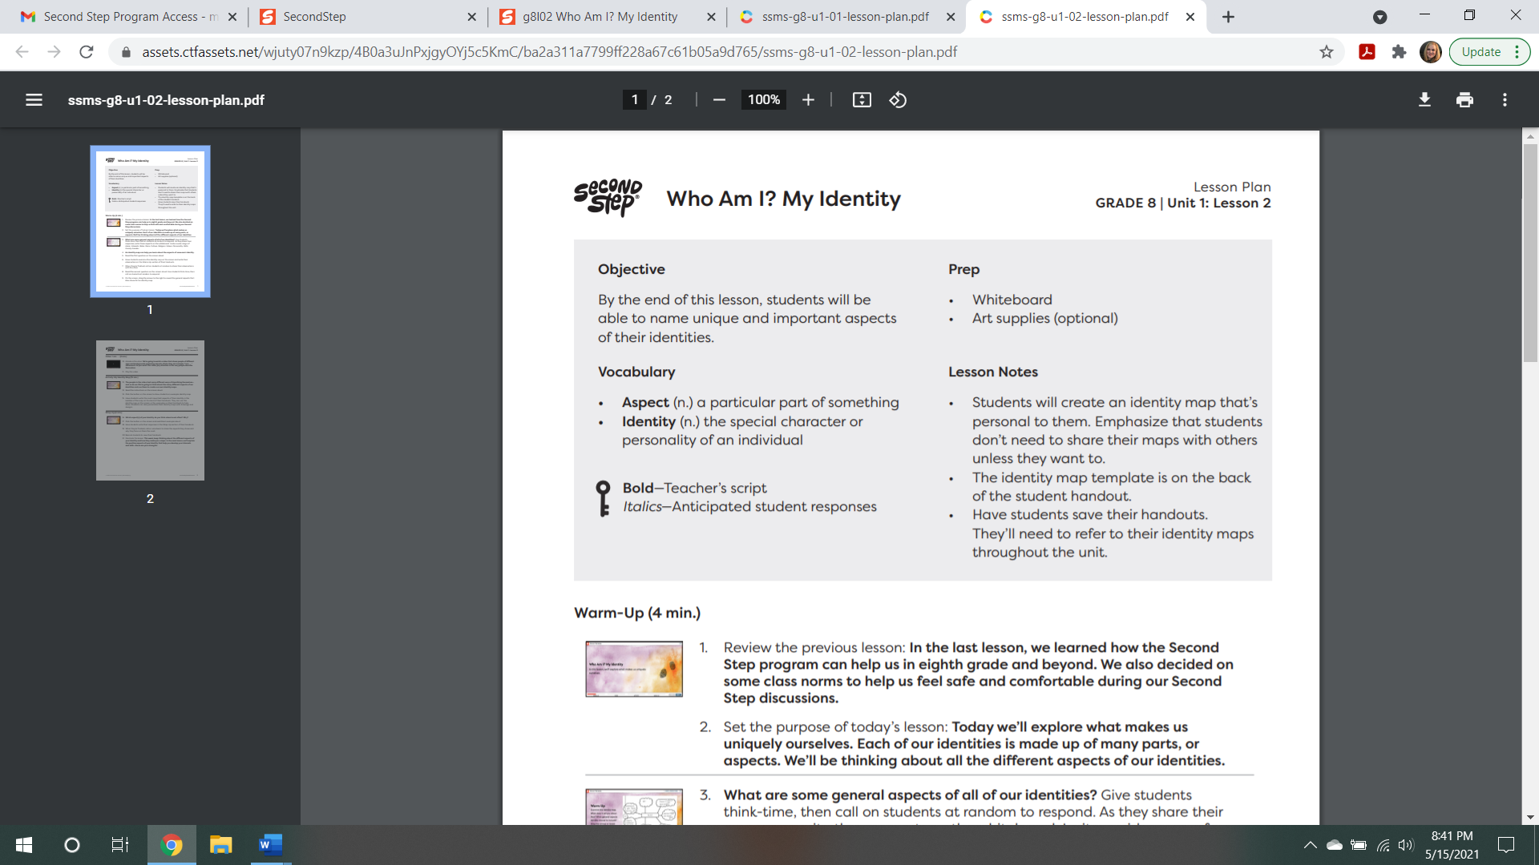
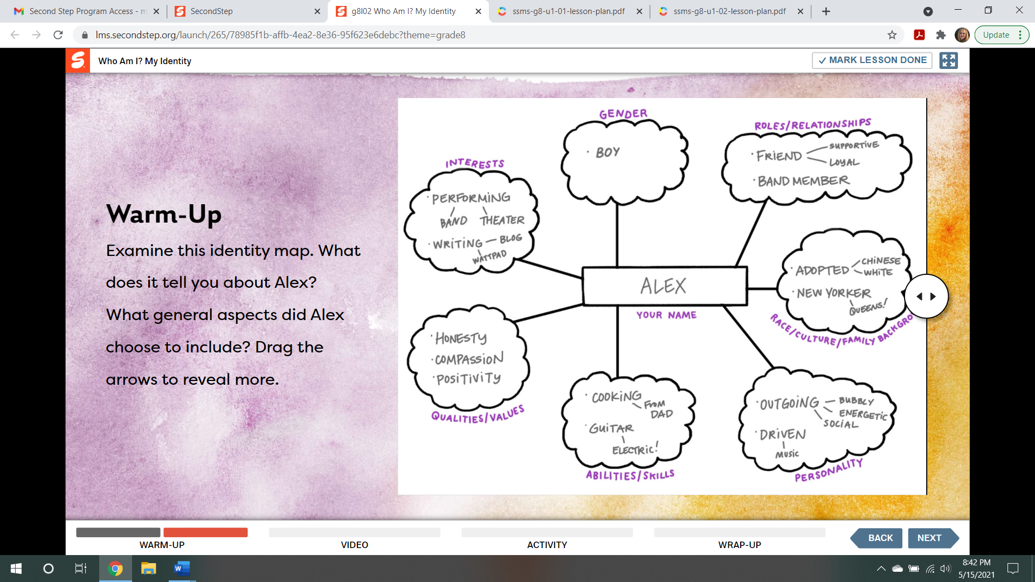
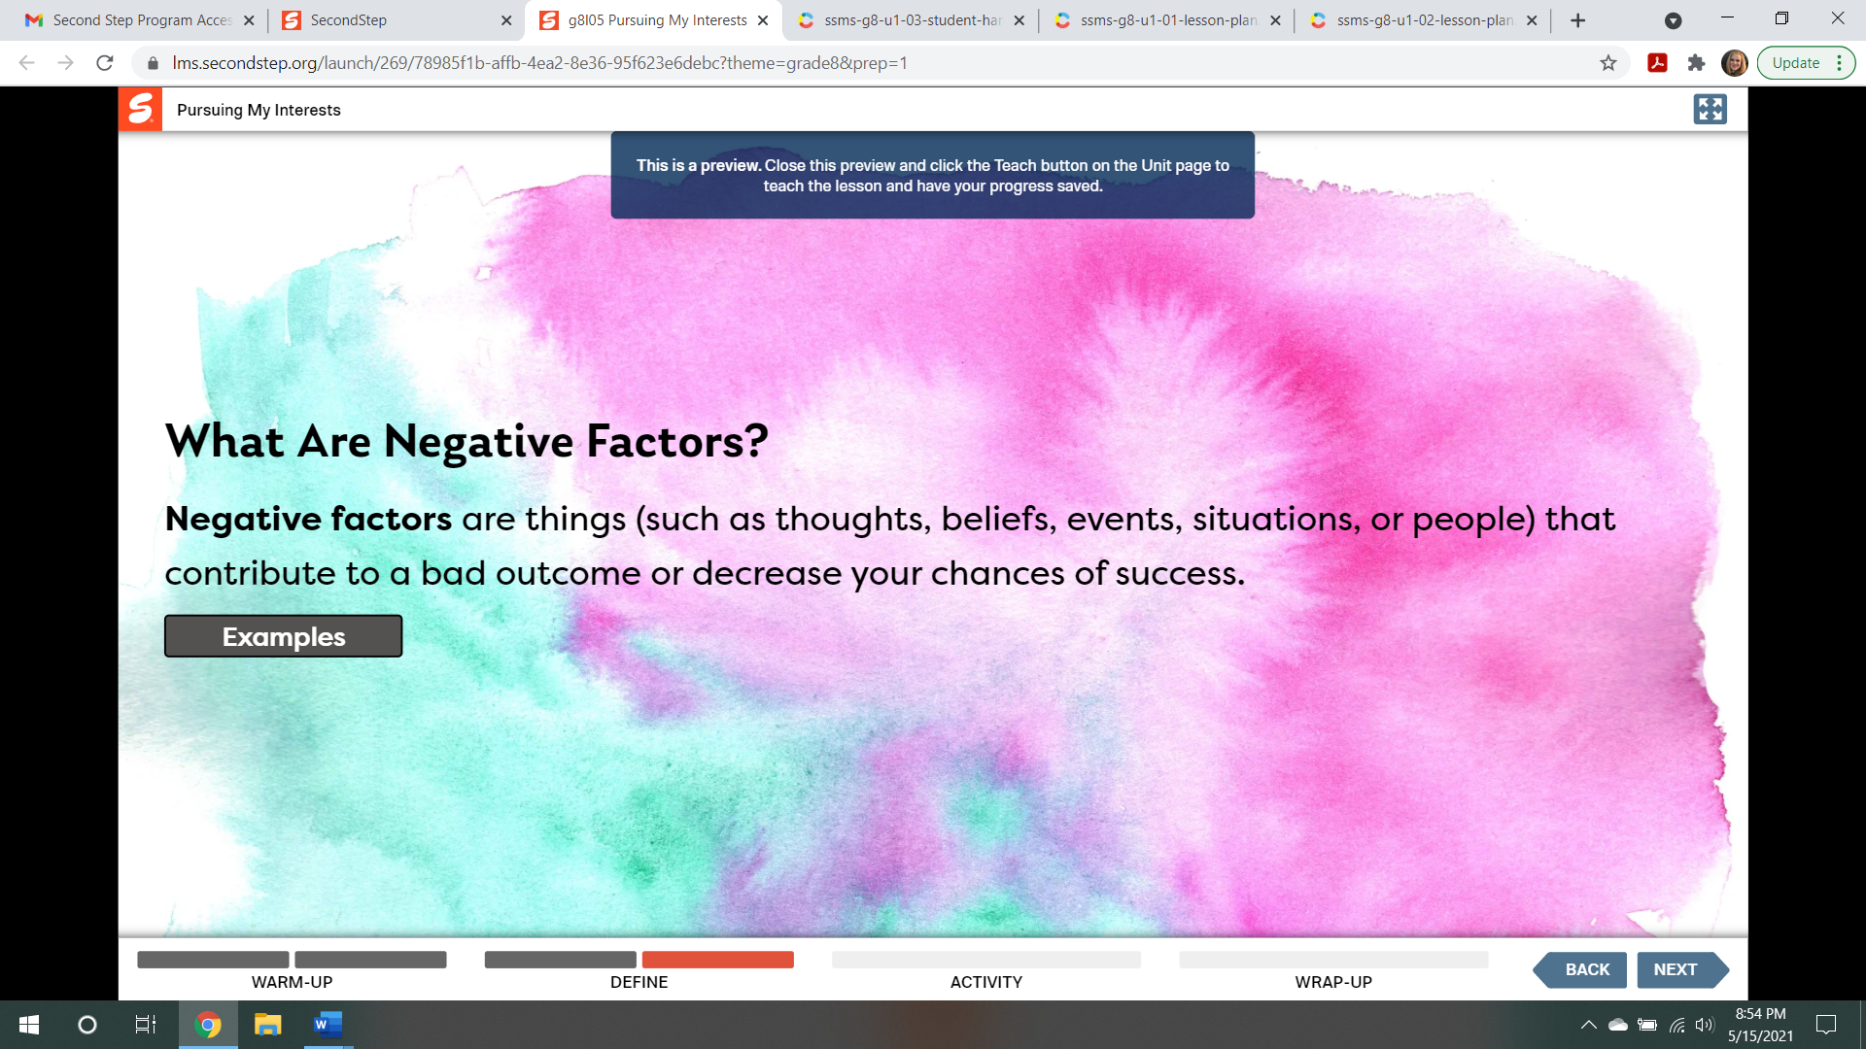
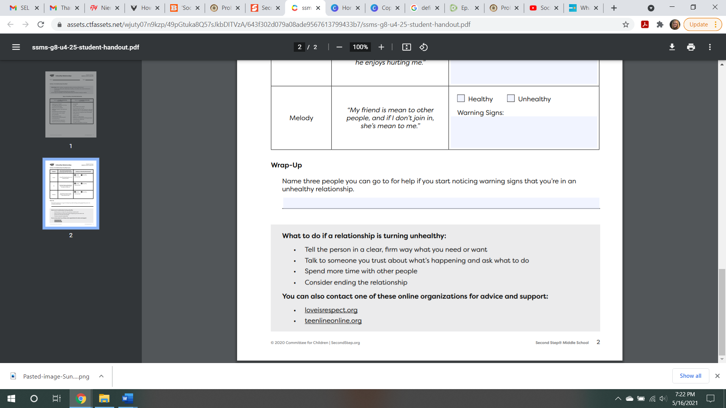
NOTICE THE WEBSITES ON THE BOTTOM OF THE WORKSHEET ABOVE
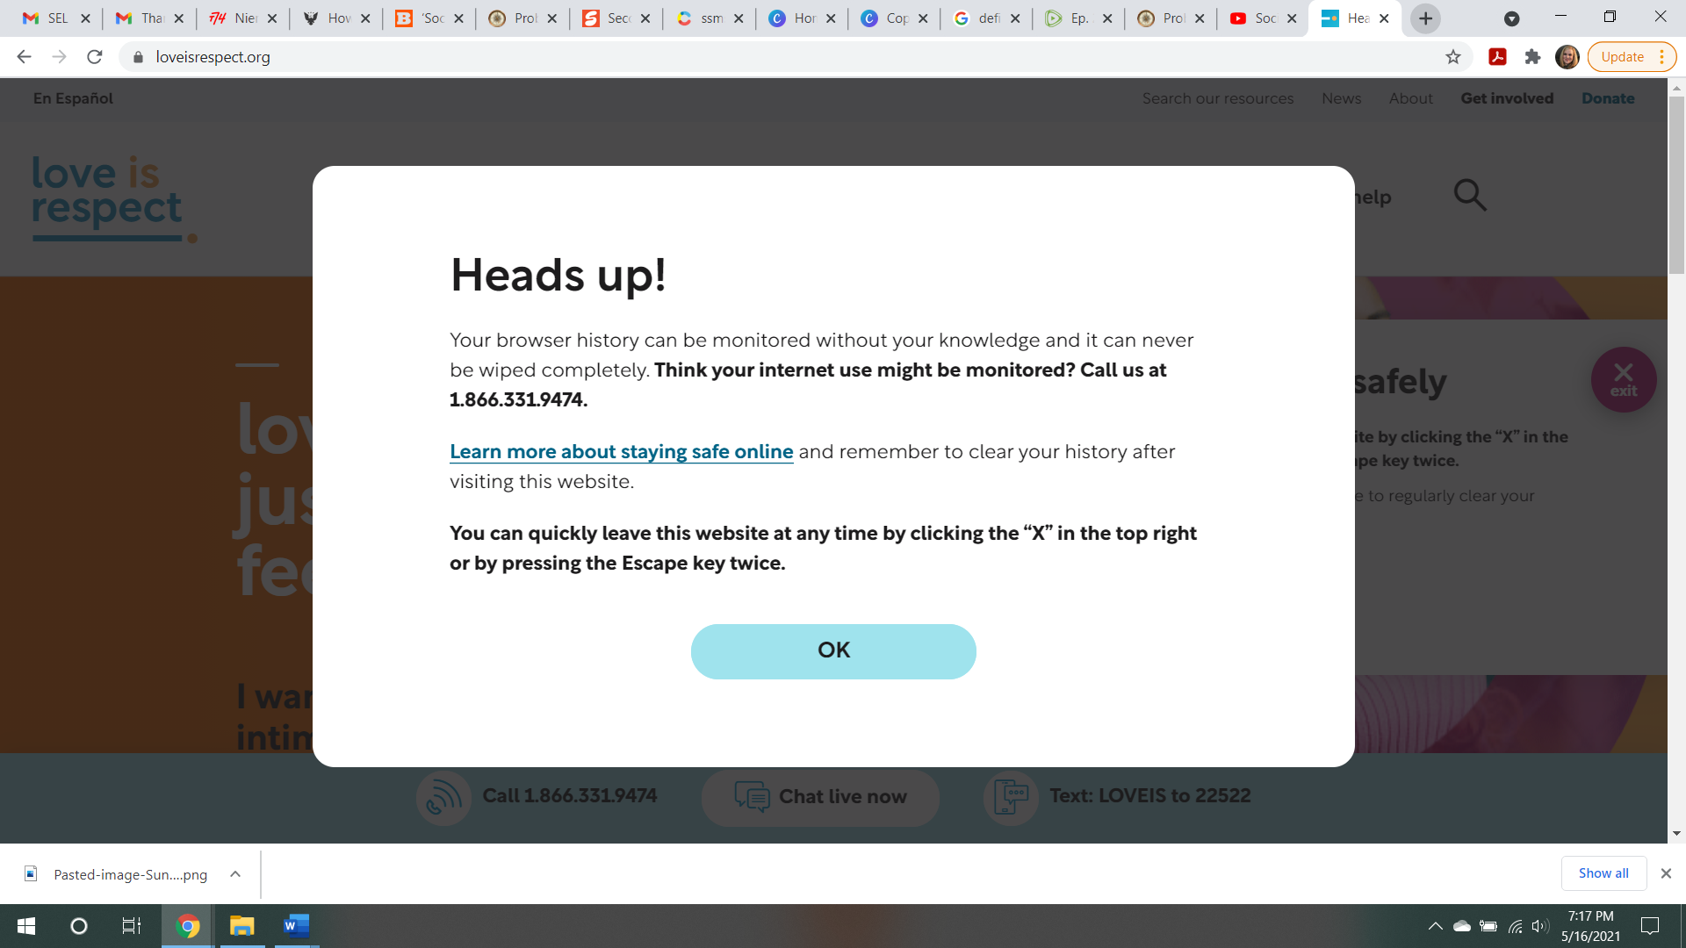
THIS IS WHAT CAME UP WHEN I TRIED THE WEBSITE AT FIRST (ABOVE)

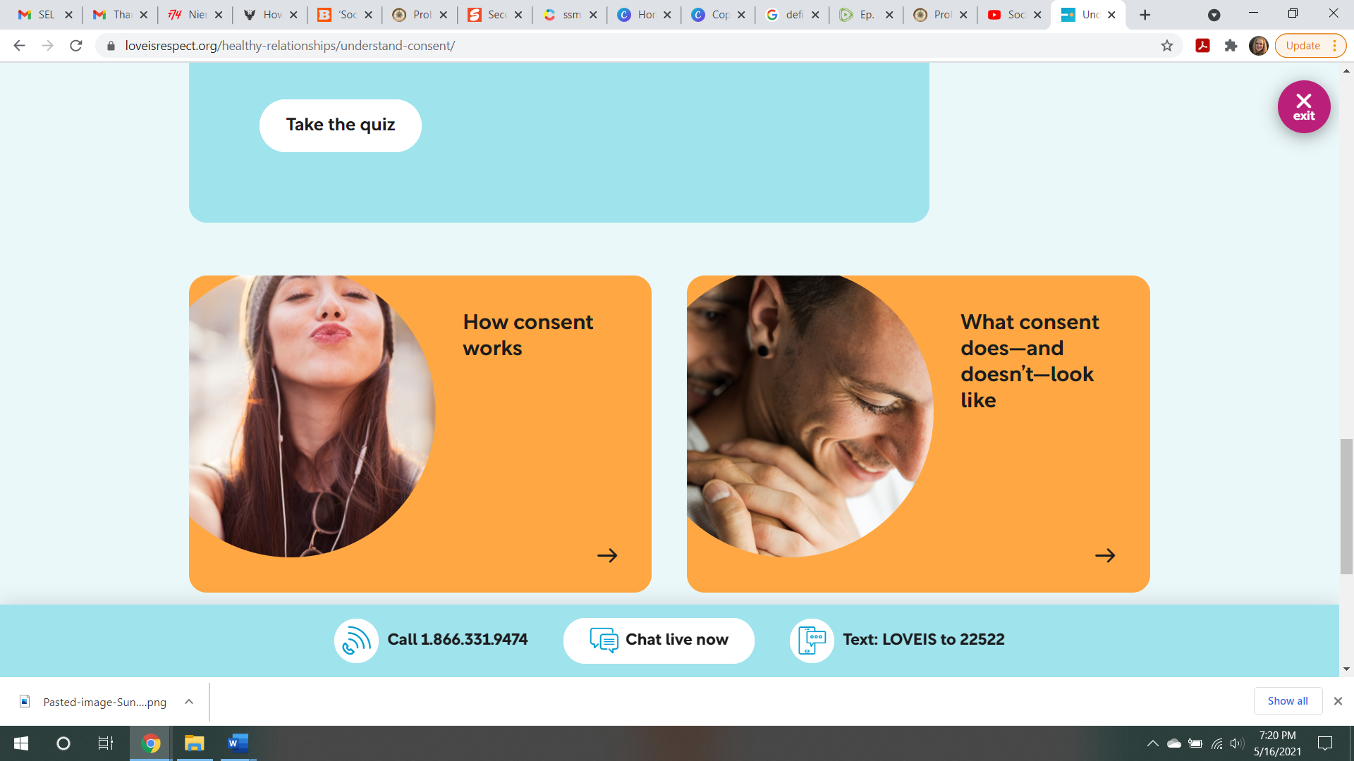
THIS PICTURE ON THE ABOVE RIGHT – NORMALIZING HOMOSEXUALITY
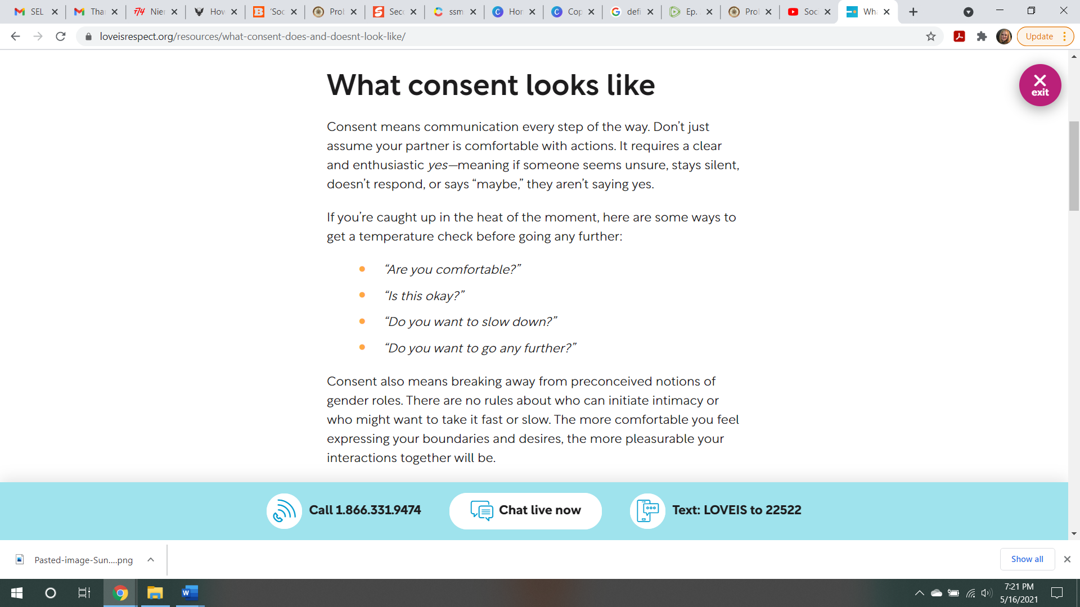
COACHING CONSENT INSTEAD OF TEACHING SAFEGUARDS OF NOT CONSENTING TO PREMATURE TEEN SEX, PROMOTING PLEASURE
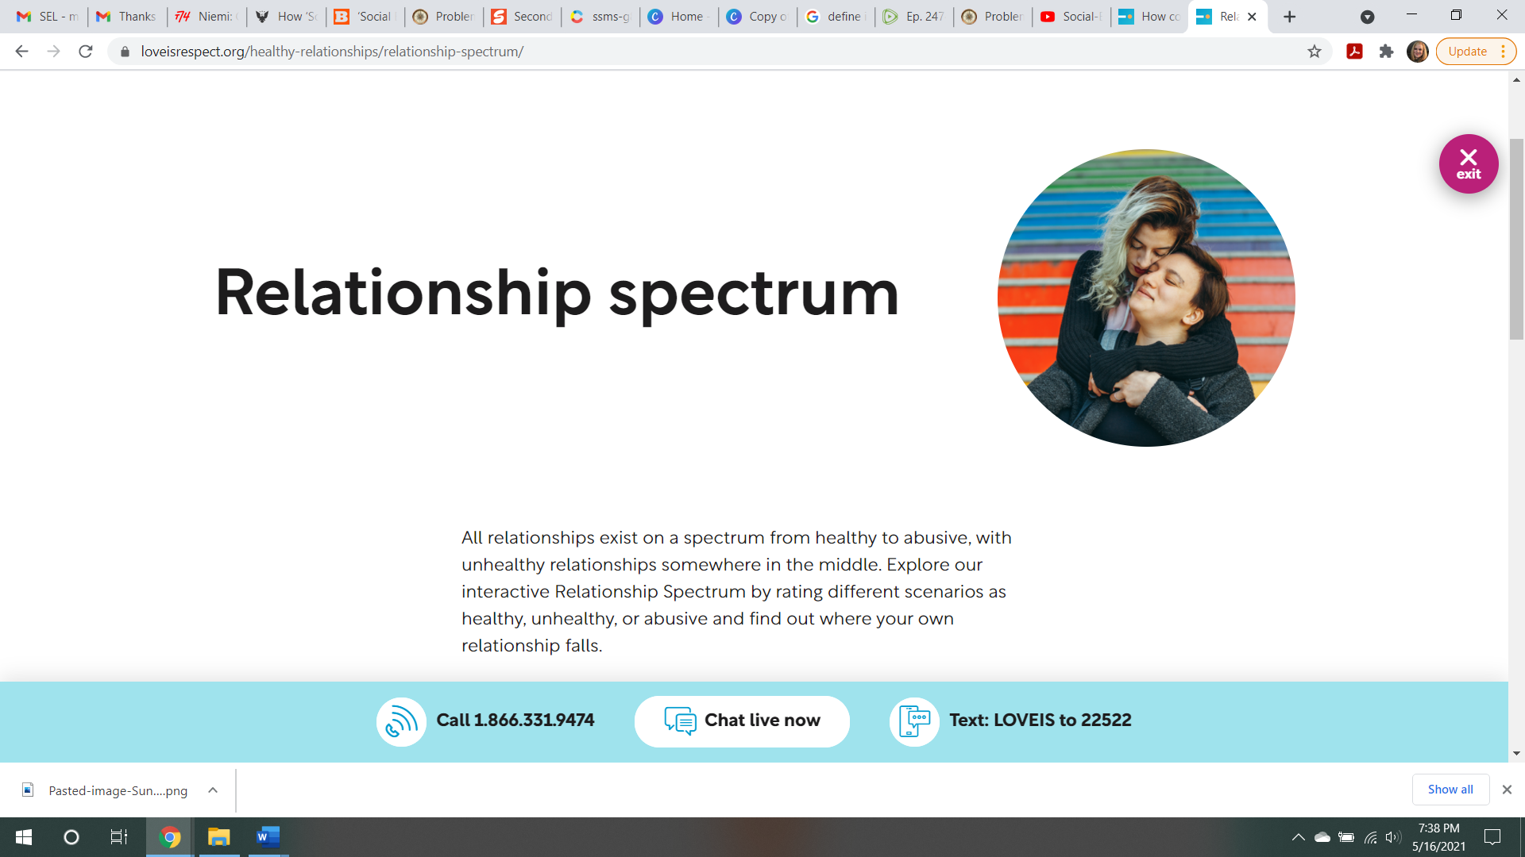
MORE NORMALIZING OF HOMOSEXUAL RELATIONSHIPS

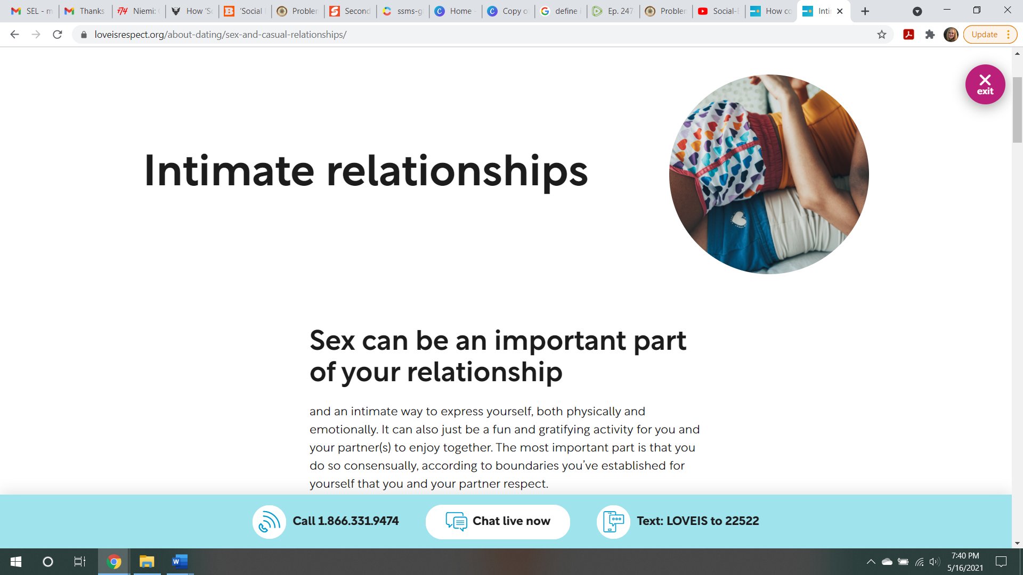
TWO TEENAGE GIRLS ABOVE, MORE NORMALIZING
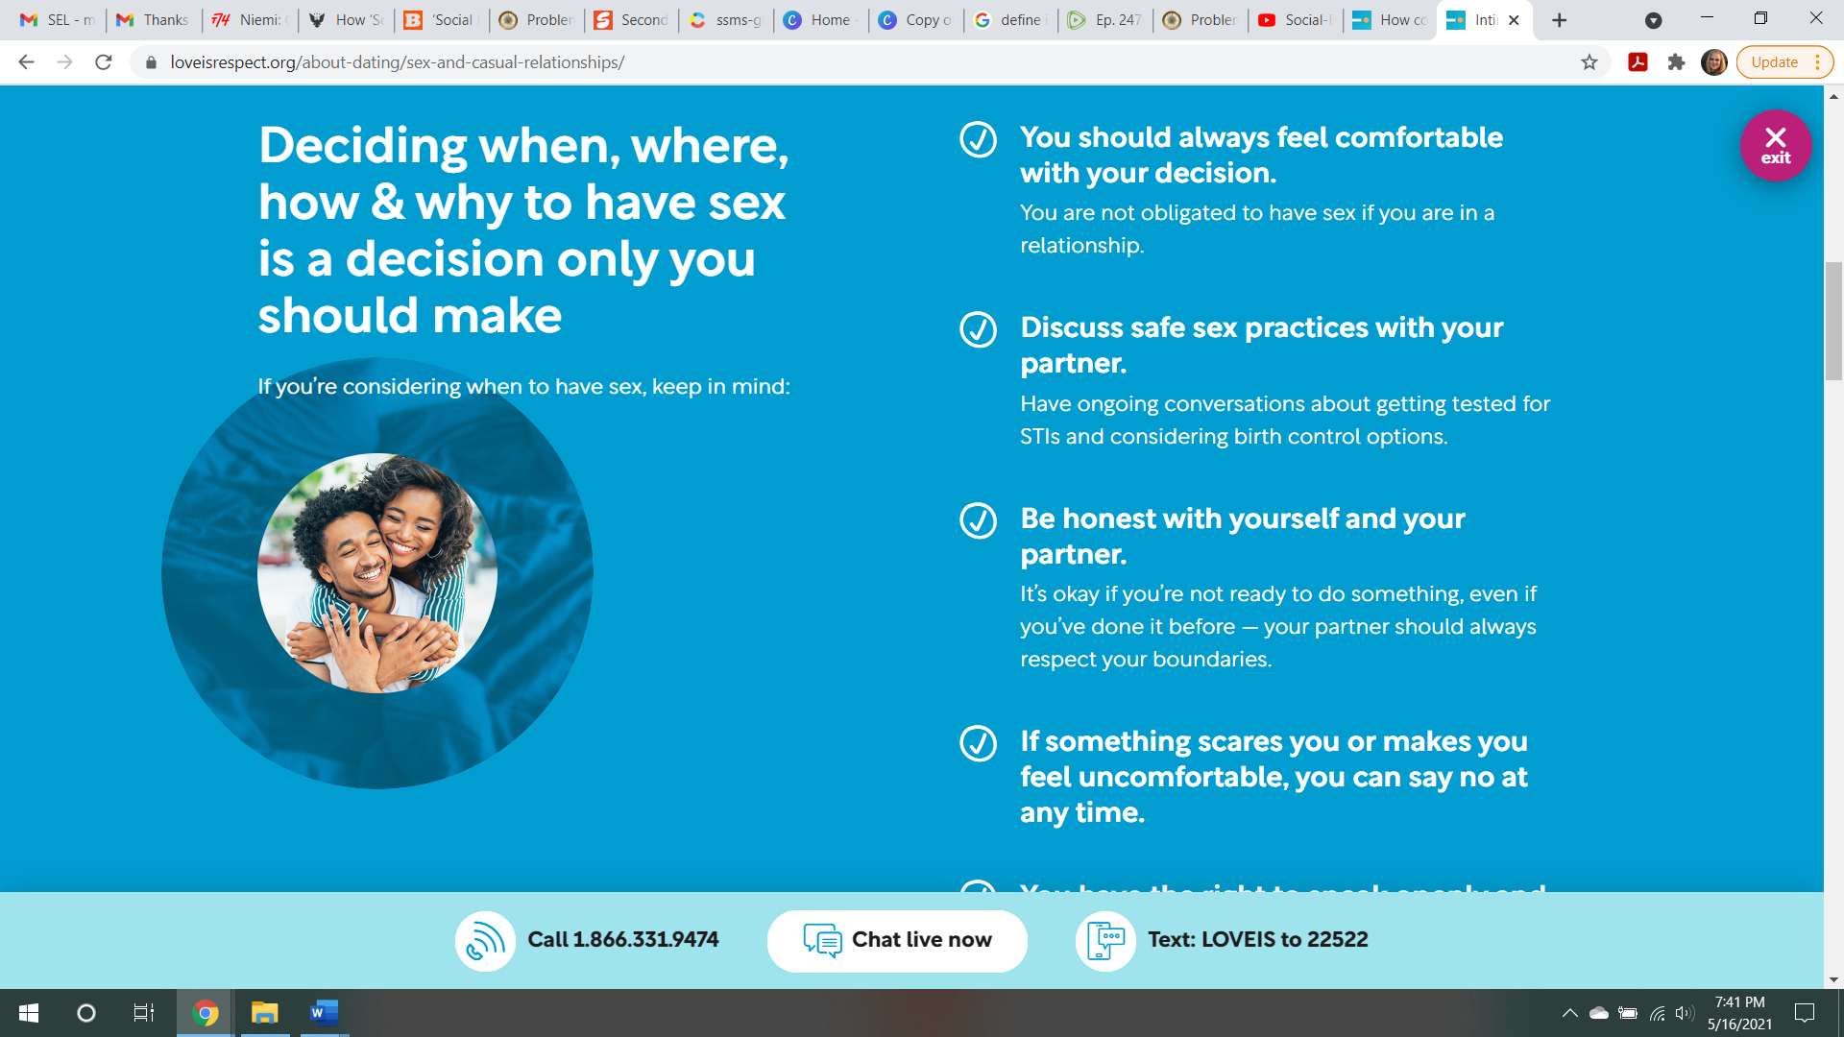
PROMOTING “SAFE” SEX - -- DANGEROUS FOR KIDS, NO SUCH THING AS SAFE SEX OUTSIDE OF A COMMITTED, MONOGAMOUS RELATIONSHIP
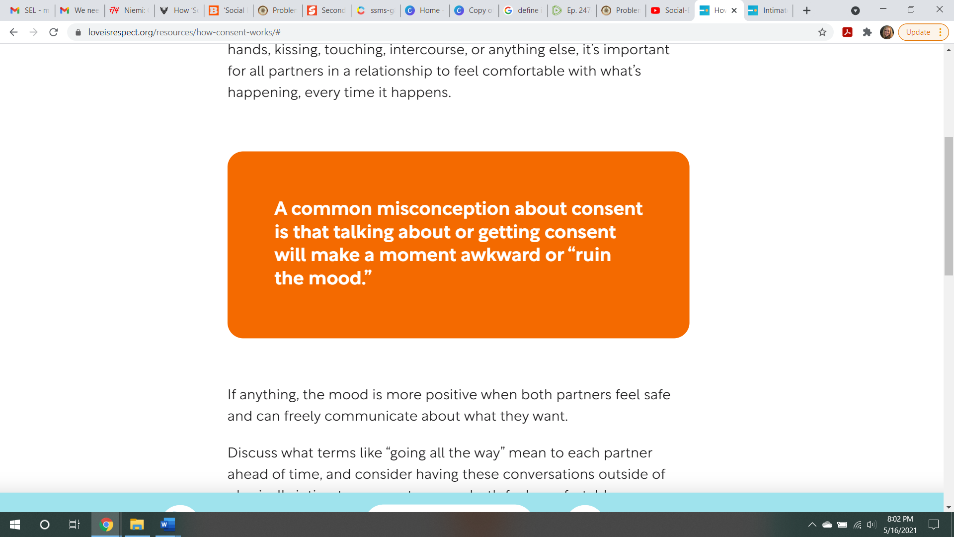
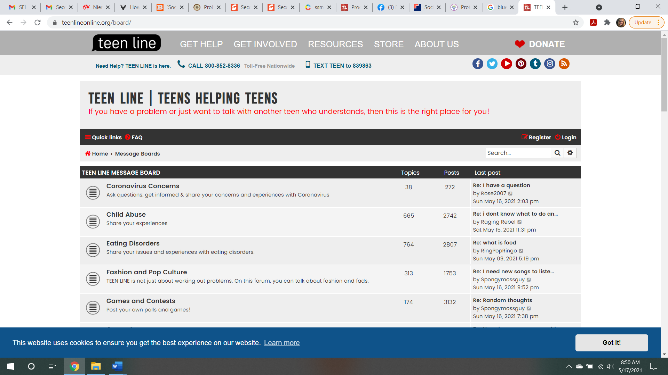
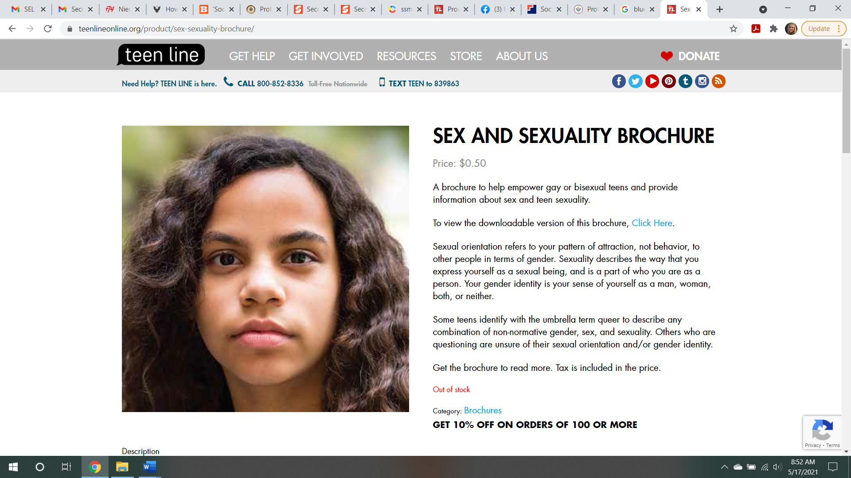

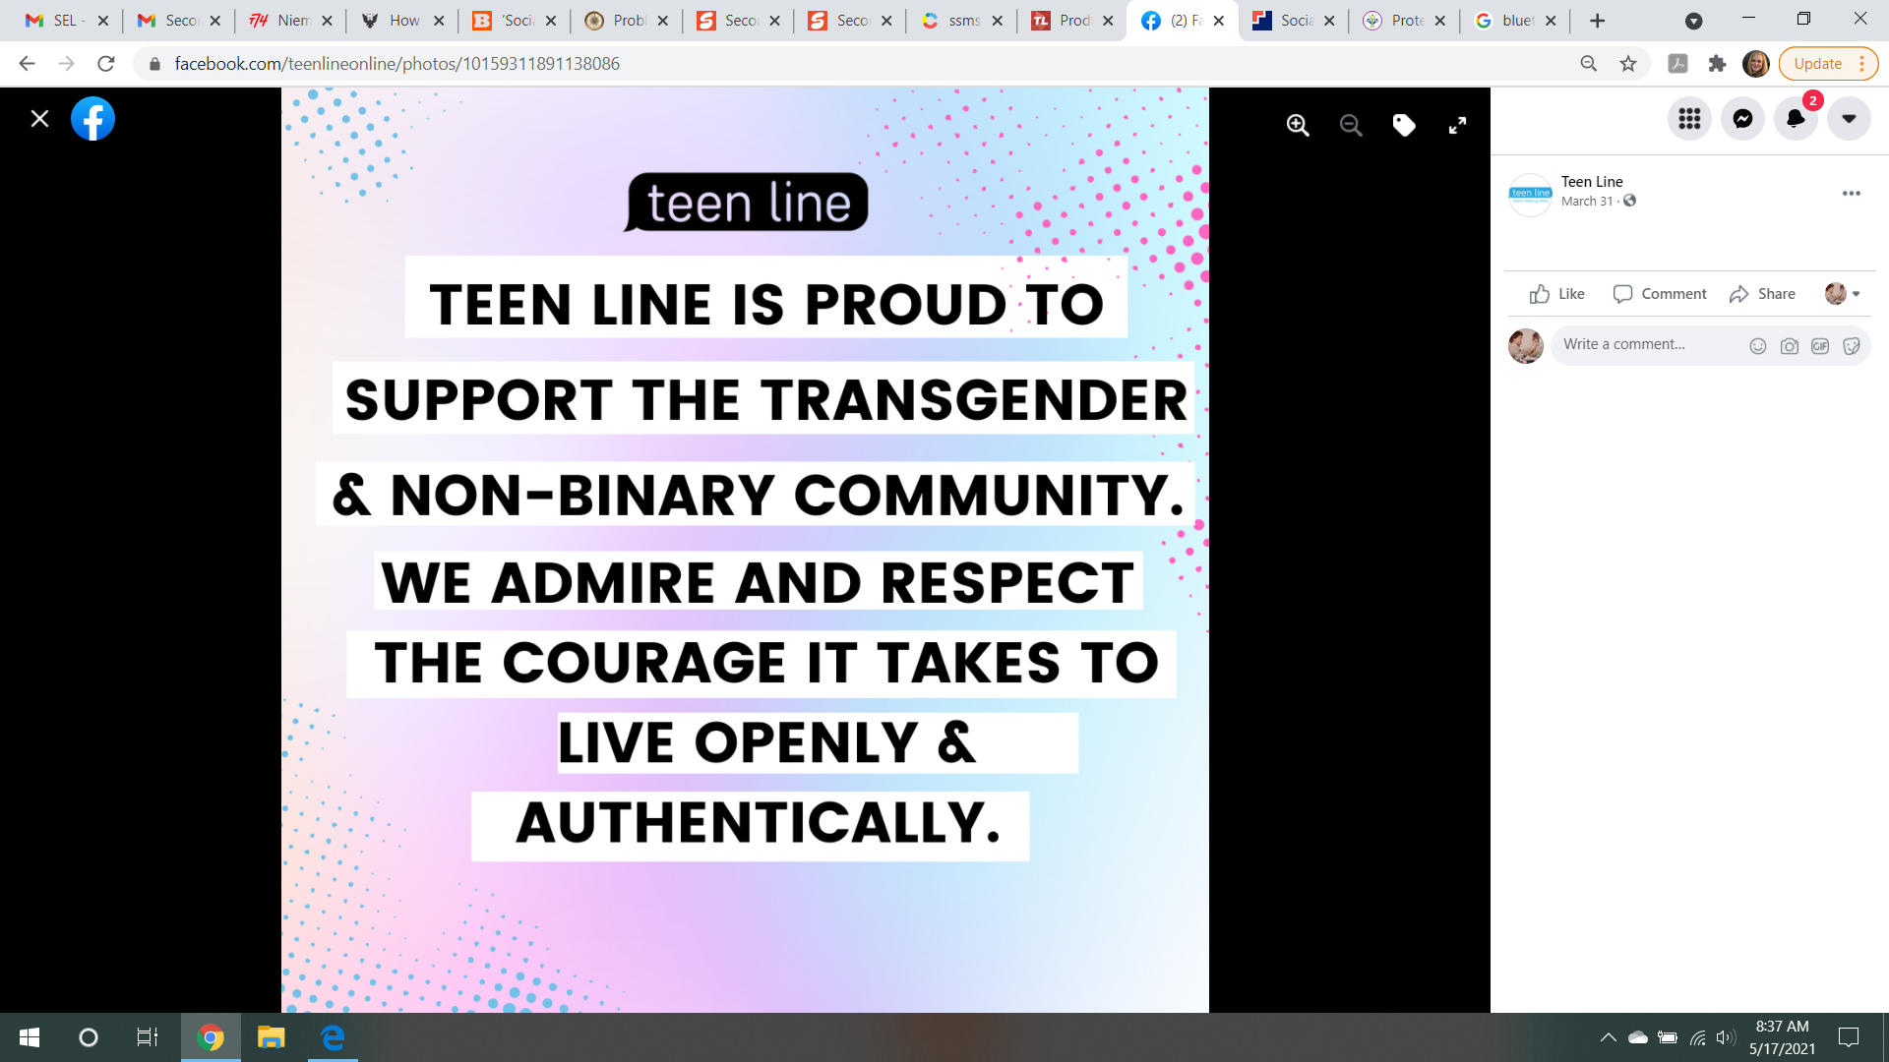
ANOTHER LINK FROM SECOND STEPS FOR KIDS TO EXPLORE

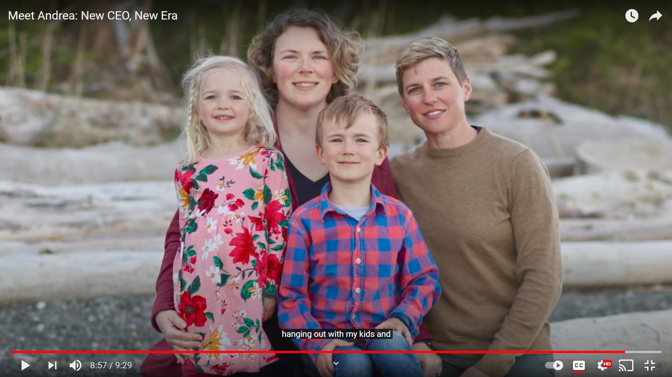
CEO OF THE COMMITTEE FOR CHILDREN, PARENT COMPANY FOR SECOND STEPS CURRICULUM – LESBIAN RELATIONSHIP
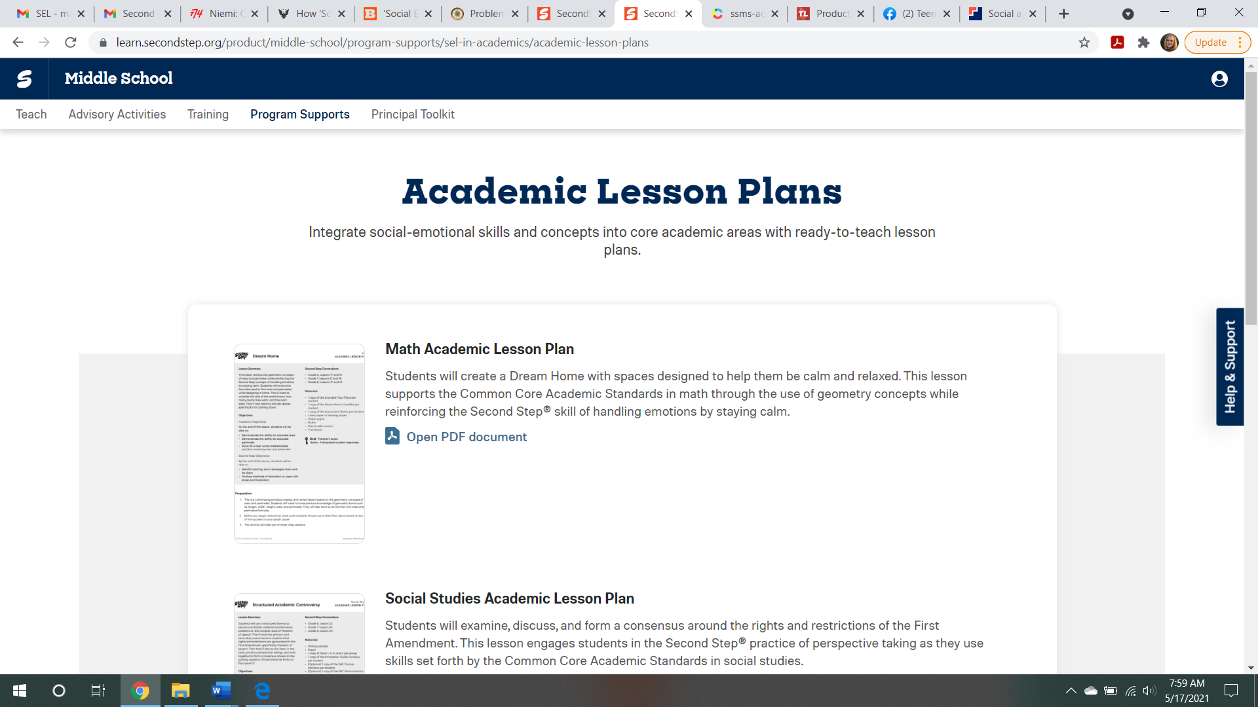
THE GOAL IS FOR ALL CLASSES TO BE INTEGRATED WITH SEL WITH THEIR INCULCATING MESSAGE.

