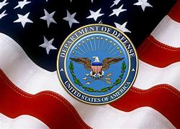
UNCLASSIFIED
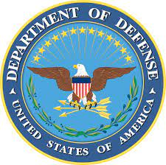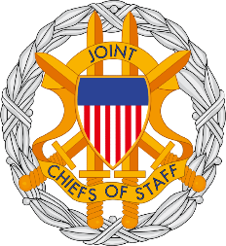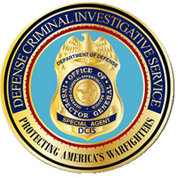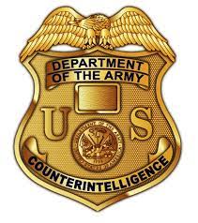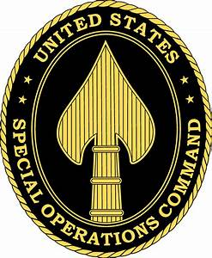
MILITARY WHISTLEBLOWER PROTECTION ACT COMMUNICATION
5/1/2022
AUTHORITY TO PROSECUTE:
ARTICLE I, SECTION 8, U.S. CONSTITUTION.
COUNCIL OF NATIONAL DEFENSE ACT OF 1916, AS AMENDED.
THE ESPIONAGE ACT OF 1917, AS AMENDED.
THE SECURITIES ACT OF 1933, AS AMENDED.
THE SECURITIES EXCHANGE ACT OF 1934, AS AMENDED.
THE COMMUNICATIONS ACT OF 1934, AS AMENDED.
FOREIGN AGENT REGISTRATION ACT OF 1938, AS AMENDED.
NATIONAL SECURITY ACT OF 1947, AS AMENDED.
THE INTERNAL SECURITY ACT OF 1950, AS AMENDED.
THE SUBVERSIVE ACTIVITIES CONTROL ACT OF 1950, AS AMENDED.
THE IMMIGRATION AND NATIONALITY ACT OF 1952, AS AMENDED.
THE COMMUNIST CONTROL ACT OF 1954, AS AMENDED.
THE ATOMIC ENERGY ACT OF 1954, AS AMENDED.
THE COMMUNICATIONS SATELLITE ACT OF 1962, AS AMENDED.
TITLE 18 U.S.C. SECTIONS 1961-68, 207, 792, 793, 798, 1030(a)(1), 2381, and 2382.
50 U.S.C. SECTION 783, as amended. 50 U.S.C. CHAPTER 13, AS AMENDED.
42 U.S.C. SECTIONS 2274, 2278, AS AMENDED.
FOREIGN INTELLIGENCE SURVEILLANCE ACT OF 1978, AS AMENDED.
EXECUTIVE ORDER 12333 OF DECEMBER 04, 1981, AS AMENDED.
TITLE 10 U.S.C. SECTION 1034, AS AMENDED.
PROVIDING MATERIAL SUPPORT TO TERRORISTS (2339A).
THE ANTITERRORISM AND EFFECTIVE DEATH PENALTY ACT OF 1996, AS AMENDED.
THE USA PATRIOT ACT OF 2001, AS AMENDED.
THE INTELLIGENCE REFORM AND TERRORISM PREVENTION ACT OF 2004, AS AMENDED.
JUSTICE AGAINST SPONSORS OF TERRORISM ACT (JASTA) OF 2016.
GARTHERING OR DELIVERING DEFENSE INFORMATION TO AID FOREIGN GOVERNMENT (18 U.S.C. SECTION 794.)

https://nationalfund.org/investor/bill-melinda-gates-foundation/?gclid=Cj0KCQjw37iTBhCWARIsACBt1Iztj7i_M102Pk9y3y_3Yf3NCdVtrjWAt8m1SUKQBmM4a2c9CvYsTUAaAvj2EALw_wcB

AUTHORIZED FOR PUBLIC RELEASE---MILITARY WHISTLEBLOWER PROTECTION ACT---PAGE 1 OF 4
UNCLASSIFIED
UNCLASSIFIED
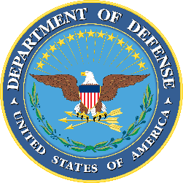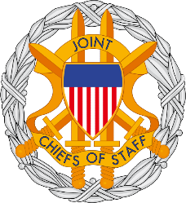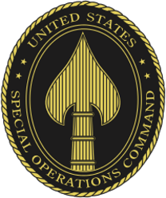
MILITARY WHISTLEBLOWER PROTECTION ACT COMMUNICATION

Bill & Melinda Gates Foundation
Certificate ID 1.3.6.1.5.5.7.3.1
http://r3.o.lencr.org/
https://www.r3.com/
https://www.fisglobal.com/en/gs?q=merchant-solutions-worldpay
Certificate server ID 1.3.6.1.5.5.7.3.1

Certificate Profiles - U.S. Federal Public Trust TLS PKI
https://devicepki.idmanagement.gov › certificateprofiles

5. Required Extended Key Usage: Server Authentication id-kp-serverAuth {1.3.6.1.5.5.7.3.1} Optional Extended Key ...
You visited this page on 5/1/22.

https://devicepki.idmanagement.gov/certificateprofiles/
https://www.gsaig.gov/
https://www.ignet.gov/
https://www.ignet.gov/content/inspectors-general-directory
https://www.dodig.mil/Components/Administrative-Investigations/DoD-Hotline/
Department of Defense Office of Inspector General
Search :: Search

AUTHORIZED FOR PUBLIC RELEASE---MILITARY WHISTLEBLOWER PROTECTION ACT---PAGE 2 OF 4

UNCLASSIFIED

UNCLASSIFIED

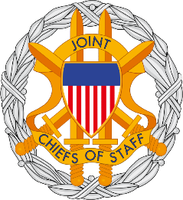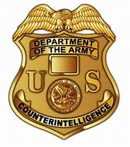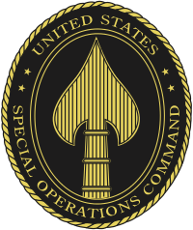

MILITARY WHISTLEBLOWER PROTECTION ACT COMMUNICATION

Administrative Investigations
- Investigations of Senior Officials

https://www.dodig.mil/Components/Administrative-Investigations/Investigations-of-Senior-Officials/

Investigations of Senior Officials

Mr. Anthony Jones, Director

Anthony Jones Member of the Constituents Foundation club ...
https://www.clubmadrid.org › miembro › anthony-jones

At present Dr. Jones is Vice President and Executive Director of the Gorbachev Foundation of North America and Professor of Sociology and Anthropology, since ...

https://clubmadrid.org/miembro/anthony-jones/
https://clubmadrid.org/club-de-madrid/partnerships/
https://clubmadrid.org/contact/
https://clubmadrid.org/who/?fwp_categories=full-members
file:///C:/Users/maver/Downloads/List-of-members-brochure-CdM-2022-digital-1.pdf
List of Members INCLUDING, BUT NOT LIMITED TO, WILLIAM J. CLINTON AND MIKAIL GORBACHEV.
List-of-participants_AC-2012-LR_12.12_CLINTON_FOUNDATION_CLUB MADRID.pdf

AUTHORIZED FOR PUBLIC RELEASE---MILITARY WHISTLEBLOWER PROTECTION ACT---PAGE 3 OF 4
UNCLASSIFIED

UNCLASSIFIED
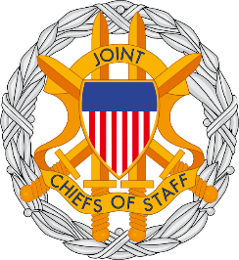
MILITARY WHISTLEBLOWER PROTECTION ACT COMMUNICATION

I CERTIFY UNDER PENALTY OF PERJURY UNDER THE LAWS OF THE UNITED STATES OF AMERICA, I AM AN EMPLOYEE OF THE UNITED STATES GOVERNMENT, DEFENSE CONTRACT MANAGEMENT AGENCY, DEPARTMENT OF DEFENSE. I AM A U.S. ARMY SPECIAL OPERATIONS -DELTA FORCE NATIONAL NUCLEAR SECURITY OFFICER/”Q” NATIONAL NUCLEAR SECURITY ADMINISTRATION. I AM A MEMBER IN GOOD STANDING OF THE NATIONAL TELECOMMUNICATIONS SECURITY WORKING GROUP, COMMITTEE ON NATIONAL SECURITY SYSTEMS. I AM A DEFENSE SECURITY SERVICE CERTIFIED U.S. ARMY FOREIGN DISCLOSURE CONTACT OFFICER/DEFENSE COUNTERINTELLIGENCE AND SECURITY AGENCY. I AM WITH THE DEFENSE INTELLIGENCE AGENCY/JOINT CHIEFS OF STAFF, ASSIGNED TO THE OFFICE OF THE SECRETARY OF DEFENSE. I HAVE PERSONAL KNOWLEDGE OF THE FACTS STATED HEREIN. THAT THE FOREGOING DOCUMENT IS TRUE AND CORRECT, TO THE BEST OF MY KNOWLEDGE AND BELIEF, PURSUANT TO THE PROVISIONS OF TITLE 28 U.S.C. SECTION 1746. EXECUTED ON 5/01/2022.
/s/ WILLIAM MAVERICK WINSLOW AC 56__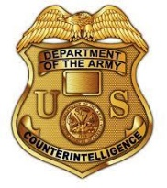 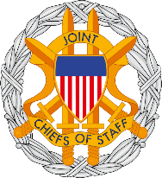
OFFICE OF THE SECRETARY OF DEFENSE
DEFENSE CONTRACT MANAGEMENT AGENCY
DEFENSE INTELLIGENCE AGENCY/JOINT CHIEFS OF STAFF
DSS/DEFENSE COUNTERINTELLIGENCE AND SECURITY AGENCY
U.S. ARMY SPECIAL OPERATIONS-DELTA FORCE
williamwinslow@deltaforce12333.army
williamwinslow@us-armedforces-foundation.army

UNITED STATES SPECIAL OPERATIONS COMMAND
UNITED STATES OF AMERICA

AUTHORIZED FOR PUBLIC RELEASE---MILITARY WHISTLEBLOWER PROTECTION ACT---PAGE 4 OF 4
UNCLASSIFIED

