Volunteer Training Manual

# 

Mind, Energy, Spirit, Attitude

#### Promoting self-esteem, self-confidence, social interaction

#### and physical independence through equine-assisted activities.

Updated: February 2019



# **M.E.S.A. Therapeutic Horsemanship, Inc.**

PO Box 516

Pinedale, WY 82941

(307) 749-3979

[subletterides@gmail.com](mailto:subletterides@gmail.com)

www.mesarides.org

Welcome to M.E.S.A. Therapeutic Horsemanship, Inc. We are thrilled to have you here and are very thankful that you are interested in helping us provide outstanding riding lessons to our participants. Without your help and enthusiasm we could not offer the quality lessons that we are committed to providing. So, thank you for being here and your willingness to join our team.

## M.E.S.A. Therapeutic Horsemanship, Inc. and You!

* Please remember that while you are volunteering you are seen as a representative of M.E.S.A. Therapeutic Horsemanship, Inc. We hope that you will be proud to represent us and will do your best to be professional, friendly and knowledgeable. Thank you.

**About M.E.S.A.**

* M.E.S.A. was founded in June 2012 and is a non-profit organization that is run by a 9 person volunteer Board of Directors. M.E.S.A. is a Professional Association of Therapeutic Horsemanship, International (PATH, Int’l) center member. This means that we follow strict guidelines and procedures for safety.

**Confidentiality**

* Please be sensitive when sharing your volunteer experiences with friends and family. Not all of our riders want their personal stories told to strangers. If you feel compelled to share powerful experiences you have had while volunteering here please leave the names and other identifying facts out of the story to protect the confidentiality of our riders.

## Therapeutic Riding Benefits

We believe that horseback riding helps all people realize benefits that reach far beyond their actual time on a horse. Relationships are enhanced between the student and their bodies, their instructors, their volunteers, and most importantly, the horse. The benefits are as varied as the individuals we serve. The following benefits may be gained through the involvement in therapeutic horseback riding:

Physically, the student may experience:

* Improved balance
* Improved muscled strength
* Improvements in coordination, faster reflexes, and better motor planning
* Stretching of tight muscles
* Decreased muscle spasticity
* Increased range of motion of joints,
* Improved respiration, circulation, appetite and digestion
* Sensory integration

Educationally, the student may experience:

* Improved reading and math skills
* Improved sequencing, patterning and motor planning skills
* Improved hand-eye coordination
* Improved visual/spatial perception
* Differentiation of sensory stimuli

Socially, the student may experience:

* Practice of appropriate social behavior
* Enjoyment of interaction with others and the social experience
* Development of respect and love for animals and people

Cognitively, the student may experience:

* A general sense of well-being
* Improved self-confidence
* Increased interest in the outside world
* Increased interest in one’s own life
* Improved risk-taking abilities
* Development of patience
* Emotional control and self-discipline
* Sense of normality
* Expansion of the focus of control

## Criteria for Volunteers

* Volunteers need to be at least 13 years old to work directly with our horses and riders due to our insurance restrictions. Underage youth are welcome to help in other important ways. They can clean tack, tidy the stable area and do other odd jobs.
* All volunteers are required to fill out an information form and sign an insurance waiver along with complying to a background check if asked, prior to working with our participants.
* Ability to commit to a 2-3 hour block of time once per week for a six-week session. It’s helpful if you can commit to the same day and time so that you can work with the same student throughout their session.
* Willingness to attend the new volunteer orientation, attend training sessions when they are offered and willingness to continue to learn while “on the job”.
* Knowledge about horses is helpful but not mandatory. Many excellent volunteers have little or no previous experience with horses.
* Reliability is essential to the smooth operation of our program. Please be here 10 to 15 minutes before the start of the lesson and ready on time without exception.
* The best volunteers are relaxed yet attentive to their surroundings. They are always watchful of the student, horse and potentially dangerous situations.
* Having a positive and a friendly attitude is always helpful to the staff and students.

## Barn Rules

* + ASTM/SEI approved riding helmets must be worn by all students at all times when in the barn or arena working with or around the horses. Helmets must be within 5 years of the manufacturing date.
  + While on horseback at M.E.S.A., all riders (including volunteers) must wear helmets.
  + Appropriate riding attire must be worn when working with the horses: long pants (no holes), boots or hard soled shoes that cover the toes, sleeved shirts and proper headgear. ***Modest, functional clothing please.***
  + Respect instructors (both riding and equine) and cooperate with directions.
  + If you have small children, we ask that they do not attend the lessons while you are volunteering.
  + All children on site MUST be supervised by an adult at all times.
  + Only authorized staff or volunteers are allowed in the stalls, teaching arena or pastures.
  + No running in the barn area, tie-up area or near the horses.
  + No loud noises or movements when around the horses.
  + No glass in the stable area or arena.
  + Smoking is allowed *ONLY* in the parking lot of public facility. No smoking on private property.
  + No unleashed pets on the grounds. Dogs must be kept in your car when working with a lesson.
  + Observe and obey all safety signs posted.

*Thank you for making M.E.S.A. a safe and friendly environment!*

## Duties and Responsibilities

* Report to the lesson site at least ten minutes prior to your scheduled time.
* Sign in and be sure to record your volunteer hours. Round your time off the nearest half hour please.
* Check the white board or clipboard for rider and horse assignments.
* Check-in with the instructor and find out what assistance they will need.
* Assist students with clipping helmets on and helping them adjust straps for proper fit.
* Assist the instructors and students in grooming and tacking the horse prior to, and after, the lesson.
* Help keep the barn & the tie-up area neat and clean. Scoop manure, if necessary.
* Assist the instructor during the lesson as needed.
* Serve as a side-walker or lead-walker for the student during their lesson.
* Prior to leaving please check out with the instructor and log in your volunteer hours.
* Attend continuing education trainings.
* Respect confidentiality of participants and families.
* Read the volunteer training manual.
* Record your volunteer hours.
* Observe dress code: no open-toed shoes/sandals, perfume may attract insects, dangling jewelry may be unsafe around certain participants.
* Hats and sunglasses are recommended, but be cautious as they can be distracting to the riders.

## What to expect during a lesson:

Private Lessons:

* Private lessons run approximately 30-45 minutes long, depending on the circumstances.
* The first 10 minutes is spent grooming and tacking the horse. Your involvement will depend on the student’s and the instructor’s needs.
* 20 minutes are spent riding
* 5 minutes at the end of the lesson are for un-tacking and brushing the horse.
* There is a 15-minute break for the instructor before their next lesson begins.
* Prior to the lesson, the instructor will brief you on the student and expectations during the lesson. Information is also available in their riding progress file.
* Please feel free to ask any questions before or after the lesson.
* Private lessons are reserved for our riders with disabilities only. Some students require as little stimulation as possible to provide a productive and positive lesson. Sometimes interaction with these students might be limited.

Group Lessons:

* + - * Group lessons run for 45 min.
      * Group lessons will include 2-4 students and one instructor. Riders will have volunteers assigned to them based upon their needs.
      * Your responsibility in a group lesson varies from a private lesson. Volunteers are asked to help the student groom and tack their horses. The instructor will bring the tack to the saddle rack next to where the horse is tied. Volunteers will likely be asked to help. Tack assignments should be listed on notice board (clip board or white board).
      * **Please put the cinch/girths on very loose in the tie up area!!!** The instructor will tighten and check the equipment once the horses are in the arena and before mounts.
      * Grooming and tacking should take approximately 10-15 min. Prior to the lesson, please ensure that the horses are thoroughly clean, check under the bellies to remove all bedding & dirt. Being responsible for horse care is an important goal and part of group lessons.
      * After all the horses in the lesson are tacked, the instructor will dismiss all horses from the tie area to the arena. Horses are to be walked around the arena (by the student when safe and appropriate) while the instructor begins to mount the students. This is an important time for the horses to warm up, and allows the students the opportunity to learn how to handle a horse.
      * Students will be mounted either at a mounting block, platform in the arena or at the ramp, at the instructor’s discretion.
      * During the lesson, the instructor will give directions and feedback to the student. Please be aware of your student’s name. It is a huge help to the instructor if you can assist the student with holding the reins properly, heels down, etc. During the group lesson, the volunteer has more opportunity to interact with the student in a supportive role. Please keep in mind that the instructor does the teaching, the volunteer helps to ensure the student understands and offers assistance where necessary.
      * There will be times during the lesson where the instructor might ask the volunteer to unclip the horse (or tie the lead rope off) so the student can gain another level of independence. During this time, please remain within “grabbing distance” of the horse to ensure that no horses get too close to each other or the horse doesn’t misbehave and endanger the student.
      * Group lessons are a fun time, designed for social interaction between the students and volunteers. Some trotting is required, so please inform the Instructor of any physical limitations you might have.

## Handling the Horse

It is important to understand the nature of a horse to develop a good relationship with it. Horses are passive animals that will try to please you if they understand what you want. Horses are more instinctual than intelligent, they will never forget a negative experience and they are very sensitive to tension and fear. Horses are prey animals with a “fight or flight” instinct that is very important to consider when handling them. If you have had a busy day or you are a little nervous, try to relax, breath deeply and speak to the horse in a low and even tone. Horses can learn a few commands, although they respond to the tone in which the command is given more importantly. Here are a few pointers for handling horses.

* + - * Running and loud noises can startle a horse. Keep your movements calm and deliberate. BUT….do not “sneak” around a horse.
      * Approach a horse calmly at his side so that he may get the best look at you while approaching him. Horses have a blind spot directly in front of their faces or under their heads. Our older horses fall asleep easily, so please be sure they see you approaching.
      * Don’t duck under the neck or belly of a horse that is tied up. It is safer to go around the back. Stay close to the horse with one hand on their rump.
      * If you approach a horse from the rear, speak to him since he may not see you.
      * Don’t kneel or squat around a horse. It is too hard to get out of the way quickly. Never put a knee on the ground when you are near a horse.
      * When bringing a wheelchair toward a horse move slowly, making sure the horse can see you as you approach. Remember to always keep one hand on the wheelchair. Don’t forget to use the brakes, when necessary.

## Preparing for a Lesson

Groom the horse in the following manner:

1. Rubber curry comb: use a circular motion on the neck and body to loosen dirt and stimulate the skin. Do not use on the face and legs.
2. Soft body brush: use short, flicking strokes on neck, body and legs in the direction the hair grows to remove and loosen debris.
3. Hoof pick: Horses are creatures of habit and they are used to a routine. We start with the front hoof then move to the back on that side then repeat the process on the other side. To get the horse to pick up it’s hoof stand next to the horse’s shoulder or hip facing the tail. Run your hand down the horse’s leg and lean into him to help him shift his weight to the other leg. The horse will lift it’s hoof for you. Then you can slide your hand underneath the hoof to support it. Clean the dirt out by picking *away* from your body; picking from heel to toe of the horse’s hoof. Once the hoof is clean gently put the hoof on the ground.
4. Mane and tail brush: (Only if time allows) The horses mane and tail have been growing for their whole life so please be gentle to avoid pulling out hairs. You will not be able to get all the tangles out in the time you have to groom, so start at the bottom and work up. Be sure to stand to the side of the horse while you work on the tail. Please use a detangler on the mane & tale if it is available.

Tack the horse in the following manner:

The instructor will set out the tack you will be using for the lesson or you can ask the instructor which you will use for each lesson.

1. Saddle pads, English/western: Place gently over the withers and then slide back into place. On some of the horses we use two pads.
2. Saddle, English/western: Place the saddle over the saddle pad gently and adjust to fit properly. Pull the front of the pad away from horse’s back and into gullet of saddle.
3. English saddle girth: Attach the non-elastic end to the right side of the saddle, then go around and tighten only to the point of keeping the saddle in place. Girths should be re-tightened by the instructor just before mounting. Please adjust the girth enough on the right side to allow for final adjustments to be made on the left side.
4. Western saddle cinches: Check cinch so that the ring is in the center of the horse’s front legs and make sure that all rings are not folded under the cinch. Tighten the cinch enough that the saddle will stay in place. DO NOT TIGHTEN COMPLETELY IN TIE UP AREA!!!

**Note:** Instructors will check girths and cinches before students mount.

1. Bareback pads: These are used for some students. Please use a saddle pad underneath for extra padding.
2. Bridles: Bridles are rarely used during lessons and will be put on by the instructor or a trained volunteer. Side pull bridles are now being used in some lessons.
3. Reins: Most students use reins that are clipped onto the horse’s halter. Be sure that the clip levers are pointed outward, away from the horse’s face. Also, be sure the reins are clipped on both sides of the halter equally.

## Lead-Walker Responsibilities

## Take charge of the horse.

* Be constantly aware of the horse, his attitudes, and actions.
* Be responsible for the rider’s safety.
* Assists the rider’s control of the horse as necessary. Remember to promote as much independence as possible.
* Stay even with the horse’s head when leading to avoid injury to yourself and others.
* Be patient with the rider.
* Know where to stand while leading, mounting and dismounting.
* Allow the rider to make his own mistake and learn from the horse’s reaction.

## Work with and follow the instructor’s directions. Ask for clarification if unsure about anything.

## How to Lead-Walk

* Hold lead rope about 6-10” from the clasp of the lead rope to allow for the natural motion of the horse’s head.
* Hold extra rope folded in your other hand. Never wrap the rope around your hand.
* Make sure the lead rope is between the reins, not over them.
* Stay at the side of the horse’s head, not behind or in front.
* *Wait until rider initiates action. Do not give student any more support than needed.*
* Look up and forward. Focus attention on the lesson. Glance occasionally at the rider to make sure he/she is safe.
* Keep a minimum of 2 horse lengths distance between your horse and the horse in front of you, unless instructed otherwise. Sometimes we are closer for the benefit of the lesson.
* When maneuvering the horse, be sure to allow enough room for the side-walkers near the fence or other obstacles.
* Walk far enough away from the horse that you do not get stepped on.
* Allow the instructor to give any verbal instruction to the rider to avoid confusion.
* Listen closely to the instructor’s description of each horse and how to handle them. They know the horse and will offer good advice.
* If a horse steps on your foot, avoid screaming. Rather, lean into his shoulder so he can transfer his weight off your foot and onto his.
* Unless otherwise asked by the instructor, always lead horse from the left side.
* If a horse should suddenly shy, maintain your position and try to bring the horse back to you. NEVER, let go of the lead rope, NEVER!
* Remember, the instructor will always direct volunteers through conversations with the rider. So please be attentive to what the instructor is saying.

## Side-Walker Responsibilities

* Assist the rider in maintaining balance. One or two side-walkers may be assigned according to the rider’s needs. Some rider’s do not require side-walkers.
* To increase physical independence, a side-walker may be asked to release the rider or step a little further away from the rider. In this instance, you have become a “spotter” and it is imperative that you maintain proper position and are ready to immediately support that rider should he become unbalanced.

## How to Side-Walk

* + - * Several methods are used with individual riders, depending on their needs.
      * High Thigh Hold: The side-walker places their arm that is closest to the rider across the rider’s thigh and grasps the front edge of the saddle. The fleshy part of the forearm rests gently across the rider’s thigh. Be mindful of digging your elbow into the rider’s leg or the horse.
      * Therapeutic method: The rider’s leg is held at the joint (knee or ankle as specified by the instructor) with the hand that is farthest from the rider. The hand near the rider is placed near the rider’s back. The hand near their back should not actually touch the rider, but be there to correct and support the rider’s position. Be mindful that you do not lean or pull on the joint that you are holding as it will be uncomfortable to the rider or may prevent them from achieving proper balance.
      * Your instructor will let you know how to side walk and support the student you are working with.

## Emergency Procedures

**Fall of Rider from Horse:**

1. In the event that a rider falls from a horse, it is necessary for all other horses and riders in the arena walk to opposite side of arena and stop all activity. Please park your horses side by side and facing away from the downed rider.
2. If there is a loose horse from the incident, the volunteer responsible for the horse should catch and secure the horse, with assistance if necessary. All lead walkers should stay with their assigned horse and side walkers with their rider. Please do not leave your duty unless asked by the instructor.
3. If requested by the instructor, all other riders will then dismount if able to do so unassisted. If unable to dismount, riders will stay mounted facing away from the downed rider, or until a volunteer is able to assist them.
4. The horse involved with fall should be removed from the arena by the lead walker or trained staff members, or may be parked next to the other horses at the end of the arena, if he is quiet and settled.
5. The downed rider must remain still and be assessed using the Emergency Procedure for Humans.
6. Upon assessment, it is determined if other lessons in the arena can continue, or if the arena must be cleared for EMS.
7. If the rider is un-injured and chooses to continue his/her lesson, he/she can be remounted
8. Riders and parents are encouraged to monitor health for 5-6 hours following a fall for swelling that would indicate a sprain or break of a bone and for signs of a head injury.
9. The instructor will make a follow up call within 24 hours to the parents of the participant and/or participant.
10. Incident Reports of factual information will be filled out and turned in by all witnesses to the Executive Director **the day of** the incident.

**Emergency Dismount of Rider:**

An emergency dismount of a rider is done in the event that a rider’s condition requires assistance to dismount the horse to avoid injury to self at an undetermined and immediate time. Or, if the immediate need for removal of the rider is deemed necessary due to the condition of the horse, the following procedure should be followed. The Instructor will preferably have the assistance of two trained individuals to perform the dismount.

1. Instructor announces that an Emergency Dismount must be performed.
2. Lead walker must stop the horse.
3. The instructor and volunteer remove the reins from the rider’s hands and pushes the reins up towards the horse’s ears. The instructor will ask if reins are clear, and either the instructor or volunteer will confirm this by loudly stating, “Reins clear”.
4. The off-side side walker removes foot from stirrup. Once the foot is clear, the side walker announces it is removed by loudly stating, “Foot clear”.
5. The rider’s off-side leg is raised by side walker and guided over crest or rump of horse while the instructor is pulling the rider off the opposite side.
6. The instructor positions to lower the rider to the ground by hugging the rider under their arms and using the horse and Instructors right thigh to ease the lowering from the horse.
7. The rider is then lowered gently to the ground by the Instructor or with assistance from side-walker.
8. The instructor pulls rider away from horse and loudly says “Clear”.
9. The horse is carefully and quickly removed by the lead walker making sure that the horse does not step on the rider.
10. Incident Reports of factual information will be filled out and turned in by the responsible instructor to the Executive Director **the day of** the incident.

#### **Risk Management: Hazards**

In the case of an emergency, as a volunteer, your responsibility is to support the Instructor in tasks that include:

1. Moving/guiding participants from location of lesson to a safe meeting place.
2. Keeping the participants together and reassuring them that they are safe.
3. Anything else the Instructor may ask of you.

Identified potential risks as classified by PATH, Intl. and M.E.S.A. Therapeutic Horsemanship, Inc. are as follows…

# Manmade Disasters

* If there is occurrence of “violence”: Immediately remove participants from lesson area and bring to them to the M.E.S.A. tack room area or other designated area.
* Help keep participants calm and quiet.
* The instructor may ask for assistance in visually blocking the view into the room or contacting emergency services.
* **Do Not** give any statements to the press. The Chairman of the Board and the Executive Director are the only persons authorized to talk to the press!

#### **LOCATION OF FIRE EXTINGUISHERS**

Attached to the M.E.S.A. Trailer Office Door

Just inside the door of the tack room area.

**Volunteer Roles**

In order to ensure safety in the MESA Program, we assign volunteers roles that are within their comfort and ability level. Volunteers 13 years or older begin as a Side Walker or Lead Walker, depending on their skills and experience. Everyone is welcome and encouraged to gain more experience and training to help them advance to the next level. Volunteers will be informed by the volunteer coordinator when they are ready for the next level. Please take advantage of any trainings offered.

**Peer Partner**

Responsibilities: Barn work

Qualifications: 11+ years old; must attend volunteer training

**Side-Walker**

Responsibilities: Grooming, tacking, side walking, spotting

Qualifications: Attend volunteer training annually (if a peer partner, must receive an invitation from Executive Director)

**Lead walker**

Responsibilities: Lead walking, grooming, tacking, catching & bridling or haltering, side walking

Qualifications: Attend volunteer training, previous experience working with horses, demonstrate the abilities required

**Hippotherapy ( Not Applicable, Yet!)**

Responsibilities: Assisting on Hippotherapy sessions as well as therapeutic riding lessons, lead walking, grooming, tacking, side-walking

Qualifications: Attend volunteer training, at least one session of previous volunteer experience within Therapeutic Riding, Attend Hippotherapy volunteer training

**Handler**

Responsibilities: taking horses in and out, catching horses, lead walking, grooming, tacking, side walking

Qualifications: Attend volunteer training, previous experience working with horses, attend groundwork training or demonstrate abilities required skills and gain approval from Executive Director.

## Relating to a Person with a Disability

People who have a disability are really just people. They may have a different way of moving from place to place, they may have some difficulty communicating verbally or may look different somehow. It can be challenging to get to know people who have some differences before you feel able to successfully assist them. The key is patience and observation skills on your part. Here are some general points to consider and hints that other volunteers have found helpful.

|  |
| --- |
| THE TEN COMMANDMENTS OF COMMUNICATING WITH PEOPLE WITH DISABILITIES |
| 1. Speak directly rather than through a companion or sign language interpreter who may be present.  2. Offer to shake hands when introduced. People with limited hand use or an artificial limb can usually shake hands and offering the left hand is an acceptable greeting.  3. Always identify yourself and others who may be with you when meeting someone with a visual disability. When conversing in a group, remember to identify the person to whom you are speaking.   When dining with a friend who has a visual disability, ask if you can describe what is on his or her plate.  4. If you offer assistance, wait until the offer is accepted. Then listen or ask for instructions.  5. Treat adults as adults. Address people with disabilities by their first names only when extending that same familiarity to all others. Never patronize people in wheelchairs by patting them on the head or shoulder.  6. Do not lean against or hang on someone’s wheelchair. Bear in mind that people with disabilities treat their chairs as extensions of their bodies.   And so do people with guide dogs and service dogs. Never distract a work animal from their job without the owner’s permission.  7. Listen attentively when talking with people who have difficulty speaking and wait for them to finish. If necessary, ask short questions that require short answers, or a nod of the head. Never pretend to understand; instead repeat what you have understood and allow the person to respond.  8. Place yourself at eye level when speaking with someone in a wheelchair or on crutches.  9. Tap a person who has a hearing disability on the shoulder or wave your hand to get his or her attention. Look directly at the person and speak clearly, slowly, and expressively to establish if the person can read your lips. If so, try to face the light source and keep hands, cigarettes and food away from your mouth when speaking.  If a person is wearing a hearing aid, don’t assume that they have the ability to discriminate your speaking voice.  Never shout to a person. Just speak in a normal tone of voice.  10. Relax. Don’t be embarrassed if you happen to use common expressions such as “See you later” or “Did you hear about this?” that seems to relate to a person’s disability. | | |

## Other helpful hints from volunteers:

* Laughter and humor make the world a richer place to live…so smile and laugh whenever possible.
* Patience is a virtue that you will practice while you are at M.E.S.A.
* Charity begins at home and pity does not belong anywhere.
* You can’t judge a book by it’s cover, so take a close look at the student, because there is more to them than meets the eye.
* Faith, love and hope...but the greatest of these is love. We can learn a lot from each other about love.
* To have a friend you have got to be a friend. Some of our students may have a hard time expressing their gratitude for your time and friendship. So, thank you on their behalf, because without you riding would not be possible.
* Be yourself and relax, speak directly to an individual with a disability and explore common interests such as movies, hobbies, foods, etc.
* Let the person set the pace for walking or talking and do not be afraid to say to someone, “I’m sorry I cannot understand you. Please say it again.”

## Be sensitive to:

* Separating a student from their wheelchair, crutches or braces unless asked to do so by an instructor.
* Help a student only when they request it. Allow a student time to sort out their problems before asking if your help is needed. When a person is trying to improve their abilities some struggle. Effort is necessary. Don’t rescue them too soon!
* Your language when working with people who have a disability. Focus on the person and what they can do. Select words that describe the person while avoiding labels that are inaccurate or imply pity. Choose to treat individuals with dignity and respect.

## More Helpful Information

## Parts of the Horse:

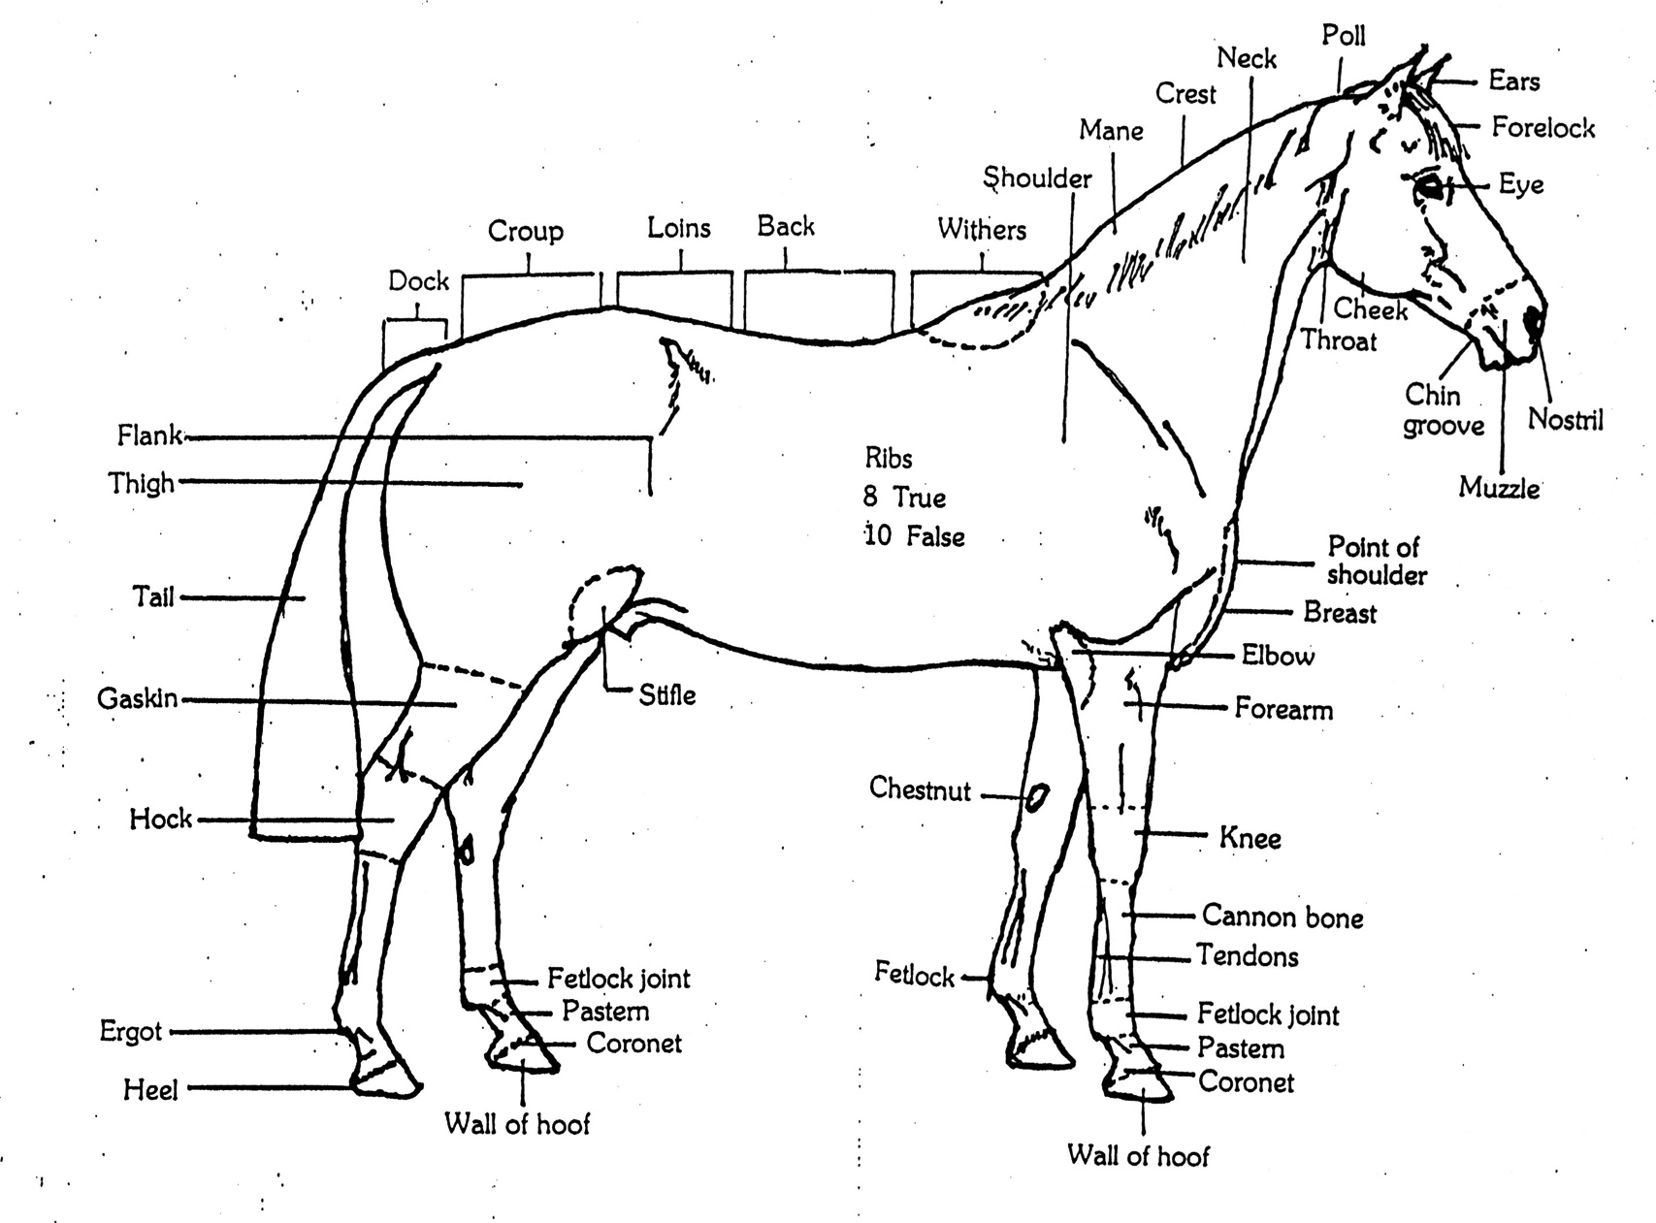

**English Saddle:**

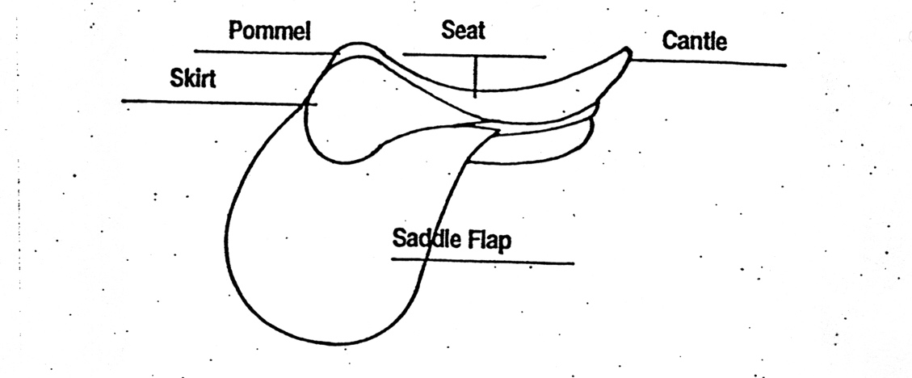

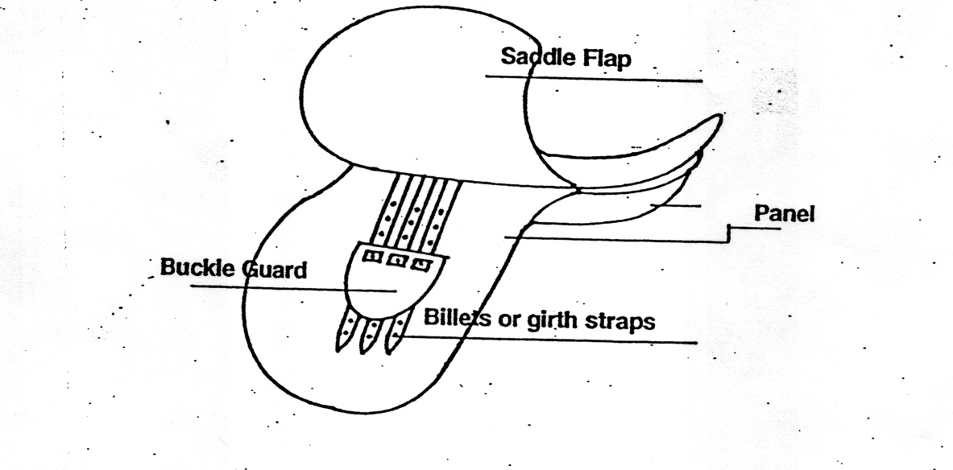

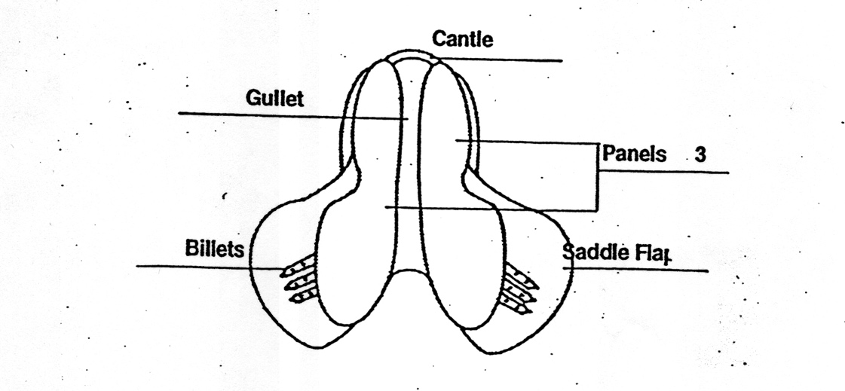

**Western Saddle:**

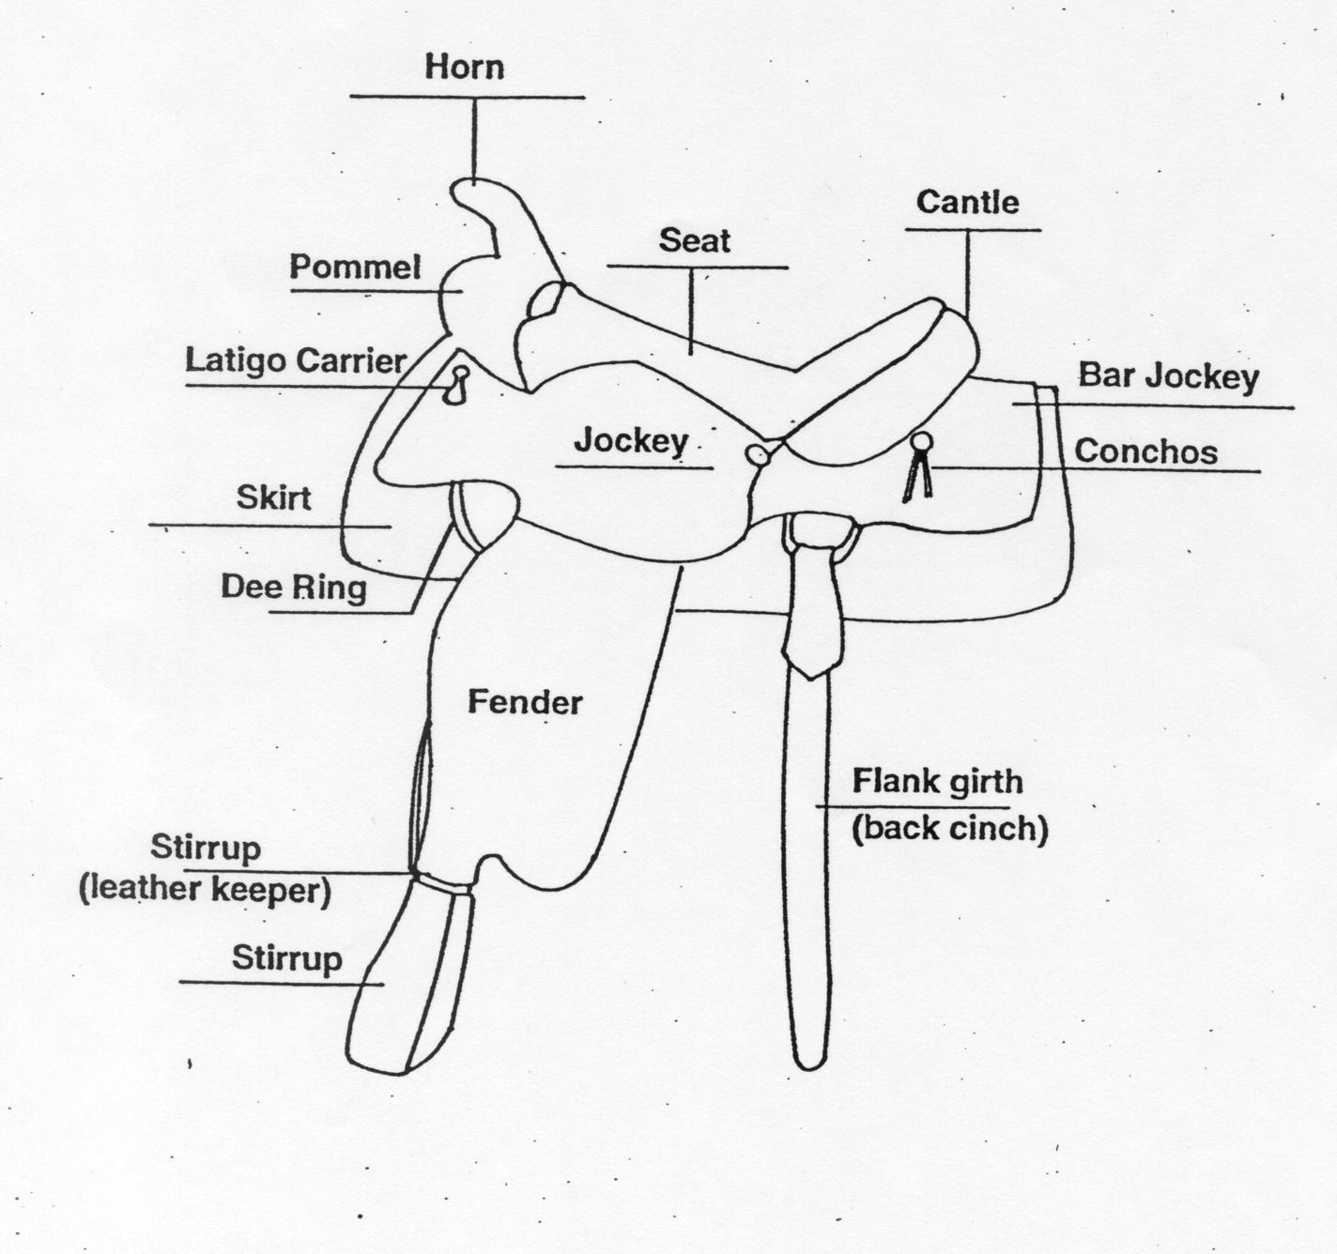

**Horse Language:**

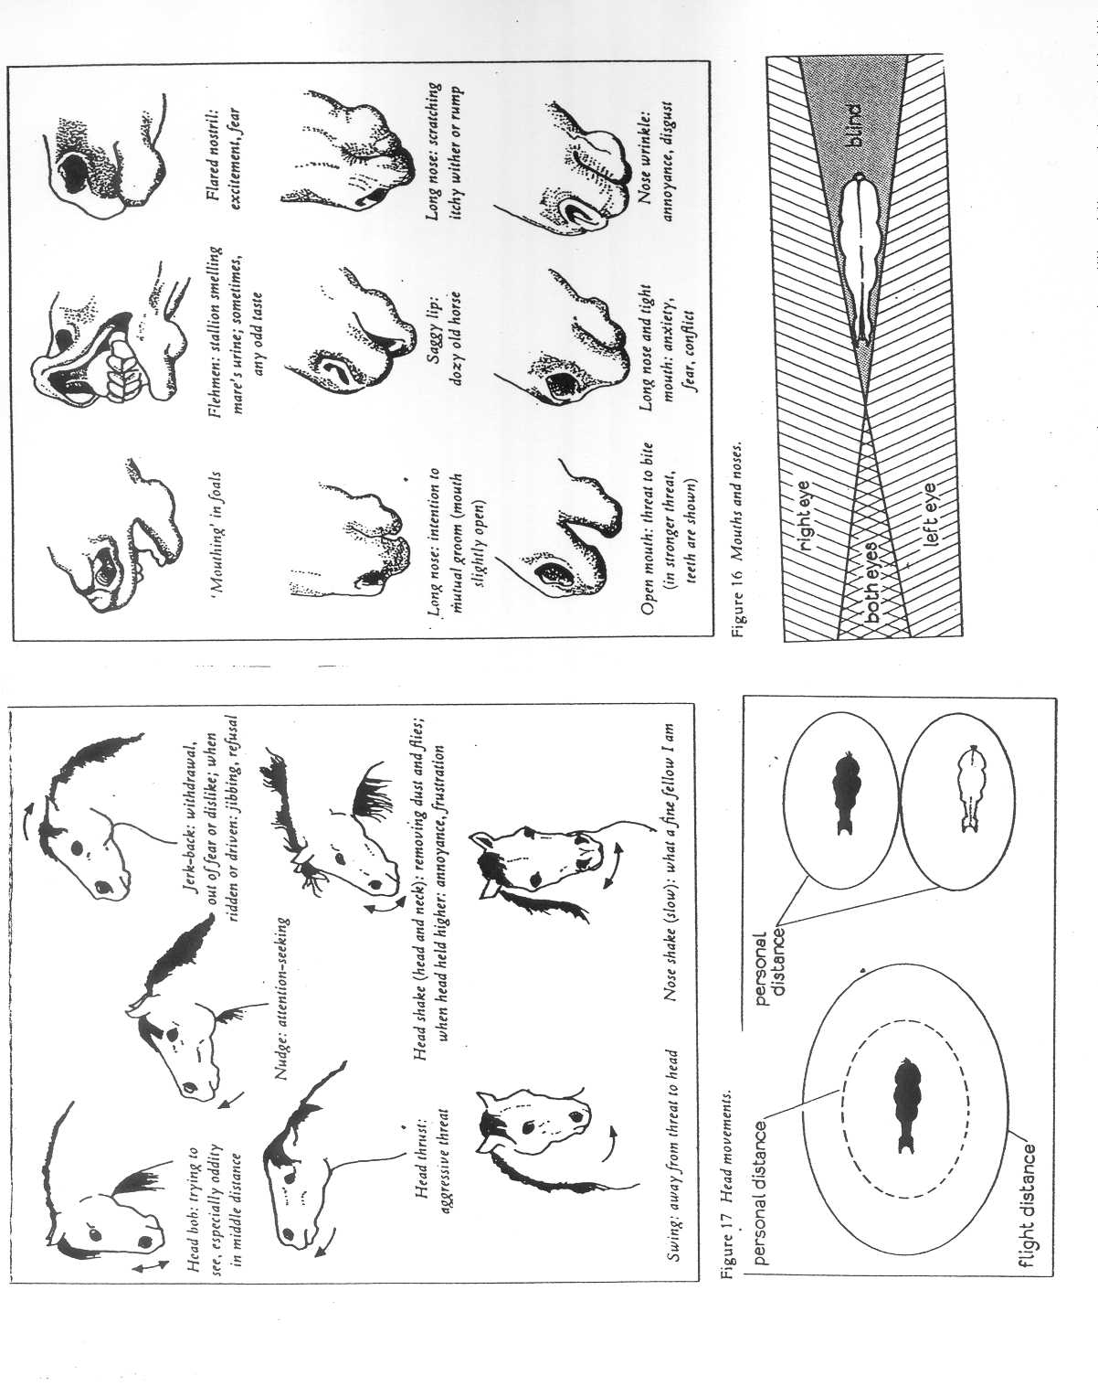

**M.E.S.A. Therapeutic Horsemanship, Inc.**

**Emergency Procedure Certification Form**

**Part 1**

Verification of Manual Contents

I, (print name) ____________________________________, verify by signing this form that I have read and understand the policies and procedures in this manual. I also understand and voluntarily agree to follow the rules, roles, and responsibilities that explained in this manual and expected of me.

Sign___________________________________________ Date___________________

**Part 2**

Verification of Rehearsal & Understanding

I, (print name)_____________________________________ ,verify by signing this form that I have completed the rehearsal and I understand the M.E.S.A. Therapeutic Horsemanship, Inc.’s Emergency Procedures on (date) ______________________.

Sign__________________________________________ Date_________________

Office Use Only:

Date: ____________

Verified: __________