https://www.theplayerstribune.com/articles/gosuke-katoh-ichiro-suzuki-retirement-baseball

Otsukaresama Deshita, Ichiro
Gosuke Katoh April 2, 2019

I was reading an article recently where Yusei Kikuchi, a Japanese pitcher for the Mariners, described Ichiro in a way that I think a lot of people do not fully understand. He spoke in Japanese, and what he said basically translates to a person above the clouds.

What this means is that Ichiro is not reachable. He is not real. He is not one of us.

He is a legend.

Ichiro’s final major league baseball game — which was played in Tokyo — was a beautiful and monumental moment in baseball history. I watched a replay of the game on my phone while I was on a bus to a spring training game, and I could hear the fans at the stadium showering Ichiro with words of respect and gratitude.

Some yelled, “Arigatou gozaimashita!” — which basically means “thank you.”

Others chanted, “Otsukaresama deshita!” — which is something for which there is no direct translation. I have seen many attempts to put this in English, and they usually amount to something like, “Thank you for your hard work.” But that is not accurate. That is not enough. In the English language, you cannot communicate the sense of respect and admiration conveyed by otsukaresama deshita. You cannot fully express the level of gratitude and appreciation. The words simply do not exist.
That is how much Ichiro means to his many fans.

I play Triple A ball in the Yankees organization. My parents are both Japanese, and that is one of the many reasons why I have had strong admiration and respect for Ichiro since I was a child. Watching his final game and his farewell, I was not only overwhelmed with gratitude and respect, but also with immense sorrow at the end of Ichiro’s spectacular career. I was moved by the fans in the stands that day as they tried to somehow express to Ichiro what he meant to them — what he means to his many fans all over the world.

Now I want to take this opportunity to share with you what Ichiro means to me.

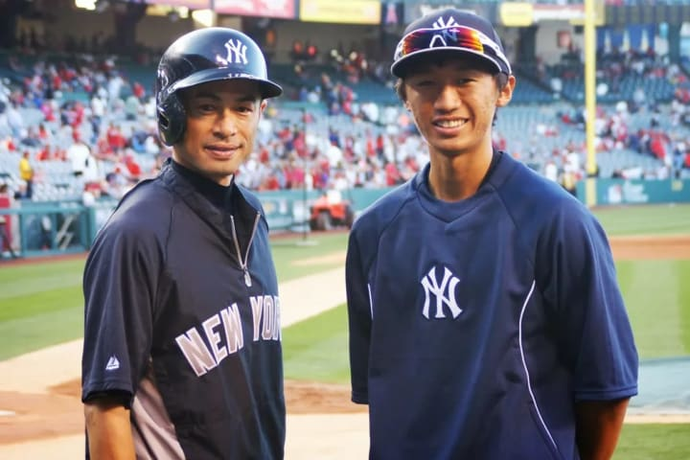
When I was six, my dad took me to a Padres game in San Diego. They happened to be playing the Mariners. And throughout the entire game, my attention was on Ichiro in right field. I felt a special connection to this player who looked like me.

My family had recently moved back to the U.S. from Japan. I was in kindergarten and I only spoke Japanese. I had no friends. It was a difficult transition for me.

But that day, watching Ichiro on the field … I was mesmerized. He was shining. It was not only how he played the game with consistency and precision that captured me, but also how he carried himself. He was the only Asian player on the field. He was different — someone I related to. We had both crossed over the Pacific Ocean to start a new life within a year of each other. But Ichiro did not let the fact that he was in an unfamiliar environment negatively impact his play, or his demeanor. He fully embraced the fact that he was different and he carried himself with comfort and confidence.

I saw that as a huge display of courage. And after that day, I couldn’t get enough of Ichiro. I watched him play every time I could. I wanted to be just like him.

I, too, wanted to shine.

Watching Ichiro gave me the courage to start talking to my classmates. At T-ball practice, I used the game to connect with my teammates. And pretty soon, without even really noticing, there were playdates and birthday parties and … friends. I had real friends — friends that I am still very close to today. I finally felt like I belonged.

Ichiro gave me the courage to integrate into American society. To seek out new friends and create lasting relationships. To not only accept the fact that I was different, but to embrace it.

It changed my life.

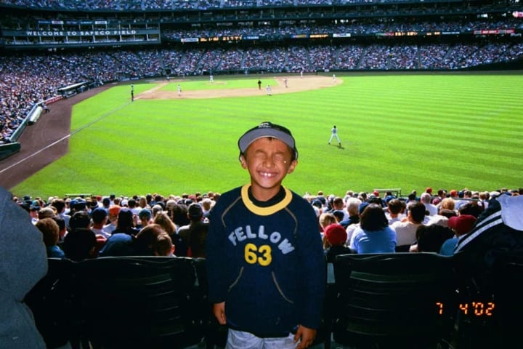

I was always the smallest kid on my baseball teams, so I related to how Ichiro was also a smaller, skinnier player. He was not like the big power hitters that had become so popular in major league baseball. He was able to succeed despite this because he possessed amazing talent. But his true strength was his work ethic. He worked every day to be as disciplined, thorough and consistent as possible. He was completely dedicated to his craft.

To me, that is the secret to his greatness.
I modeled my game after Ichiro’s. I learned how to bat lefthanded because of him. I tried to emulate his work ethic and dedication to become the best player possible. And when I was a senior in high school, my hard work paid off. I was drafted in the second round by the New York Yankees.

The team Ichiro played for.

After I was drafted, the Yankees invited me to take batting practice with the team in Anaheim. On the field that day, I met Ichiro for the first time. He came up to me and congratulated me on being drafted, and then … well, I unfortunately don’t remember much else. It was such a dream come true just to meet him that the whole thing was kind of a blur.

But it was the opportunity of a lifetime.

The following off-season, I worked up the courage to email Ichiro through a mutual connection we shared. I asked him for some hitting and base-stealing tips. I didn’t expect him to respond, so I was pleasantly surprised when he actually did. He said there was no way he could possibly give me tips in an email, as there were too many details to discuss.

So he invited me to work out with him in Japan.

I had never been so excited in my life. I was very nervous to practice alongside a legend such as Ichiro, but once we got on the field, all of that nervousness went away—because he put me to work. He hit me fungoes, one after another. He would not even let me go back to my position. Immediately after I caught a ball, he would hit another one in the opposite direction. He had me running all over the field. And I was not allowed to stop until I caught 50 in a row. If I missed one, I had to start over at zero. So whenever I would get close to 50, he would tease me and hit a line drive over my head so I would have to start over. Nothing came easy. He wanted me to work.

It was a long, hard workout. The conditioning was incredible. But it was also very fun … just Ichiro and me, enjoying the game — enjoying the work.

Together.

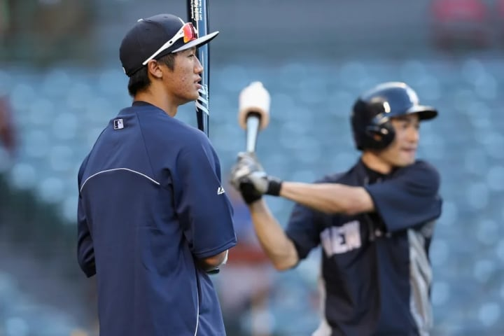

I recognize how rare it is for someone to get the opportunity to meet their heroes, let alone get to spend time with them and have them take a real, genuine interest in them. And I don’t believe I ever properly thanked Ichiro for inviting me to train with him in Japan, because we were both active players and I wanted to keep my level of fandom to myself so we could connect strictly on a professional level.

But now that he has stepped away from the game, I want to take the opportunity to thank him properly.
I want to say, “Arigatou gozaimashita.”

Thank you, Ichiro.

Not just for inviting me to Japan to train with you, but also for everything else. Thank you for setting such an amazing example for young players. Thank you for representing our country and heritage. Thank you for leaving your mark on this game we both love, and for making a lasting impact on me both as a player and a person.

Actually, “thank you” doesn’t quite cut it.

Otsukaresama deshita, Ichiro.

You are above the clouds.

