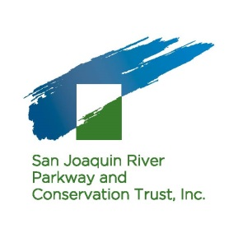
Special Events VOLUNTEER JOB DESCRIPTION

General Description
Scheduling
River Center Docents volunteer at the River Center, Saturdays and Sundays between 10:00 am and 3:00 pm, (AM Shift: 10:00 am to 12:30 pm, PM Shift: 12:30 pm to 3:00 pm), and during select special Trust events which occur at the River Center.
Duties, Responsibilities, and Expectations
- Participate in job training with a veteran volunteer, staff, or board member
- Become familiar with the River Center Docent Manual
- Develop knowledge of River Parkway Trust projects, programs, and activities

Qualifications
- Passion for the River Parkway Trust’s work to create and protect the 22-mile San Joaquin River Parkway
- Flexible schedules – the ability to volunteer for two 2.5 hour shifts on weekends each month
- Enjoy meeting and conversing with new people

Contact Info
Bryna De Fede, Development Associate
bdefede@riverparkway.org
559-248-8480 ext. 216

